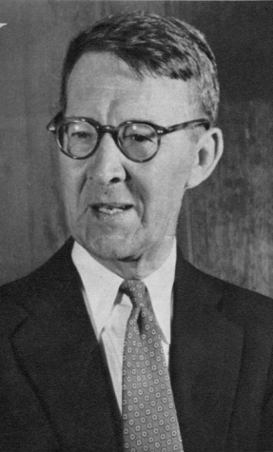
Yuri Doykov

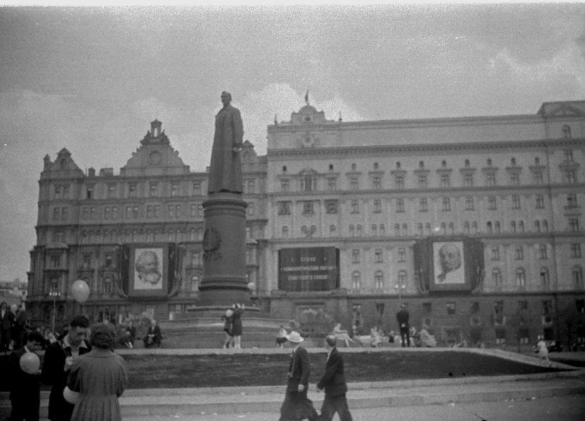
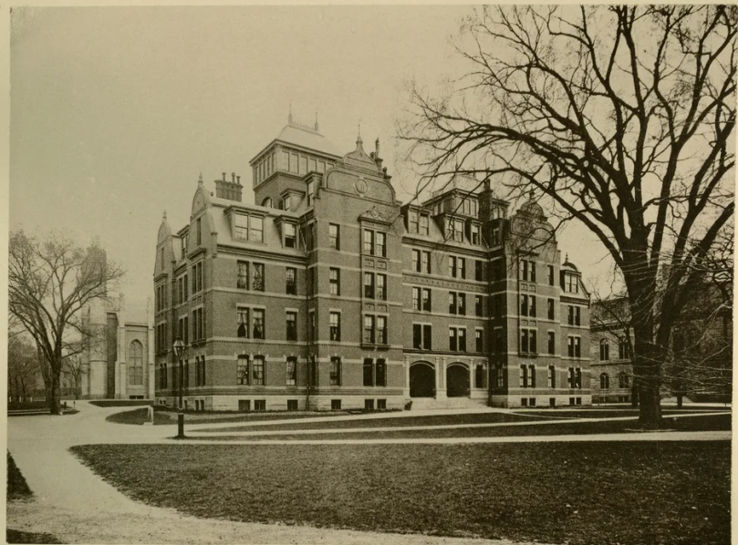

Why was he silent?
Pitirim Sorokin?
From the Lubyanka to Harvard
(1918-1930)

Arkhangelsk
September 2023

Based on materials of the Central Archive of the Federal Security Service, the Russian State Archive of Historical Studies, the Veliky Ustyug Museum-Reserve, the Hoover Institute, the Museum of Russian Culture in San Francisco; and periodicals from the 1920s in the USA, Germany, and Spain.

Cover photos:

Pitirim Sorokin. The American Magazine. November 1950. pg. 21

Lubyanka Square. Monument to Dzerzhinsky. Photo source: pastvu.com

Weld Hall Harvard University. 1900. Photo: mavink.com

Instead of a Preface

On June 7, 2023, Roger W. Smith wrote to me:

Dear Mr. Doykov. I'm at the NY Public Library.

Your email made me think of something again.

Why didn’t Sorokin, the staunch critic and opponent of the Bolsheviks, have anything to say, from the mid-1930s on, about Stalin and Stalinism? (1)

Mark Vishniak, a Socialist-Revolutionary and Pitirim Sorokin's comrade-in-arms in the anti-Bolshevik struggle in Russia, wrote in his memoirs, published after Sorokin's death:

In his published diary, Sorokin erased many traces of his past political activities as a member of the Socialist Revolutionary Party and his collaboration with it. In the biographical reference books “Who’s Who in America,” one can easily trace over the years how Sorokin’s attitude towards his political past had changed.” (2)

Sorokin in his Leaves from a Russian Diary (1924) and his memoir A Long Journey (1963) overlooked much of his biography and embellished a lot. … The ideological transformation of political and public figures is commonplace. Sorokin did not escape this outcome.

As soon as he was released from the Lubyanka prison, he gave his name to Bolshevik propaganda and became probably the first in a long list of repentant and repudiated Socialist-Revolutionaries, Mensheviks, Trotskyists up to the dissidents of the Brezhnev era.

December 4, 1918

Dear Vladimir Ilyich!
Not having the opportunity to see you in person and personally express my appreciation and gratitude to you, I will do it in writing, in the hope that my letter will reach you. Through your intervention, you have given me freedom and saved me from being threatened with execution – not because I deserved it, but because the executions were for nothing or for trifles, alas! they have become the norm in the provinces of socialist Russia. (Forgive me for reminding you of this bitter truth!)
Your article made me very happy, as a symptom of the new attitude of the authorities towards the democratic strata of Russia. It seems that you have correctly diagnosed the "turning point" and specified a totally correct recipe for uniting these elements with the Communists and thereby uniting forces for the purpose of saving Russia and the revolution from international and domestic reaction. Of course, not all of these groups have shifted from their old position of hostility to the authorities, but it is undoubtable that many taken a position of neutrality or of outright approval. It remains to be hoped that this process of regrouping forces will go faster and take more definite forms. Under the right conditions, the position of "neutrality" could very quickly turn into one of outright approval.
Once again, I sincerely thank you for my release.
I have done away with "politics," and, therefore, I am deprived as a "politician" of the opportunity to contribute to the organization of a new Russia. But in non-political activity, from now on I am ready to devote all my strength to the work of putting into practice the great principles of socialism. You were not mistaken and correctly understood both my letter and my evolution from "hostility to Soviet power to neutrality."
During this time, the position of neutrality has been replaced, if not by direct sympathy for communism, then at least by a completely "benevolent neutrality." Forgive me for simply addressing you with a letter.
With sincere and deep respect,
P. Sorokin (3)

Lenin's reaction to this appeal is unknown, but Sorokin (according to him) was offered the post of People's Commissar of Education, which he refused. Such a "flight" from one camp to another would indeed have been too steep, and he preferred to remain simply a professor at Petrograd University.

On the political situation in Petrograd in December 1918, the American newspaper New York Tribune on the last day of 1918 printed a telegram from its correspondent in Stockholm, who referred to information received from Russia:
A split is threatening among the ranks of the Bolsheviki in Petrograd. … A number of Bolshevik leaders are urging a policy of reconciliation with the Socialist Revolutionists and Mensheviki, pointing out that a continued policy of enforcing the will of the Bolshevik government will only lead to aggravation of the internal situation. This group is led by Zinovieff, president of the Petrograd Soviet. Another group of Bolsheviki, however, a group counted among the followers of Trotsky and Bucharin [sic], are opposed to this and insist upon the maintenance of the policy of "revolutionary violence." Neither of the two Bolshevik groups, however, is willing to have the Bolshevik government surrender its power to the Constituent Assembly.
The overwhelming majority of Socialist Revolutionists, led by Victor [sic] Chernov, as well as the Mensheviki, led by Martoff, have rejected the overtures of the Bolsheviki on the ground that no reconciliation is possible until the Bolsheviki agree to quit their dictatorship and hand surrender complete authority to the elected representatives of the people—the Constituent Assembly.
A small group of Socialist-Revolutionists, led by Pitirim Sorokin, as well a group of Mensheviki, have accepted the Bolshevik proposal on the assurance that new elections to the Petrograd Soviet would be ordered and that the Bolsheviki would abide by the vote. (4)

Sorokin kept silent not only about his activities in the Socialist-Revolutionary Party ...

There were many ambiguities in his relations with the Cheka, high-ranking Communist friends such as Eliava, Pyatakov, Vetoshkin, etc.

The records of Sorokin's interrogations in Petrograd+, Veliky Ustyug, and Moscow were not made public...

Sorokin concealed from readers of his diary and memoirs his entry into the "Society of Marxists" in Petrograd in 1920 (something like the embryo of the "Group of Red Professors" created in 1921 and immediately dissolved) ...

In December 2001, I flew to Veliky Ustyug and spent a week there ...

Eighty-three years later, after Sorokin was preparing an anti-communist coup here, the main street of the city was still called Sovetskaya. The Sukhona Hotel, where I was staying, was located on the corner of Krasny Lane and Krasnaya Street. Symbols of a seemingly bygone communist era are everywhere in this small Russian town.

On the embankment there is a monument to V. I. Lenin. Not far from it is the FSB building. The local newspaper is still called Sovetskaya Mysl [Soviet Thought].

One of its journalists told me: "Pitirim Sorokin doesn’t belong in Veliky Ustyug. He overthrew the tsar-father. Besides, he was a Freemason." There were more than fifty churches in pre-Soviet Veliky Ustyug. A negligible number survived ...

From the windows of the hotel room I could see the Assumption Cathedral, the former Market Square (where future member of the All-Russian Constituent Assembly Pitirim Sorokin made a speech to his fellow countrymen), the building of the former Provincial Committee of the Russian Communist Party (Bolsheviks), where Sorokin came to surrender to the Bolsheviks ...

A local historian told me: "The building was bought by my brother, an entrepreneur, who plans to open a café called Paris. When the foundation was laid, bullets were found. Apparently, they were shot not only in the Cheka, but also right in the provincial committee."

The building of the Cheka (the former mansion of the merchant brothers Chebaevsky) has been preserved. Now it is a city hospital. The oldest local historian of Veliky Ustyug, N. M. Kudrin, said:
"When Sorokin was arrested in 1918, his paternal aunt's husband, Mikhail Drankovskiy, was also arrested. After that he disappeared. Pitirim himself avoids this in his memoirs. I remember the Drankovskiy house. It stood on the hill near the Pokrovskoye cemetery. Now it has been demolished and something else has been built in its place. When I. M. Shumilov was arrested in 1937, his wife Katya was exiled to Kazakhstan. She stayed there for twenty years. Then, after Stalin's death, she returned to Moscow. Klaas died in prison."

In the Veliky Ustyug Museum, there were photographs of Sorokin's friends shot by the Cheka (Sorokin mentions the names of both in his memoirs—Pyotr Zepalov (5) and Pyotr Dvuzhilny).

... The year 2002 marked the 80th anniversary of the expulsion of Sorokin and others from Soviet Russia. Regarding this unusual action of the Bolsheviks, an American journalist wrote at the time:
St. Petersburg. Russia. Imagine that President Bush is fed up with the position of leading American intellectuals Noam Chomsky, Susan Sontag and their ilk criticizing Bush's war on terror and other policies.

So he gathered them all. He allowed them to take some basic necessities with them, made them sign an oath that they had been warned that they would be shot if they returned to the United States, and then put them on a pair of Boeing 747s and sent them to Europe.

Neither Bush nor the intellectuals have such a choice. We have the American Constitution. But 80 years ago, such an action was carried out by Vladimir Lenin with foremost non-communist philosophers, literary critics, economists, and other scientists of post-revolutionary Russia. In early August 1922, he arrested hundreds of them. Such as Nikolai Berdyaev, N. O. Lossky, Fyodor Stepun—three of the greatest Russian philosophers—and the eminent sociologist Pitirim Sorokin, who helped create the Department of Sociology at Harvard. Lenin then embarked them on two German liners, the Oberburgomaster Hagen and the Preussen, which sailed from St. Petersburg to Stetten, Germany, on September 28 and November 16.

The Russian newspaper Izvestia also celebrated its 80th anniversary by publishing two opinions.
Political strategist Modest Kolerov confidently stated:
"All of them did not want to leave, they wanted to be loyal citizens ... we were ready to put up with the regime, to go to work."

The FSB spoke even more confidently through the mouth of the Deputy Director of the FSB of Russia, State Secretary Vladimir Shultz:
"Thanks to the action of the Bolshevik leaders, outstanding scientists who made a significant contribution to the development of world science, technology, and art survived."

The essence of Schultz's opinion: "We, the Chekists, saved these intellectuals from being shot."

A few decades before these authoritative opinions of Russian figures, Winston Churchill expressed his opinion:
"They've expelled the last remaining brains from Russia."

§1

Even before Sorokin's arrival in the United States, the president of Vassar College, Henry Noble MacCracken, had "long conversations with him in Prague" in December 1922.

The result of these conversations was MacCracken's review of Sorokin's Russian language book The Current State of Russia (Prague, 1923), the predecessor of his English language The Sociology of Revolution (1925).

MacCracken wrote:
“The 120,000,000 of Russians must not pay for the crimes of the 1,000,000. President Masaryk is right in recognizing Russia de facto and in affording her people almost the only contact they have with the Western world. The work of the A. R. A., the Quakers and the Y. M. C. A. amounts practically to a de facto recognition by American private initiative. The official step would merely open the way to other groups and build up in that great country a friendship for America and an admiration of her best institutions which would not only do much for the future Russian republic that is to come, but would bring lasting reward to our own people." (1)

From these concluding words of the review it is evident that in the solution of the "Russian question," MacCracken was on the side of the pro-Soviet Senator Borah – the Soviet government must be recognized ...

Sorokin, in a lecture he gave at Vassar College in January 1924, stated:
The population of Russia has decreased by twenty-two millions since 1914; three millions were killed in the war, two millions have emigrated, and the remaining seventeen millions are the meat of the revolution." (2)

After lectures at Vassar College, Sorokin went on a lecture tour in the Midwest. In the summer of 1924 he wrote to MacCracken from Minneapolis:
"From my county are coming [sic] very bad news: again famine, cholera, tyfus [sic] and so on. But at the same time it seems, new young forces are growing. Therefore, finally I am optimistic" (3)

In his first American interviews, Sorokin constantly said that he came to the United States not as a politician, but as a scholar (his letters of 1924 to Alexander Guchkov indicate the opposite, not only as a politician, but also with an anti-Bolshevik mission) ...

The first three books he published in the U.S. were featured in both scholarly and popular periodicals.

Traces of all three of Sorokin's first American books should be sought in his archive in Canada, which, judging by the archival inventory, was thoroughly cleaned up by Sorokin himself or his widow. There are no traces of his anti-Soviet, and then pro-Soviet activities...
This is not surprising, since even the articles about himself in Who’s Who were changed by Sorokin from year to year, from volume to volume, in accordance with the political and other climate ...
His activities in Russia in the Socialist-Revolutionary Party were purged from the reference book ... And in his 1963 memoir A Long Journey Sorokin hid a lot of things ... In particular, he did not mention at all those reviewers and reviews of his first books that were published in the United States.
Let's fill the gap ...

Leaves from a Russian Diary was published on October 19, 1924.

Pitirim Sorokin. Leaves from a Russian Diary
E.C. H. [Edward Cary Hayes]. Editor’s Introduction
New York. E. P. Dutton and Company – 310 pp.

identical editions of this book:
London: Hurst and Blackett. 1925.
New York. Harper and Bros. 1927.

In the beginning of November, there were reviews...

1924

- S.H. An Émigré Looks Back. Christian Science Monitor. Nov. 5, 1924.

- H.B. [Henry Brickell]. Book on the Our Table. New York Evening Post. Nov. 11, 1924.

- Princess [Catherine] Radziwill, Bolshevik Russia. The Saturday of Review of Literature. Nov. 8, 1924. pg. 261.

- Bowers, Claude G. Russia Under Czar and Mob. The World (NY). Nov. 9, 1924. pg. 8E.

- Recht, Charles. Refugee Psychology. The Nation (NY). Nov. 26, 1924. pg. 577.

- Nazaroff, Alexander I. Trotsky Sets Forth Ideas of Communism. New York Times. Dec. 7, 1924. Review of Trotsky's Problems of Life (translated by Z. Vengerova) and Sorokin's Leaves from a Russian Diary.
Professor Sorokin's "Diary" is first and foremost a human document. In the Red Minister's book there are neither facts nor history. Trotsky simply prays, lectures, and philosophizes. The entire volume is his "morning prayer" on various problems of life published in Pravda.

- A Russian Diary. Prof. Sorokin’s Adventures in the Russian Overturn. Boston Herald. Dec. 13. 1924.
"Sorokin, a professor at Petrograd University, was repeatedly arrested by the Bolshevik tyranny, and at least once sentenced to death. As a result, he left Russia with only a pair of shoes given to him by a Czechoslovak fellow scientist and a suit he had received from the American Relief Administration.

- Smertenko, Jonas J. Social Upheaval. New York Herald Tribune, Dec. 14, 1924. pg. F11.

- E.N. The Diary of a Russian. A Personal Account of the Tragedy of Sovietism. Boston Evening Transcript. Dec. 17, 1924. Part 3, p. 5.

- Hickman, Walter D. Getting Other Side of the Story of Free Russia After Czar Fell. The Indianapolis Times, Dec. 23, 1924.

- C. V. D. A Russian Girondist. The Century Magazine. December 1924. Vol. 109, No. 2. pg. 287.
This record … is among the most dramatic yet written about the Revolution. His hatred for the dictatorship is immense, and will doubtless serve to strengthen the hands of Secretary [of State Charles Evans] Hughes.

1925

- Bittelman A. A Disillusioned Intellectual. Workers Monthly. Jan. 1, 1925. pg. 113.
"Professor … Sorokin is one of a group of counterrevolutionary intellectuals deported from Russia by the Soviet government some two years ago. … Now he has published his diary which a sort of confession and political “credo” combined.”

- Nikolaieff A. M. (Colonel). Russia From Within. New York Evening Post Literary Review. Jan. 3, 1925. pg. 4.
"This is an important book. … Professor Sorokin’s is so far the only narrative written in English by a Russian eye-witness which covers the whole period of five years from the beginning of the revolution up to the famine of 1922, including the latter.”

- (Unsigned, probably H. L. Mencken). The Land of Lunacy. The American Mercury. January 1925, p. 127.
“Five more reports from the Russian madhouse. [In addition to Sorokin's Diary, the author reviews Magdaline Marx’s The Romance of New Russia, Alexander Kaun's Leonid Andreev: A Critical Study, Maxim Gorky's Fragments from My Diary, and Alexander Kornilov's Modern Russian History] … Sorokin escaped to Germany, and is now a professor in the University of Minnesota, teaching sociology. … the net result of the war was the destruction of the intelligentsia—some of them. like Sorokin, taking to the woods and the swamps, and others, like Andreev, dying of chagrin—and the complete revival of Oriental despotism. Today Russia is in the cultural stage of Persia. Even Turkey, Portugal and Rumania are more civilized.”

- Martin, Lawrence. A Sociologist’s Political Memories. The Chicago Evening Post Literary Review. Jan. 30, 1925.
As history or as sociology it has two manifest defects: it is written from a bitterly anti-bolshevist point of view, and undoubtedly it has been retouched and revised.

- The Truth About Russian Misrule. Former Supporters of Soviet Government Tell of Horrors Under Reign of Bloodthirsty Internationale Dictatorship. (a review of Sorokin's "Diary" and an article by Catherine Breshkovsky in The New York Times). Labor Digest. A National Magazine for the Advocacy of Industrial Peace. February 1925. Vol. 17, No. 2. pp. 3-5.
In the face of such evidence [presented by Sorokin], it seems hardly possible that there are sane men and women in America who wish to overthrow our government … for the madhouse of Russia.

- Wetmore, Louis H. The Commonweal. Mar. 4, 1925. Vol. 1. Iss. 17. pg. 469-470
The Russian mentality is as distinct from that of the European as the Chinese. Before the war of 1914-1918, we were plagued with a series of books whose authors sought to prove that the Russian people was not of the East, but of the West. For many years, Dr. Wallace’s classic work on Russia was the chief volume (in English) defending this indefensible viewpoint. When the popularity of that large tome passed, Mr. Stephen Graham provided us with a series of volumes, reeking with sentimentality, which aimed to show for the Russian peasant as a sweet and simple soul, filled with a pungent Christian mysticism, the sole inheritor of Christ’s teachings in the modern world. Before our eyes passed lines of Russian pilgrims, pietistic and holy, contact with those souls was to bring back Christian faith and practice to a materialistic world. During the war, Mr. H. G. Wells added to the myth of the Western-minded Russian by producing a grossly ignorant and propagandist t volume in which his chief point seemed to be that the revolutionary Russian greatly resembled the modern Englishman! Ex-Senator Beveridge had previously written a book to show that the Russian advance in Asia was in reality the advance of western civilization. The Russian revolution has, for the moment at least, closed a chapter in the interpretation of Russian mentality as western; and a reading of Professor Sorokin’s Leaves from a Russian Diary disposes once and for all the sugary version of Mr. Stephen Graham regarding the spiritual beauty of the Russian peasant’s soul. … One who has come in close contact with many Russians … is authorized to say that outside of learning they have a keen appreciation of hard liquor, of oversweetened tea, and an utter lack of appreciation of what we western people mean by the term morality. …. Professor Sorokin’s book is worth reading, … He saw much, heard more, and was, for a while at least, in a position to survey and understand the strange course of the Russian revolution.

- The Bookman. A Review of Books and Life. March 1925. 61.1. pg. 96.
… "Leaves from a Russian Diary" is heartily recommended to Communists and Aristocrats and those who are stand midway.

- Dorr, Rheta Childe. The Soviet Paradise at Close Range. The Literary Digest International Book Review. April 1925. pp. 187-189.
[The] fatal division of the intellectuals, coupled with what Sorokin calls the “damned passivity" of the Russian masses, was responsible for the triumph of Bolshevism and accounts for the continued rule of the Communist tyranny.

- Lasswell, Harold D. (University of Chicago). The American Journal of Sociology. July 1925. Vol. 31, No. 1. pp. 108-109.
[Sorokin's] observations … are deformed by a very mélange of passion, facts, rumor, and polemics which reveals so much about the witness.

- Davis, Jerome. Bolshevism: Destructive or Constructive? The New Republic. July 15, 1925. pp. 213-214.
A review by a Yale professor of six books, including Leaves from a Russian Diary and The Sociology of Revolution by Sorokin.
In considering any theory from the sociological point of view it is necessary to study carefully the life history of the individual who formulated it. In the case of Dr. Sorokin we find a partial case record in his book Leaves from a Russian Diary. … Dr. Sorokin does not agree with the leading historians of the world that "after many generations a better valuation of historical events is possible." He thinks that contemporaries are "the better judges of historical events.” In so far as his book is submitted in evidence it disproves his thesis.

- Advocate of Peace through Justice. Vol. 87, No. 9, Sept. 1925. pg. 567.
Dr. Sorokin … was, indeed, himself a member of the Kerensky’s Government while it lasted.
Sorokin, however, had not much faith at any time in Kerensky as a force to guide the revolution. “Hamlet, wavering to and fro, such was the impression Kerensky created,” he says. …
In October 1917, came the Bolshevik Revolution.

- [probably E. E. Mavrogordato E. E ]. Out of Russia. The Times Literary Supplement. Oct. 8, 1925. pg. 648.

- Three Books on Russia. The Birmingham Post (West Midlands, England). Nov. 10, 1925. pg. 3.
Review of Leaves from a Russian Diary by Sorokin, The Red Terror in Russia by S. P. Melgunov, The Tcheka: Red Inquisition by George Popoff.

The real essence of [Sorokin's] book is that the author remained throughout a healthy and normal soul … and, on his showing, there were thousands like him. Most of them died ...

- American Political Science Review. November 1925. Vol. 19, No. 4. pp. 845-867.

1926
- How Russia Collapsed. Courier, Brisbane, Queensland. Jan. 16, 1926.
Professor Sorokin … tells a remarkably vivid story of human futility and of human savagery; ... it is one that politicians especially ought to read. Then they will understand how Lenins naturally succeed Kerenskys.

- S.N.H. The Annals of the American Academy of Political and Social Science, Vol. 125, Modern Crime: Its Prevention and Punishment. May 1926. pg. 271.
The psychology of the "emigre" is noticeably present, though what one has more definitely is the interesting fact of the changes in attitude of a Socialist and revolutionist under the influence of the actualities of revolution.

- Davis, James. “Professor at University Here Relates His Own Experiences in Days of Russian Upheaval: Was One of Central Figures During Early Years of Revolt – Fought Bolshevism at Risk of His Life.” The Minneapolis Sunday Tribune. Nov. 7. 1926.
“… there is plenty of interesting material about the great leaders, especially Lenin and Trotsky. For the former Mr. Sorokin expresses contempt, for the latter there is acknowledgment of ability.

- D. C. T. M. The Scottish Geographical Magazine. 42.3. Nov. 15. 1926. pg. 177.

We will also cite those reviews of Leaves from a Russian Diary, which were published thirty years later...

Pitirim Sorokin. Leaves from a Russian Diary
and Thirty Years After
New York, Boston
E. P. Dutton and Co.
Enlarged Edition
Beacon Press, 1950. 346 pp.

1950
- Barber, Kathleen L. A 30-Year Audit of Bolshevism. “Diarist” Less Better Than in ’24. The Washington Post. Feb. 19, 1950, pg. B6.
From the vantage point of 30 years later, Harvard Sociology professor Pitirim Sorokin has added a new chapter to his famous “Leaves from a Russian Diary.” … His story became the classic account of the fate of the Girondists of the Russian Revolution. ...
The author’s most important message to contemporary America is that the anticommunist leaders are fighting “a few spots of the red rash covering the social body" instead of the real disease.

- Duncan, Clarence. Revolution’s Failure. The Nashville Banner (Nashville, Tennessee). Mar. 5, 1950. pg. 34.

- Eminent Sociologist Analyzes Success and Failure of Revolt. New York Herald Tribune. Mar. 12, 1950. pg. 3.
The book objectively depicts the Red Holocaust: terror, tyranny, famine. What the Bolsheviks turned a once great country into.

- Scharschug, George J. An Idealist’s Plan to Stop Communism. Chicago Daily Tribune. Mar. 12, 1950. pg. H2.
[Professor Sorokin] decries present efforts and methods to stop the communist drive for world domination. He says:
“The techniques of love instead of hate, of creative construction rather than destruction, of reverence for life in place of serving death, of real freedom instead of coercion and pseudo-freedom—such are the techniques for rebuilding the house of humanity.
A beautiful dream?

- Author Who Fled Russia Blasts Revolution, Reds. The Spokesman-Review (Washington). Mar. 12. 1950. pg. 86.
The book needs to be read particularly by those who think revolution and communism will bring about a millennium for man. It demonstrates that just the opposite will result.

- Davis, Alice. Russia Comes Under Scrutiny. Richmond Times-Dispatch. Mar. 19, 1950. pg. D9.
This little book will be very useful to anyone who is trying to understand the current crisis in world affairs.

- Pisko, Ernest. Russian Hamlets. The Christian Science Monitor. Mar. 23. 1950. pg. 26.
The men who overthrew czardom ranged all the way from middle-of-the-road conservatives to Social Democrats and radical agrarian reformers. In their political and social views they were diametrically opposed to Bolshevism. In their moral convictions their leaders superior to Lenin. They were Russian Hamlets, architects of dream castles who did not know a brick even if they stumbled over it. And so they lost.

- Sociologist’s Soviet Escape Expanded. The Los Angeles Times. Apr. 2, 1950. pg. 118.
[Sorokin] well knows Soviet ways and objectives, and his book is authoritative in substance, containing much that every thinking American must learn.

- Clouch, Beulah. Exiled Russian Views U.S.S.R. Tulsa World (Tulsa, Oklahoma). Apr. 23, 1950. pg. 71.
Professor Sorokin says that only people who have gone through the tragic, possibly fatal, communist experiment can be cured of it once and for all.

- Sherwin, Stephen. Communism and Its Antidote. St. Louis Post-Dispatch. May 14, 1950. pg. 28.
Sorokin's protest against communism is equal to the methods of modern opposition to communism. If Sorokin knows how to implement his good Bible counsel, then we hope that he will share his knowledge with the State Department.

- Don Wolin. Russian Diary Has Little Cheer. Democrat and Chronicle (Rochester, New York). May 21, 1950. pg. 76.
Sorokin presented us with a picture of complete chaos: torture, hunger, death, lawlessness... The book can be recommended as additional material to the understanding of modern Russia...

- Bruni, Thomas. The Morning Call (Allentown, Pennsylvania). May 28, 1950. pg. 35.
The standard of living in Russia 30 years later is still lower than in pre-revolutionary Russia, political freedoms are completely absent, and the social classes and strata that the Bolsheviks loudly promised to destroy are still in place and have taken a different form. The exploiter is now the state itself.

- Iswolski, Helene. The Commonweal. June 16, 1950. pp. 252-253.
In a new additional chapter, "30 Years Later," Sorokin concludes that the Russian Revolution was a colossal failure because it did not produce any cultural values. The Russian Communists destroyed all areas of culture of which Russia had previously been justifiably proud: philosophy, poetry, music, literature, drama, all of which were strangled in Soviet Russia.

- Carpenter, David. Daily Worker. June 23, 1950. pg. 10.
Why Pitirim Sorokin thought it necessary to reprint his Leaves from a Russian Diary, originally published in 1924, is a mystery to the reviewer. …
Perhaps Sorokin, who is now undoubtedly sincere in his espousal of the struggle for civil rights in the United States, for the Communists as well as other progressives, feels that he must prove that he is an anti-Communist from way back to save himself from personal reprisals.

- Marks, Harry J. (University of Connecticut). The Hartford Courant. July 6, 1950. pg. 8.
Sorokin describes the head of the Provisional Government, Kerensky, as follows: "A good man, but a bad leader. In essence, he is an excellent type of Russian intellectual."
Of Lenin, Sorokin writes: "The face of this man reminds me of the type of born criminal from Lombroso's album."

- C.G. International Affairs (Royal Institute of International Affairs). Vol. 26, No. 3. July 1950. pg. 438.

The most interesting part of this book deals with the vicissitudes of the Russian men of learning, especially the university professors, at the hands of the Marxist revolutionaries and the tergiversations which men like Professors Tarle and Derzhavin have survived in Soviet Russia. Though the Bolsheviks have themselves proclaimed that the Soviet proletariat is triumphant over its class enemies at home, there is still no slackening in the total dictatorship over all forms of intellectual activity. Whereas in 1922 recalcitrant anti-Bolshevik intellectuals, like Professor Sorokin, had the option of banishment from the U.S.S.R., to any country giving them a visa, or ‘massacre’ at home (Trotzky, p. 301), no such option exists for Soviet intellectuals today.

- Walsh, Warren B. (Syracuse University). The Russian Review. Vol. 9, No. 3. July 1950. pp. 233-235.
The Russian Revolution … has never fulfilled its promises of greater freedom in society and politics, or of the abolition of exploitation and inequalities. It has produced, instead, greater despotism, less freedom, and more inequalities. And it has replaced the limited exploitation of employees by private employers with the exploitation of an entire people by its government.

- Anderson Paul B. (International Committee of YMCA, New York City). The Annals of the American Academy of Political and Social Science. Vol. 272 (November 1950). pp. 284-285.
In his review of Sorokin's Diary, Anderson concludes with the words: "This book is highly personal, but today each of us is involved personally involved in the fate of the world."
Anderson himself lived in Russia during the Civil War and, as he writes, read Sorokin's Diary as his own.

The second American book by Sorokin:
Pitirim A. Sorokin. The Sociology of Revolution
Lippincott Sociological Series edited by Edward Cary Hayes, Ph.D.
LL D. Professor of Sociology. University of Illinois
Philadelphia and London. J. B. Lippincott Company
1925. – XII, 428 pp.

1925

- Fling, Fred Morrow (University of Nebraska). An Indictment of Revolution. Evil Aspects of Great Historic Upheavals. The Sun (NY). Mar. 14, 1925.

- E.N. Revolution. A Plea for a Rational Progression of Civilization. Boston Evening Transcript. Mar. 14, 1925. pg. 3.

- MacDonald, William. Analyzing the Life History of Revolutionary Movements: Professor Sorokin Describes a Cycle of Effects Common to Them All. The New York Times Book Review. Mar. 29, 1925. pg. 3.
Anyone will be unconditionally happy to write a comment on this book.
Those who have read the recently published book "Leaves …" can only wonder that, having gone through the horrors and sufferings in Russia, Professor Sorokin found the energy to write The Sociology of Revolution. ... Between 1917 and 1922, the population of Soviet Russia decreased by 15-17 million people.

- Abbot, William Cortez. The Working of Revolution. The Saturday Review of Literature. Apr. 11, 1925. pg. 664.

- A Russian on Revolution. The New York Herald Tribune. Apr. 12, 1925. pg. A6. (excerpt from the final chapter of The Sociology of Revolution).
"A society which does not know how to live, which is incapable of carrying out adequate reforms, and which puts itself in the hands of the revolution, will pay for its sins with the death of a considerable proportion of its members."

- G. S. L. The Minnesota Alumni Weekly. Apr. 23, 1925.
Between 1917 and 1922, at least 600,000 people died without trial at the hands of Cheka. Professor Sorokin knows the subject he is writing about."

- Walling, William English, Revolutionary Movements Dissected and Exposed. Twin City Review (Champaign, Illinois). Apr. 24, 1925.
Sorokin's book "The Sociology of the Revolution" is recognized as impartial even by the American friends of Soviet Russia.

- Gaines, Clarence H. Revolution and Patriotism. The North American Review (Boston, Massachusetts). June 1, 1925. pg. 757.
The critical internal state of affairs in many European countries, the collapse of Russia, and, finally, the emergence of threatening subversive tendencies in many European countries, even in the United States, all this stimulates reflection on ethics and demonstrates its necessity. The tremendous work done by Professor Sorokin, in his book on the sociology of revolution, strips the camouflage of revolutionary propaganda.

- Rubinow I. M. Are Revolutions Worth While? The Efficacy of Revolutions As Judged By a Great Sociologist – The Marxian View. The New Leader. June 6. 1925. pg. 4.

- Barnes, Elmer Harry. Revolution in America. The Nation. 1925. Vol. 120, No. 3127. pp. 668-669.
Dr. Sorokin presented a picture of the horrors that can await our country if we do not stop the new barbarism ...

- The Times Literary Supplement. July 2. 1925. pg. 451.

- Calhoun, Arthur W. (Brookwood College). Social Forces. Sept. 1925. Vol. 4, No. 1. pp. 217-218.
There is no reason to believe that the author has achieved his ambitious goal of erecting a dam for revolutionary projects. The cataloguing of the evils of revolution is no substitute for other methods of purifying social relations.

- Grierson, John (Chicago). The American Journal of Sociology. 1925. Vol. 31, No. 3. pp. 399-400.
Professor Sorokin too often falls into invectives against the Bolsheviks.

- The Ottawa Evening Citizen. Dec. 22, 1925.

- Hanna Meuter. Review of The Sociology of Revolution (Cologne). Kölner Vierteljahrshefte fur Soziologie. 5. 1926. pp, 461-464 (review of the 1925 American edition).

1926

- Park, Robert E. The Annals of the American Academy of Political and Social Science. Jan. 26, 1926, Vol. 123. pp. 230-231.

The purpose is to state, no doubt, the phenomena in such abstract and formal terms that the events of one revolution can be compared with those of another, so that the conclusions which the author is able to draw at the end of the volume will have a general character. …
Those who are eager for facts to discredit communism as an economic and political ideal will find them here. And this no doubt explains why, in spite of the pedantry of its naturalistic style, it has met with such favorable comments in the popular reviews. …

The Sociology of Revolution was also reviewed in Europe ...

Pitirim Sorokin. Die Soziologie der Revolution
Ins Deutsche ubertragen mit einer Einleitung
versehen von Dr. Hans Kasspohl
J.F. Lehmanns Verlag / Munchen. 1928. 358 pp.

Reviews in German
1928
1. Kasspohl, H. Einleitung zur deutschen Ausgabe [Introduction to the German edition], in: Sorokin P. Die Soziologie der Revolution. Ins Dt. übertragen und mit einer Einl. versehen von H. Kasspohl [The Sociology of Revolution, Transl. in Germ. and Foreword by Dr. H. Kasspohl], (pp. 7–30), Munich: J.F. Lehmanns Publ. (in German).

2. Meusel, A. Sorokin P. Soziologie der Revolution: Rezension [Sorokin P. The Sociology of Revolution: Review], Archiv für Sozialwissenschaft und Sozialpolitik, 60, pp. 206–210 (in German).

3. Soziologie der Revolution. Pitirim Sorokin & H. Kasspohl. Annalen der Philosophie und philosophischen Kritik, 7. Bd. (1928), pg. 70.

4. N. V. Bubnoff. Soziologie der Revolution by Pitirim Sorokin and Hans Kaßpohl. Zeitschrift für die gesamte Staatswissenschaft (Journal of Institutional and Theoretical Economics), Bd. 85, H. 2. (1928), pp. 387-391.

1929
1. Jenny, E. Sorokin P. Die Soziologie der Revolution. Ins deutsche Uebersetzt von Dr. Hans Kasspohl. Muenchen: J.F. Lehmanns Verlag, 1928. 360 p. [The sociology of revolution by Pitirim Sorokin. Translation in Germ. by Dr. Hans Kasspohl], Zeitschrift für Voelkerpsychologie und Soziologie, 5 (1), 77-79 (in German).

Reviews in Russian

1925
Repeynikov F. (Lutokhin, D.A.). The Face of the Revolution. Volya Rossii (Prague). 1925. No. IV.
A long negative review by a former friend and colleague ends with the words: "Let us not be afraid of the terrible face of the revolution."
«Не устрашимся грозного лика революции».

1929
Stepun, Fyodor. The Religious Meaning of the Revolution. Sovremennyye zapiski (Contemporary Notes, Paris). 1929. XL. pp. 443-444 (in Russian).
In this article, Fyodor Stepun mentions Sorokin's The Sociology of Revolution in passing:
"In his scientifically very unrespectable, but journalistically very passionate The Sociology of Revolution, Pitirim Sorokin collected a great deal of material and undoubtedly proved the truth, which did not require proof, that all revolutions fatally describe one and the same vicious circle: in the process of their development, they destroy the principles in the name of which they begin their journey." (pg. 143).

Федор Степун в этой статье мимоходом упоминает «Социологию революции» Сорокина:
«В своей научно очень не солидной, но публицистически очень страстной «Социологии революции» Питирим Сорокин собрал большой материал, безусловно, доказал не требовавшую доказательств истину, что все революции роковым образом описывают один и тот же порочный круг: разрушают в процессе своего развития те принципы, во имя которых начинают свой путь» (С. 143)

Review in Ukrainian
Mukhin M. Suspilstvo (Prague). 1925. Sat. I-II. pp. 149-150.
"By the way, Czar Alexander III is awarded in Sorokin's book the title of 'great', which he does not deserve at all."

Review in Japanese

Dr. O'Hara translated The Sociology of Revolution into Japanese (1926).
Dr. Musagawa (possibly Nunokawa) issued a special pamphlet on this publication.

Sorokin in Spain

Dr. Posada translated The Sociology of Revolution into Spanish.

Posada, Adolfo. La Llama Íntima: Meditaciones, Ensayos, Recuerdos (The Intimate Flame: Meditations, Essays, Memories). Valencia: Prometeo, 1925 (a long chapter on "Sociology" by Pitirim Sorokin).

Posada, Adolfo. Estetica y Sociología de la Revolución. La Nación. Nov. 1, 1925. pg. 6.

Posada, Adolfo. Sociología y Etica de la Revolución. La Nación. Dec. 6, 1925. pg. 11.
"Although it may not seem very consistent with the above—I think it is, essentially—I cannot resist the temptation to extract a tragic page—from [Boris] Pilnyak—in a story entitled "Bielokonskoye."

Sorokin in Czechoslovakia

An authoritative response from Lukáš Babka in Prague:

"As far as I know, only two works by Pitirim Sorokin have been published as books in Czech.”

Krise našeho věku. Překlad František Dědek. V Praze: Tiskařské a vydavatelské družstvo československého obchodnictva, 1948. 289 pp.
https://aleph.nkp.cz/F/?func=direct&doc_number=000059074&local_base=SLK

Sociologické nauky přítomnosti. Překlad Blažena Jirsová. V Praze: Jan Laichter, 1936 [spr. 1935]. viii, 714, [iv] s. Laichterova filosofická knihovna; sv. 13.
https://aleph.nkp.cz/F/?func=direct&doc_number=000527089&local_base=SLK

I know nothing about the publication of the book 'Sociology of Revolution' in Czech."

Now let's turn to the situation in the United States at the time of Sorokin's arrival overseas. While Europe had repulsed the onslaught of Bolshevism by the early 1920s (Italy thanks to Mussolini, Finland thanks to Mannerheim, etc.), in the United States the left wing movement, fueled by Moscow, was gaining strength. As early as September 1, 1919, at a congress in Chicago, the first Communist Party in the United States was created under the leadership of C. E. [Charles Emil] Ruthenberg. The next day, September 2, another Communist Party appeared, led by John Reed.

Lenin's "Martens Mission" was engaged in Bolshevik propaganda until it was deported from the United States in 1921.

In 1924, it was replaced by Amtorg, headed by GPU agent Ilya Khurgin.

Khurgin's legal assistant was attorney Charles Recht. The same individual who was one of the first to give a negative assessment of Sorokin's diary in the American press (The Nation, November 26, 1924). It is likely that Khurgin or Recht conveyed to Sorokin the "proposal" of the Bolshevik government to return to his homeland and work for the benefit of Russia.
Recht himself worked for the benefit of Soviet Russia until his death at the beginning of the Brezhnev era. Recht's biography is typical of "Soviet sympathizers" in America. At the age of fifteen he came to the United States from Bohemia. He studied law at New York University. He fortuitously married the daughter of the president of an insurance company. He collaborated in various left wing organizations, defended radicals subject to deportation from the United States in courts. He was a paid lawyer for the Martens Mission. As early as 1924, Recht was awarded the title of "Honorary Member of the Moscow Institute of Soviet Law" ... Shortly before his death, he once again visited Moscow, where he told Soviet journalists about how almost half a century ago he had fulfilled "Lenin's request."

Another "leftist" reviewer of Sorokin who had engaged in heated debates with him about Russia was Jerome Davis.

In January 1925, the US Communist newspaper Daily Worker reported on the final session of the American Sociological Association, held at the Auditorium Hotel in Chicago, during which 1,000 professors from various colleges listened to a speech in defense of Soviet Russia by a young professor at Yale University against the foolish attacks of Pitirim Sorokin of the University of Minnesota:
"One thousand college professors heard Davis blast Sorokin's lies with a concise statement of the actual facts." (4).

That young professor was Jerome Davis, who had just become a professor at Yale.

Another left wing opponent was Burn Starr in The Communist (July 1927). He began his article as follows:
The most recent attack on Marx is that of Professor Pitirim Sorokin, a Russian emigree [sic], now a professor of sociology at the University of Minnesota (Russians can get jobs at capitalist universities if they are on the safe side). In his new book, Social Mobility, Sorokin, like most bourgeois sociologists, is vehement in his claim that he seeks the "truth."
The anti-communist psychosis of this "impartial" scientist often manifests itself in symptoms well known to psychopathologists.

And concluded it like this:
Ten years have passed but he is still trembling from the experience of his flight from Russia. He sees the tremendous influence of Russia in awakening the exploited of the world and he tries futilely to stem the rising tide by his counter-revolutionary propaganda disguised as science.

The longtime editor of The Communist was Alexander Bittelman, who fled from exile in Arkhangelsk to New York in 1912.

It was only after the 20th Congress of the Communist Party of the Soviet Union, which exposed Stalin's crimes, that Bittelman finally became a "revisionist" and was expelled from the Communist Party in 1960.

There were a huge number of reviews. From clippings, it is possible to compile a small bio-bibliographic dictionary of their authors’ "Who's Who" and determine their slant and position in the “left-right center" of the American community of a hundred years ago: Countess Katerina Radziwill, Isaac Rubinov, etc.

From Sorokin's letters to P. B. Struve in Paris, it follows that Sorokin sent him both of his first American books in February 1925.

A review by the founder of "legal Marxism in Russia," who had since gone far to the right, an academician and editor of Vozrozhdenie, would have been very important for the benefit of Sorokin's cause. Struve was not "Burdocks" and "Burn Starr" ...
Sorokin wrote:
"Few Russian professors here live much differently than you and Russian scientists in Paris. We are scattered, and therefore we live in an American environment. This has its positive aspects, but often the "Russian environment" is lacking, especially the environment that is with you and around you. But there is nothing to be done, despite this "Americanization," we are still more Russians than ever. At least, perhaps I have never felt so Russian, intimately and inseparably connected with Russia, as I do now. And I'm glad that's the case. ...

In terms of properly informing about Russia, I am doing what I can. And since I have recently begun to receive orders from the press syndicate, this, in addition to individual newspapers, gives me the opportunity from time to time to write such an article in 100-150 newspapers.

I will not hide the fact that this is blocking my way in the eyes of the "pink socialist,” of whom there are quite a few among the professors, especially sociologists in the colleges and universities here. This "intelligentsia" is, as always, poorly informed, "instinctively" sympathetic to Bolshevism. But I have long since ceased to reckon with them and with all such facts, and therefore I am pursuing my line as best I can. (7)

He broke with his colleagues in the Socialist-Revolutionary Party, Chernov, Kerensky, etc., with his "Renunciation" in Soviet Russia. In Prague he broke with Sergei Maslov. It was necessary to "lean” on someone somewhere, and thus it was Struve.

On November 6, 1925, Sorokin wrote to him:
"Dear Pyotr Berngardovich:
Two weeks ago, I finally started receiving Vozrozhdenie [Revival]. I read it very carefully. If, from the point of view of technique, the newspaper has defects, from the point of view of its content and the great campaign which you have begun, I can only welcome the paper, the cause, and the foreign congress. ...

So far, I wish you every success. I have no hope for our "democrats." ...

For Christmas I will be in New York for two weeks. Could you tell me where you think I could be useful to your cause?

Secondly, what kind of articles from me would be desirable for Vozrozhdenie? During my stay in New York, I could hold a meeting of Russians and formally produce – or enroll – a large number of Russians in the conference. ...

In the newspaper and in general I will not publicly declare my full solidarity with you and your movement yet: "ours" are already putting spokes in my wheels here (although so far without success). This is where the campaign gets even stronger. Therefore, for the time being, for the time being, I will do what I can, but let it remain between us or in a close circle. Secrecy of communication and organization is also not a bad thing." (8)

The "Russian Congress Abroad" organized by P. B. Struve was held in Paris on April 4-11, 1926, under his chairmanship. Four hundred delegates from twenty-six countries gathered. Four unnamed delegates arrived from the United States.

To noisy, stormy, long and other applause, patriotic speeches about the great Russia were made by various individuals, groups, organizations... Sorokin did not send a greeting...

However, it was not possible to create a "united front" against the Third International, which had overtaken Russia. It was also not possible to elect a single leader of the emigration. It was decided to not even create a collective leadership...

Only the speeches remain in historical memory from the Russian Congress Abroad...

Soon Sorokin turned to Struve again. This time, he was to find a suitable candidate among Russians in Paris to compile a compilation of works published in France over the past twenty years for an important new monograph "Rural and Urban Population, Rural and Urban Migration, and the Role of Rural and Rural Relations in the History and Fate of Society."

At the end of the letter there is a postscript: "Did you receive my letter and subscription fee for Rossiya?" (9).

Not much has survived from Sorokin's correspondence with Struve. ... In June 1926 he wrote a letter of introduction from Minnesota to “Academician Peter Berngardovich Struve / Paris-Prague”:
"I take the liberty of recommending to your attention Mrs. Ponafidina. A native American, married to a Russian diplomat, Mrs. Ponafidina stayed in Russia until 1922, saw all the horrors of the revolution, lost her estate, etc., and returned to America in 1922. Here, by her articles, lectures, and other activities, she, more than anyone else, has contributed to the dissemination of correct information about Russia, and thereby has brought and continues to be of great benefit to Russia. Now she visits Europe and the former Russian regions in order to return to America and continue the great cultural work she is doing.

I am sure that the meeting with Mrs. Ponafidina will be pleasant and useful both for you and for the Russian cause.

I might add to this that Madame Ponafidina, in addition to her brilliant qualities as a lecturer and writer, loves Russia as the best Russian patriots love her, and, not belonging to any party, belongs to the real, profoundly honest and truthful elites. (10)

Sorokin's position on the "Russian question"? On recognition of the USSR he was neutral, neither for nor against He wrote about this in a letter to [the economist F. A.] Harper, and expressed it as a "public intellectual" in the press, stating that there was no reason to fear Soviet Russia. That the government there was not the government of Russia, but the government of the "Union of Soviet Socialist Republics." The word "Russia" or "Russian" was absent from the name...

Sorokin still believed that the government would not last long, that the Russian people would be able to overthrow tyranny, and that the "Third International" that would come to the United States in the event of recognition of the USSR “could not do anything more than increase a little the work of the police.” (11)

Sorokin's ambivalent position played into the hands of Senator Borah and other apologists for the recognition of the Soviet Union and contradicted the policy of non-recognition of the USSR of three American presidents: Harding, Coolidge, and Hoover ...

Of course, this position of Sorokin played into the hands of the Kremlin itself and its agents: Foster, Bittelman, and many other "pinkos" ...

Alexander Guchkov, a former minister of war in Kerensky's government, who, like Pyotr Struve, sought to unite all émigré anti-Bolshevik forces, wrote to Sorokin in April 1924:

«... Never before in history in general, and in the history of our Fatherland in particular, has terror been indicated to such an extent as a means of fighting the authorities as at the present moment in Russia.

Work in this direction is being carried out persistently. But the modest results of this work and its insignificant result are explained by the fact that there are no funds for a different way of setting the matter. In fact, it can be said that if it were possible to dispose of large funds, this method of struggle would produce very tangible results.

If you, dear Pitirim Alexandrovich, agree with my assessment of the internal situation in Russia and share my point of view on the methods of struggle for the liberation of our fatherland, then you could render a great service to our cause by using the numerous tentacles with which you have apparently grown in the American milieu.

It is necessary to find out whether it is possible to find in America such persons and organizations that would be ready to assist us in our struggle.

I do not dare ask you to take over the negotiations on this subject. You and your mission should not be compromised by being associated with such a case. For this purpose, it will be necessary to send a special person who is intimately familiar with the work to be done and the task at hand.

But you, like no one else, can say, on the basis of your general impressions, whether there is a chance of sympathy and assistance in this cause? If you come to a positive result, then do not refuse to ascertain a little more closely which persons and on which circles you could count on. I don't think my question will take you by surprise. I am convinced that even if you did not ask your American interlocutors direct and definite questions on this subject, you silently and imperceptibly have assessed each of them from the point of view of his readiness to render active assistance in the struggle for the liberation of Russia.

Therefore, it seems to me that you will be able to give me at least a general but definite answer in the near future, without making any special reconnaissance.

If there were some, even faint, chances of success, it would be a sin not to make use of them.

I do not, of course, need to remind you of the absolute secrecy that must surround this affair. If our adversaries knew that work was being done in this direction, they would increase their vigilance. (12)

But by the end of 1925, Sorokin had even changed physically—he had become obese, etc. In a letter to him dated December 2, 1925, MacCracken joked unhappily:
"It will be wonderful to see the metamorphosis of your transformation into a corn-fed Midwestern farmer. I don't know if you include that among your positive life characteristics." (13)

Sorokin was offended and immediately replied (Dec. 5, 1925):
"Thank you for the letter. Your fat hypothesis is incorrect. ...I could be fat physically and mentally, but that's impossible for me. "(14)

That was the end of his correspondence with his first American sponsor.

In his "six happy years" at the University of Minnesota, Sorokin trained only two graduate students. Time was spent on paperwork, picnics, correspondence...

The chairman of the Department of Sociology, F. Stuart Chapin, had trained eight...

One of Chapin's graduate students, Dorothy P. Gary, who defended her PhD in 1928, lived a long life and shortly before her death remembered Sorokin:
"I didn't like him because he was a careerist making a good life for himself. "(15)

Dorothy Gary's boyfriend, future husband and collaborator John F. Markey, was also a student of Chapin, but he enjoyed playing softball with Sorokin. In his 1963 memoirs, Sorokin even mentions him as "one of the foremost sociologists of modern America." He doesn't mention Dorothy...

The fact that Sorokina tried to prevent the defense of her dissertation was told by Dorothy herself (16).

Don Martindale, who wrote a 75-year history of sociology at the University of Minnesota, cites Chapin as saying that Sorokin's arrival in the sociology department in 1924 created a stir, that students found it difficult to adjust to his teaching style, and that Sorokin himself quickly entered into competition with everyone from students to faculty. (17)

No more specifics ... As in Sorokin's memoirs, there are only vague references to the "ideological battles" of faculty liberals and Marxists. The word "anti-communism" is not even mentioned...

One of the "progressive" professors whose lectures were loved by students and appreciated for his anti-establishment style, Luther Lee Bernard, was removed from his seat because Sorokin needed it. Barry Johnston writes about this in his biography of Sorokin. (18)

In his memoir, Sorokin denied participation in Bernard's dismissal with one line...

In his memoir, thirty-four years later, he devoted three pages to another unpleasant incident. "Somebody," Andrew W. Lind, published a review of Social Mobility with which Sorokin was disheartened...

Lind wrote:
"The citation of seven hundred or more authors in the 550 pages of the book testify to the breadth of research upon which this treatise is based. Although Professor Sorokin modestly characterizes his present study as ‘a general theory of the vertical mobility of individuals and social objects,’ he presents a comprehensive treatment of social stratification and social change ... If there is one noticeable weakness in the book, it consists in the very extensive range of its materials and the sweeping character of its generalizations" (19)

There were only fifteen lines in Lind's review, "blood had been shed,” Sorokin was offended...

Andrew Lind was only 28 years old at the time. A graduate of the University of Chicago, he was a member of the Department of Sociology at the University of Hawaii, created in 1920.

Rudolf Heberle, who at that time was an intern at Harvard on a scholarship from the Rockefeller Foundation, was chosen for a "retaliatory strike.” In the end, as a result of complicated moves (pressure on the editors of the journal, etc.), two months later, in June 1928, the American Journal of Sociology published a six-page review by Heberle, with which Sorokin (according to his memoir of 1963) was quite satisfied.

On Christmas Eve 1924, Sorokin sent letters to numerous correspondents.

On December 22, 1924, he wrote from Minneapolis to I. V. Emelianoff in Prague:
«... I'm sorry I haven't replied to your letter yet. Was busy as hell ... Both of us sincerely wish you both a Merry Christmas and a Happy New Year and wish you a great deal and, most importantly, a New Year in Russia. ... Vinnychuk wrote to me that you were setting up some kind of bank there with Aladyin [? – the last name is illegible – Y. D] I have already written to A. G. that I do not know Aladyin, I have heard not very important comments about him ... The bank is still unclear to me, so I can't get involved in this business. ... I can't get involved in a business I don't know or understand. ...
During this time I was working on my "Millionaires" - part or chapter of my new big work on "Social Mobility.” ... The university here is growing by leaps and bounds. Now it's the third largest in the U.S. Now Rockefeller will give it another 2 1/2 million and the state will give it another 2 1/2 million, so it's swelling. It has grown tremendously in these three years, so you would probably be amazed at its growth.
Today is Christmas, but alas, there is nothing to drink here, it is bad." (20)

On March 20, 1927, Sorokin wrote to Yemelyanov:
«... Even before your letter, I wrote about your department; His answer is enclosed herewith. Upon receipt of your letter, I immediately wrote to Yale University. I will be very glad if your business settles down and you move here. I will be happy to help in any way I can. I'm in a hurry now. Therefore, this letter is brief. Please tell Dolgopyatov that his letter and the letter from Editor (? – the word is illegible – Y. D.) I got a mug, but, unfortunately, I don't have the time and the ability to raise money. Therefore, I can't send them yet: I can't use my own money either, since I'm not a millionaire, and I have to send what is left to different places. You can't even imagine what an incredible number of money requests we receive. ...
Cordial greetings to your wife, Zubashev, Dolgopyatov, Vinnychuk and all the brethren. For the last four months and another month I have been incredibly busy: studying, a number of articles, plus one book will be published in two weeks (Social Mobility, a brick of 600 pages), another book is Contemporary Sociological Theories, a brick of 700 pages, ends with correspondence and goes into print and will be published in the fall. Over the summer, I plan to write another small volume of Leaders and Leadership (a sociological and statistical study) and together with by my student Professor Zimmerman a monograph. ...
You see, I'm busy: there's no time to collect money, which I don't know how to collect." (21)

The matter – Yemelyanov's arrival in the United States at the invitation of Rutgers University – was arranged in the same year...

Contemporary Sociological Theories was published in New York and again, like Social Mobility, contained references to about 700 or more authors.

This time, there was no one willing to rudely mock Sorokin about this in the style of Andrew Lind. Albert Wolfe, a professor of economics at Ohio University, wrote quite diplomatically that the Russian émigré Sorokin showed an education and erudition rare in the modern world, and especially in the United States, and was able to avoid a bias towards "sterile antiques" ... (22)

Sorokin's boss, Stuart Chapin, gave the book a corresponding advertisement in the foreword...

Whereas in Prague the publication of Sorokin's Sociology of the Revolution was hindered by Girs and Lyacka, a Pamphlet on the Revolution was published by the International Institute of Sociology in French without Sorokin's knowledge. Unbeknownst to the author, "The Ideology of the Present Agrarian Movement..." was also published.

In Germany, the popularization of Sorokin's name was taken up by the "retired major" Hans Kasspohl.
In 1925, the major's scientific baggage included two works on Bolshevism ("The Persecution of Religion in Soviet Russia" and "Kulturbolshevism in Germany"). Kaspohl translated The Sociology of Revolution into German, wrote an extensive preface to it, and in 1928 it was published by the Munich publishing house J. F. Lehmanns Verlag. The head of the publishing house, J. Lehmann, was a Nazi Party activist and a friend and supporter of Adolf Hitler, A participant in the Beer Hall Putsch of 1923, he was arrested several times. ...

The publishing house, which he and his wife founded in 1890, specialized in the publication and distribution of nationalist books, social psychology, etc.

Hitler, who did not have a higher education, drew his knowledge from the books of this publishing house. It is quite possible that the future dictator of Germany also read Sorokin's Sociology of Revolution. Lehmann officially became a member of the NSDAP in 1931 and was awarded a gold party badge and an obituary in 1935 in the Voelkischer Beobachter. (23)

Almost nothing remains of Adolf Hitler's library of 17,000 works, and it is impossible now to ascertain whether it contained books by Sorokin with the dictator's marginalia.

In 1928-29 The Sociology of the Revolution received only five reviews in German scholarly journals. Probably, the Nazi "brand" did not inspire the reviewers... The patriarch of German sociology, Leopold von Wiese, even remarked that Dr. Kaspohl had distorted the meaning of Sorokin’s book. It is not known whether self styled experts such as Eduard Bernstein, Karl Kautsky, and Otto Bauer, not to mention other, lesser experts on the revolution, responded to Sorokin's first American magnus opus.

Kaspohl, on the other hand, stubbornly continued his mission. In 1931, for the more respectable J. F. Lehmanns Verlag, he published Sorokin's Contemporary Sociological Theories for the much more respectable Munich publishing house C. H. Beck, promising in the preface to make Sorokin's works "accessible to the German reader." After that, the "retired major" Dr. Kaspohl disappeared from the horizon ...

Neither he nor Lehmann, who paved the way for his books in Germany, are mentioned by Sorokin in his memoirs... Much more world famous sociologists, von Wiese and Thurnwald, deserve mentions.

Even earlier than in Germany, The Sociology of the Revolution was published in Latvian in Riga. The translation and publication were done by Arthur Kroders. He was three years younger than Sorokin. The son of a village teacher, Kroders took part in the "revolutionary battles" of 1905 with his father at the age of thirteen. He was expelled from Russia. He lived in Vienna, Berlin, Leipzig, and Stockholm. He worked for Latvian magazines. After the overthrow of Nicholas II, he was a supporter of Kārlis Ulmanis, the ideologist of the Peasant Union...

Sorokin sent his preface to the Latvian edition to Kroders as early as April 1927, and in 1929 The Sociology of Revolution was published. (24)

The fate of the Kroders family was typical for citizens of a country occupied by the Soviet Union... In 1935, the Ulmanis regime was established in Latvia— unique among other interwar dictatorships in Europe (there was no ruling party, parliament "stamping" laws, etc.).

Kroders became one of the main ideologists of the new regime: a member of the propaganda department in the Ministry of Foreign Affairs and editor of magazines.

Unlike his boss Ulmanis, he eluded the Chekists and in 1941 and 1945 he left for Sweden, along with thousands of Latvians.

The fate of Arthur Kroders' family:

1. Father – Jan Arvidovich Kroders (1860, Lauteres, Livonia Province – 1938, Leningrad). Member of the RSDLP since 1904, arrested on February 26, 1938 by order of the Special Troika of the NKVD of the Leningrad Region. He was shot by order of the Special Troika on October 21, 1938.

2. Mother – Anna Kroders (1868-1913).

3. Wife – Zelma Kroders (1897, Riga – 1981, Valmiera). She lived in Petrograd (1914-1918). Librarian. Translator of European classics of the 20th century. Under the Germans, she owned a bookstore in Riga, then lived with her youngest son in Liepāja (1944-1978).

4. Eldest son Voldermars Kroders (1923, Riga – ). During the Second World War, he was in the Latvian Legion. Then came West Germany. Citizen of the Federal Republic of Germany. In 1948, he became a businessman in Pakistan. Consul of the Federal Republic of Germany in this country. Journalist, writer, publicist.

5. Youngest son Jan Kroders (1935-2016). Famous basketball player. Latvian Champion, twice European Champion. Coach, teacher.

6. Elder brother Pavel Kroders (1887-1956, Riga). He participated in the Revolution of 1905 and the First World War. Then, in Siberia, he worked his way up (under a pseudonym) from a clerk in various companies to a director. He returned to Latvia in 1921 and worked in the Department of Forestry and Customs. Journal Editor. Author of books.

7. Elder sister Milda Kroders (1886, Latvia – 1970, Riga). Before the First World War, she worked at a publishing house in Leipzig. In Latvia, she was a proofreader and editor for newspapers.

8. Twin brother Robert Yanovich Kroders (1892-1956). Journalist. Theater critic, translator. On June 14, 1941, in Riga, together with his wife and two sons, he was arrested and deported to the Soviet Union (Solikamsk, Perm region). On January 2, 1945, he was arrested in the village of Podtyosovo, Yenisei District, Krasnoyarsk Territory, under Article 58-10 of the Criminal Code of the USSR. He was sentenced to ten years in a labor camp. After ten years, he returned to Latvia and died.

9. Wulf, Herta (1890-1942, Dorofeevsk, Krasnoyarsk Territory). Wife of R. Kroders. Actress. On June 14, 1941, she was arrested and deported with her two children to Kansk, Krasnoyarsk Territory. The term was 20 years. She died in exile.

10. Olgerds Robertovich Kroders (1921, Riga – 2012, Valmiera). He was the eldest son of R. Kroders. Student of History. He was arrested on June 14, 1941 and sent to Kansk with his mother and younger brother. In 1942, together with his mother and brother, he was deported to the Dorofeyevsk trading post. In 1956, he returned to Latvia. He became a well known theater director. Since 1989, he has been the chief director of the Latvian National Theatre.

11. Kroders, Gunārs Robertovich (1926, Riga – 1999, Norilsk). He was the youngest son of R. Kroders. Gymnasium student. He was arrested on June 14, 1941 and deported to Kansk, and in 1942 to Dorofeyevsk. From 1943 he worked in Norilsk at the Combine. Soviet journalist and editor. "I have lost my typical Kroder identity, but I have retained my Latvian identity."
From 1960 to 1999, he was editor-in-chief of the newspapers of the Norilsk Combine Gornyak, Honorary Citizen of Norilsk, Honored Worker of Culture of Russia, etc.

In 1917, Kroders, who, like Sorokin, began his career in the revolutionary ranks, and in 1917, together with his friend and peer Aleksanders Plesner, organized the National Union of Latvian Soldiers, which played a major role in the creation of the Latvian National Army in November 1918. Sorokin became Russian, Kroders Latvian. Both went into involuntary exile.

In a review of the first volume of Kroders' memoirs (25), published the following year in Copenhagen in Latvian, Edgar Anderson wrote:
"Arthur Kroders was an interesting person. ... He can be passionately loved or hated. He thought very highly of himself and did not see a single politician or journalist to equal him among his countrymen. He was an interesting interlocutor who was acquainted with a significant part of Latvia's active society. He had sarcastic, incisive observations and evaluations of many of his contemporaries ...

Kroders' book contains a lot of valuable information. ...
Kroders writes about the May 15 regime, but makes no mention of his role or his brother's role in glorifying the regime. " (26)

In Kroders' memoirs, there is information about the "Bruce Lockhart case" in Moscow in 1918.

Four Chekists are considered to be responsible for the Soviet policy of genocide (executions, deportations, etc.) and the main murderers in Latvia in 1941: three Jews:
Semyon Shustin,
Zinovy Krivitsky,
Alexander Brezgin
and one Latvian, Jānis Cinis (27).

Meanwhile, on January 12, 1928, Struve's Vozrozhdenie (Revival) published a "response" to Sorokin's works. There was no signature. Perhaps Sorokin himself wrote it. The style is recognizable ... His two books, Social Mobility and The Sociology of Revolution, and the release of a third, Contemporary Sociological Theories, in early January were reported.

It was reported that The Sociology of Revolution had already been translated into Japanese, partly into Czechoslovak, and had been published in German.

It was also reported that:
«... The Spanish sociologist A. Posada devoted an extensive chapter from his book La Llama Intima to an analysis of Sorokin's works. The same was done by France Veber, professor at the University of Ljubljana, in his book Idejni Temelji Slovanskega Agrarizma: Programatična Socialna Študija (Ideological Foundations of Slavic Agrarianism: A Programmatic Social Study, Ljubljana: Kmetijska tiskovna zadruga, 1927).
This year, the Czechoslovak Academy of Agriculture elected Sorokin a member. In previous years he had been elected a member of the Deutsche Gesellschaft für Soziologie, The International Institute of Sociology, etc. (28)

In December 1927, Professor Huntington put it bluntly: "If the only consequence of the Russian Revolution had been Professor Sorokin's arrival at the University of Minnesota, we should have owed it a great deal." (29)

Sorokin's Sociology of Revolution was read assiduously in Calcutta and Prague.

Sorokin's monograph, which warned against all kinds of revolutions, somehow found its way to the desk of Professor V. K. Sarkar, and he included in his review "dates, names and titles, ideas about the revolution."

In the preface, dated Calcutta, September 18, 1928, Sarkar wrote: "The time has come for India to begin to study European-American developments, as well as Asian and African developments, and to see with her own eyes and interpret from her own point of view.
One cannot depend solely on Western interpretations, even when many facts and phenomena are of Western origin. ...
The lack of good libraries in India has had a strong impact on my research, especially on the European continent. In the better conditions that prevail all over the world, my sketching work can be improved. "(30)

Despite “difficulties,” Sarkar expresses personal gratitude for the friendly assistance of books, booklets, and bibliographies to a dozen sponsors from Europe and America, not to mention friends and sponsors in India itself. Sorokin’s name is not on this list of acknowledgments, although Sarkar dedicated three whole countries to Sorokin.

The only remark on Sorokin's Sociology of Revolution is the absence of nationalist anti-foreign revolutions, such as the Czechoslovak revolution of 1918 and the American revolution of the eighteenth century. (31)

Sarkar was probably the first in a long line of Asian and Latin American scholars to write responses to Sorokin's work and translate them over decades.

What is most important is that, in a successful career, Sorokin learned "self promotion" well in Russia. He was published in newspapers of various orientations - from the pogrom Zemshchina to the professorial Russkie Vedomosti.

It is interesting to note that the first articles about Sorokin appeared in the American press even before his arrival from Trieste to Boston on November 1, 1923.

The Indianapolis Star commented on November 22, 1923:
"He believes that the bolshevik regime will not last longer than three years more. While recognizing the danger of prophecy atter the refutation of previous predictions apparently based on sound judgment of close students of Russian affairs, Dr. Sorokin still insists that the present oligarchy of six or seven men can not continue to impose its will on the masses indefinitely. He is not willing to say whether the next regime will be a republic or a monarchy. Of all the millions that can call Russia the fatherland, he declared, scarcely 1 per cent are in favor of the bolsheviks, and at least 95 per cent hate Trotzky, Kamineff, Radek and their associates.” (32)
This article about Sorokin can be considered his first American publication so far.

Soon an article by Sorokin appeared in a major newspaper: the New York Evening Post. It was a translation of his article "The Modern Intelligentsia" from Kerensky's Berlin newspaper Dni, published on November 21, 1922. Sorokin wrote that the romanticism and sentimentalism typical of the old intelligentsia had burned up in the fire of the revolution, and he assured that revolution and civil war were "not the decline" of Russia. (33)

Five years after the Bolshevik putsch and the civil war, Sorokin still did not understand that Russia no longer existed and would never exist. There was the "USSR" (Union of Soviet Socialist Republics).

Jan Slavik, an astute historian of the Russian Revolution, believed that Sorokin's interpretation of the sociology of revolution was even more erroneous than Lenin's. (34)

Some of Sorokin's Czechoslovak and Ukrainian colleagues read The Sociology of Revolution in its Russian version. This can be seen from Sorokin's letter to Josef Kralj dated May 5, 1924:
«... About a year ago you wrote to me in a friendly manner that you were going to write an article on works on revolution, including my Sociology of Revolution. Can you inform me whether you have carried out this intention and, if your research is published, send me a copy of it?" (35)

Noting the release of Sorokin's third book, Columbia University professor Franklin Giddings noted in his review that it was the best study of revolutionary psychology. (36)

It was in vain that Sorokin complained in A Long Journey about a certain "group of people" who were "at the throat" of his "anti-communist activities." His works received excellent press in the most respectable publications in the United States. The marginal communist press could not be perceived so painfully. In addition, "anti-advertising is also advertising."

And it was not appropriate for Sorokin, who had passed through tsarist and Soviet prisons, to complain and be afraid of poison pens.

It was much more necessary to fear the long arm of the GPU and its New York agents, Khurgin, Skvirsky, etc.

On January 20, 1924, Sorokin told the press that he and two of his colleagues in Russia from Czechoslovakia had received an unofficial invitation from the Soviet government to return to Russia and "continue economic, cultural and educational work among the peasantry." (37)

A week later, an unsigned article appeared in the New York Times:
Coincident with the official message of the death of Nikolai Lenin, Premier of the Russian Red Government, last Tuesday, Russian exiles in America took hope that they might soon return to that country.

One of them, Professor Pitirim A. Sorokin, formerly connected with the University of Petrograd, expressed a very optimistic view of the future of his native land. He declared Russia would come back with her own in the eyes of the world—not to her pre-war days of Czarism and Cossacks, but under “the faithful rule of the strongest political power in Russia today, the peasants.” …

Professor Sorokin has received many requests to come back to Russia, and help the peasants in their fight for recognition.

“Give us about two or three years at the most,” he said last week. “At the end of three years Russia, under the peasants, will be one of the richest countries in the world and will regain her prestige among the big nations.

“With our wonderful resources it will be impossible to hold her down any longer, now that the end of the Bolshevist régime is in sight.” [italics added]

Asked who would lead the peasants in their fight for liberty, the professor answered that it would be impossible to say just now, but he was positive that Trotsky would not have anything to do with it. He said Trotsky had been very ill for several months with an incurable disease.

Professor Sorokin is a firm supporter of Secretary of State Hughes in his determination not to recognize the Bolshevist form of government and is confident that when the peasants rule Russia it readily will be recognized not only by this country but by all nations. (38)

The struggle for power between Stalin and Trotsky had only just begun, but Sorokin had already made his choice in favor of Stalin.

On March 23, 1924, in the Sunday edition of the Illinois newspaper The Decatur Herald, an editorial flattering to Sorokin was published:

No other factor has been so much responsible for the distorted popular ideas about Bolshevist Russia as the prejudiced character of the witnesses upon whom the people have depended for their information.

The Russians who fled their country at the beginning, or shortly after, the October Revolution to “tell the world” were almost exclusively of the old, privileged class. They stood to lose by any change of the social or political order and they are unreliable witnesses, like the French "emigrants" who deceived the people of England about the nature of the French Revolution a century earlier.

Observers who went into Russia from other countries were, for the most part, even less trustworthy in their judgments. Few of them were unbiased. We became accustomed to the performance of conservatives who came out of Russia to labor the Soviet with indiscriminate abuse, and of radicals who came back to shout indiscriminate praise. Those who really had the intelligence and the faculty for impartial judgment were hopelessly handicapped by the barriers of language, by the vastness of the county they visited, and by the different background of the Russian people, which remained a mystery to foreigners even in the old days.

Added to these real difficulties of getting at the truth were the deliberate efforts of a hostile propaganda, financed by the United States Government in the guise of a loan to an "ambassador" who represented a defunct regime. It is small wonder that what most persons know about Russia since 1917 is untruth.

Under these circumstances, America has particular reason for gratitude in the visit of a man like Dr. Pitirim Sorokine. A native Russian, familiar with conditions in his country both before and after the Revolution; highly educated, a trained scientific investigator of social phenomena; free from the bias of the old aristocracy and equally free from obligation to the new regime, Dr. Sorokine is probably the best qualified witness we have ever received as to the facts about the Soviet Republic.

Dr. Sorokine does not like the existing order, and testifies that many of its claims, such as high degree of liberty and patronage of learning, are unfounded. He believes that it must give way to a Government organized more along the line of older Republics, or perhaps a constitutional monarchy. At the same time, he warns Americans that most of the unfavorable things they have heard about the Bolshevist Revolution are the result of temporary derangements, and of the destructive side, common to all Revolutions not excepting our own.

We are indebted to Dr. Sorokine for what he has brought us, but we could wish for many more observers as well qualified. (39)

In Decatur (near Chicago), Sorokin made good connections and good friends in just a day or two, which once again testifies to the unique hyper-high social mobility of Sorokin, a native of the lower Zyryan-Vologda wilderness of the Russian Empire ...

In the same Sunday issue, The Decatur Herald announced:
Those who became friends of Dr. Pitirim Sorokine during his brief stay in Decatur Friday will be interested to know that he left for New York that evening to meet Mrs. Sorokine, who is coming on a steamship from Russia within the next day or two. Dr. Sorokine was banished from Russia two years ago, and this will be their first meeting since that time.

Mrs. Sorokine, like her husband, is a member of the intelligentsia. She is a botanist of considerable reputation.

While in this country. Dr. Sorokine has been seeing to the publication of a book by the Dutton Co., and now has another in preparation, to be brought out by Lippincott’s under the editorship of Dr. [Edward C.] Hayes of the University of Illinois. In addition, he is doing considerable lecturing. He expects to be at the University of Missouri before long, and to pass the summer with Mrs. Sorokine, at the University of Minnesota. (40)

December 1, 1928 marked five years since Sorokin’s arrival in the New World. In the same year, his fourth American book was published. There was no end to publishing...

New tempting horizons lay ahead (obtaining American citizenship, moving to Harvard, wide international fame in narrow circles, adding to his family...)

Not a return to Russia ...

Therefore, Sorokin, speaking in Russian, abruptly changed his "anti-communist stance."

By 1925, the "West" had "surrendered" Russia to the Bolsheviks twice. The first time, when it did not accept Churchill's policy of "crushing the reptile in its cradle" in 1918-19, and the second time, when it followed the path of Lloyd George, "we will trade with cannibals."

Germany was the first to embark on this path in 1922, recognizing the Soviet government, and in 1924-25 diplomatic recognition of the USSR became widespread...

From an interview with Sorokin published in the Washington Post on April 26, 1925, it follows that although he assured P. B. Struve, who was at the head of the "White Cause,” that he was his supporter, in fact he had already become a "conciliator" and departed from the position of a supporter of Secretary of State Hughes.

Sorokin writes:
If we are to believe the partisans who advocate the recognition of the soviet government, such recognition would bring about the most beneficial economic results for this country. According to them the principal obstacle to the development of trade between the United States and Russia has been non-recognition. As soon as it is granted -- they assure us--the soviet bride will give a very rich dowry to American business. On the other hand, the opponents of recognition like to frighten us with the stories of thousands or agents or the third international, tales of hundreds or plots and a red revolution, as the results or soviet recognition.

In my judgment, both of these opinions are exaggerated. The truth is that recognition at the present moment can not have any considerable effect--either positively or negatively--upon the economic and poetical life of the United States. The following facts go to prove the validity of this statement:

First of all, the trade between Russia and the United States played a very small part in the total foreign trade of both countries even before the war.

...

In spite of recognition granted 1921 the share of Germany in the foreign trade of Russia diminished from 47.4 per cent in 1913 to 30.0 per cent in 1923, while the share of England and the United States, in spite of their nonrecognition, not only did not diminish, but considerably increased. Whatever may be the causes of this fact, it shows that foreign trade with Russia depends little upon recognition. Further, if we take into consideration that years are necessary to restore the economic life of Russian; that her population is now poor and has a very low purchasing power; that unless the present regime is changed the revival cannot proceed rapidly; we must conclude that the enthusiasm of the partisans of recognition regards its effects on American business is based upon illusions rather than upon the reality.

“Grant recognition to the soviets and America will get the richest concession from the soviet government.” Such is the statement from “the recognizers.” It is illusion again. Why? First of all because nonrecognition did not prevent the Americans from obtaining concessions from the soviet government. According to the number of the concessions granted by the soviet rules to all foreign countries the United States already has second place. Further, nonrecognition by America did not stop the soviet government from taking arbitrarily the German concession on magnesium and offering it to Harriman Company of the United States. These facts show again that the granting of soviet concessions depends little upon recognition. Third, up to this time almost all of Soviet concessions exist mainly on paper. Since the soviet government is breaking agreements as it please, since there are no real laws and justice in soviet Russia, only a few adventurers in business will invest money for the exploitation of the concessions obtained. It is not strange, therefore, that a considerable part of these concessions have not been exploited up to the present time; another part has been arbitrarily annulled by soviets, among them the Sinclair oil concessions; a third part, among them the earliest and biggest concession to the German Wolf Co., has been annulled by the companies themselves because of their financial losses and the impossibility of carrying on any sound business under the conditions existing in soviet Russia. This explains why the exploitation of concessions which demand an investment of money is scarcely possible at the present moment and why concessions exist merely on paper.

...

If the third international has been unable to overthrow the government in any country during the past few years, not even in Estonia and Bulgaria, we may be sure that, not only the agents, but the whole third international be brought into this country and be given complete liberty of propaganda, they could not do anything more than increase a little the work of the police and the excitement of the citizens.

To sum up: From the economic and pollical standpoints, the recognition of the soviet rulers is unlikely to call forth any change in the life of this country or in the life of Russia. From the standpoint there is no reason either to welcome or fear it.” (41)

In the U.S. at that time, there were all kinds of pinkos, such as Armand Hammer, who wanted to trade "even with cannibals."

From the interview, it is clear that Sorokin was trying to take an "intermediate position." Regarding "agreements on paper," Lenin himself would agree with Sorokin when he instructed Martens: "Obtaining American concessions, even on paper, is politically important to us." (42)

Sorokin argued, citing in part Soviet statistics (his favorite source of information), that trade with Soviet Russia depended very little on its recognition or non-recognition by other countries and the United States. At the same time, he "cooled the ardor" of supporters of the recognition of the USSR, such as father and son Hammer, and others who wanted to "trade even with cannibals."

According to Sorokin, there was no secondary or higher education in Bolshevik Russia, and only 30 percent of primary schools survived. There was no light or heat in the school buildings. There were no textbooks, no paper, no chalk, no teachers in the classrooms... Universities existed only on paper. Professors died of hunger or were exiled from the country or exiled to Siberia. ...

Since 1930, Sorokin was a citizen of the United States.
In the year of the twentieth anniversary of the October Revolution, he no longer notices the great purge in Moscow, just as he did not notice the Holodomor of 1929-33 in Ukraine and, a little later, the Soviet-Nazi pact and the occupation of Finland. And after June 22, 1941, as ordered (according to Evelyn Waugh), he fell in love with "Uncle Joe" ...

What happened was not the "digestion" of the Soviet system, of which Sorokin spoke, but the "digestion" of the Soviet system itself...

The pinnacle of Sorokin's anti-Bolshevism (in the American press) remained his two articles of 1924, written on the occasion of Lenin's death.

The first (43) was published in March 1924 in the journal Current History in the section "The Death of Lenin.” This magazine, which at that time was part of the conservative-democratic company The New York Times, accompanied Sorokin's epitaph "Fanatic and Anti-Social Extremist,” with articles by Trotsky, Radek, and G. E. Evdokimov taken from the newly published Communist newspaper Daily Worker.

As a centrist assessment of the Soviet dictator's personality, the editors of the journal included articles by Berstein and Hibben.

One obituary about Lenin was not enough for Sorokin, and, as he liked to say, "stretch your shoulder, swing your arm," the first was followed by the second, published in April 1924 in the journal of the private Drury College (Springfield, Missouri): Forum:

"We estimate a doctor, an engineer, an architect, a painter, not so much according to his subjective desire as according to the objective result of his activity. It is not enough to have the desire to cure an illness or to imagine a wonderful machine to be a good doctor or a skillful engineer. The same can be said of statesmen. Even a madman can have a profound desire to be the Saviour of humanity. Only when the statesman succeeds in the realization of his purposes and these prove to be useful to the masses—economically, biologically, morally, and intellectually,—can it be said of him that he was great and good.

From this objective point of view it is quite easy to appreciate the figure of Lenin and the results of his life and activity. Did he produce any new scientific idea or theory? Anybody who knows his books and articles must this question negatively. Beginning with his first book: The Development of Capitalism in Russia and ending with his last books, State and Revolution, The Renegade Kautsky, Imperialism as a Stage in the Development of Capitalism, and with his articles and speeches, Lenin never presented a new theory, a new ideology, or a new idea. All his books, articles, and speeches were nothing but a dull, monotonous repetition of four or five ideas of Marx and two or three other authors. Philosophic and economic materialism; rude atheism; class struggle; dictatorship of the proletariat; blind belief in the revolutionary method of social reconstruction, in the forcible nationalization or communisation of production; belief in compulsory equalization of economic standards; finally, a naïve conviction that the spontaneous development of capitalism would lead to a socialistic paradise on the earth; that the hatred and bloody struggle but not the altruism, mutual aid, and cooperation of the individuals and classes are the real creative forces,—such were the principal ingredients in Lenin's ideology. Is this ideology original? No. Can his mentality be styled as a rich one? On the contrary it is very poor. It is the ideology of an intellectual beggar.

But was Lenin, perhaps, a successful practical actor who by his genius was able to put these ideas into practice and to improve in this way the biologic, economic, mental, and moral state of the people, especially of the labor classes? Again the objective results of Lenin's dictatorship give us quite a definite answer to this question.

The objective results of Lenin's activity were, briefly, as follows.

Seventeen million men and women perished in the Revolution. Out of this "meat of the Revolution" about two million were the victims of the Civil War (from these about 500,000 were the victims of the red terror); the last fifteen million were the victims of starvation and diseases called forth by the Revolution. This loss means not only quantitative diminution but qualitative impoverishment, because the victims represented in average the best elements of the population.

All economic life in Russia was destroyed. Russian industries in 1918-21 were reduced to 10 or 15 percent of their pre-revolutionary activity, and agriculture reduced to 20 or 25 percent. Even now after the abandonment of the communistic system of 1921, Russian industry is only 20 or 25 percent, and agriculture 40 or 45 percent, of the pre-revolutionary period. This means the utmost economic impoverishment of all classes. The average wage of a worker before the Revolution was about 22 gold roubles a month. During these years it fluctuated between 2 and 10 roubles. The average yearly income dropped from 87 rubles in 1916-17 to 36 rubles in 1921-23. Instead of 19,000 steam locomotives and 476,000 railway cars in 1916, in 1922 Russia had only 7,000 steam locomotives and 195,000 cars

In the sphere of finances, on January 1, 1917, Russia had a state fund of about two billion gold roubles in gold and 9.27 billions in paper. On May 1, 1923, all the gold fund of Russia, as well as almost all private and church wealth had been spent by the Bolsheviki, whereas the quantity of paper-money had reached 6,076,000,000,000 roubles, which cost only about one hundred million gold roubles.

The terrible famine, unparalleled in the history of Russia (even the famine of 1601-3 was not so awful), starvation, disease, superhuman suffering, appalling mortality, great diminution in the birth rate and biological and destitution among the survivors, especially the younger generation—such are the results of this "successful activity."

But, alas! That is not all. Similar results can be observed in other spheres of the social life. In the sphere of morality we have had the unseen increase of criminality and licentiousness. Murders, thefts, bribery, profiteering, and other crimes increased by many fold. The criminality of the children in Petrograd in 1921 was seven times higher than it was before the revolution. The thefts on the railways in 1921 were 150 times higher, and so on.

Disintegration of the family, increase of divorces (from one divorce out of 500 marriages before the Revolution to one divorce out of eleven marriages in 1922), sexual licentiousness, venereal diseases, and so on,—all this is a further result of the activity of Lenin and his companions.

The destruction of schools and a whole system of public instruction and education is another of the "benefits" of this "liberator" of humanity. Instead of the 450 million gold roubles spent for public instruction and education in 1914, in 1922 there was spent only 36 million gold roubles for this purpose.

Side by side with the quantitative destruction, the school system has been destroyed qualitatively. The best teachers and lecturers were executed, banished, imprisoned, and dismissed. Instead of them were appointed the “red professors" and "red teachers" who have had no ability, no experience in education and teaching. If the population itself had not acted in the sphere of education in spite of the “brakes” put on by the communists for education and instruction outside of the communistic schools, Lenin and his band would surely have succeeded in the liquidation of literacy in Russia.

Finally, what has happened in the sphere of liberties and freedom? Nothing but a complete annihilation of all liberties of all classes of the Russian population excepting the communists themselves (372,000 out of a population of 129 millions of the Russian population). The liberty of the press was and is annihilated. All newspapers, excepting the communistic papers and magazines, have been forbidden. Not only books and pamphlets, but even your visiting card you could not print without a special permission.

The liberty of unions, meetings, speeches, and religious gatherings, was withdrawn also. Only the Communists themselves have had these rights. Any guarantees of rights and belongings, +any security of life, disappeared. Any real election or attempt at self-government and autonomy, any realization of the principles of democracy were declared to be "bourgeois prejudices" and persecuted.

Let the readers not think that these limitations have been confined only to the aristocratic and capitalistic classes. They have been applied to the peasants and workers as well.

Instead of liberation, there was created an unlimited despotism, autocracy, and tyranny. But this is not all. The people were transformed into the slaves of the government. Up to 1922 they had no right to choose their occupation and profession, their lodgings, their food, their dress, to travel without the permission of the government, to read the books and newspapers which they wanted; briefly, instead of freedom there was created such a system of slavery as you can find only many, many centuries ago.

No capitalist exploitation could be compared with the exploitation of the Russian workers and peasants by this small communistic group and by their allies, which has taken place during these years. Even now the Russian peasants are exploited, six or seven times as effective as during the czarist régime.

These results are evident to any man who has lived in Russia during these years and knows the real situation. Not even the Napoleonic invasion of Russia, nor all the wars, famines, epidemics, and misfortunes which Russia has experienced in twenty centuries were so destructive as six years of the dictatorial activity of Lenin and his followers.

History has its own irony. As the climax of this colossal failure, we have Lenin's own rejection of his system and his theory,—the substitution of for the communistic system of 1918-1920 by the "New Economic Policy" of 1921, which is simply the primitive capitalistic system carried on by the communists themselves. What does it mean, if not the complete bankruptcy of communism itself, if not an unmistakable testimonium pauperitatis of Lenin's activity!

Instead of communism, now we have in Russia an unprecedented growth of individualism and the complete discrediting of communism and socialism. Instead of the annihilation of the instinct for ownership and private property, we now have its reinforcement and triumph; instead of atheism, there is an unprecedented regeneration of religious feeling. Instead of the extirpation of nationalism as a result of the communistic propaganda of internationalism, we have an unprecedented spirit of nationalism and patriotism. These conditions are quite the opposite to what Lenin tried to achieve. I cannot imagine a more striking evidence of its failure.

For a man who knows that Lenin from the moment of his returning to Russia in 1917 was in the last stage of progressive paralysis, who knows that he was even abnormal, that this abnormality at the end of 1921 was medically testified,—for such a man all Lenin's psychology and behavior is quite comprehensible on pathological grounds. Half-mad and ill, he was suited to be at the head of a government distinguished by wild destruction, unlimited bestiality, cruelty, and animosity. The generous phrases and catch-words with which he tried to "beautify" all the inferiority of his nature, his anti-sociability, madness, and wild activity, are nothing but usual "veils" with which such individuals try to betray themselves as well as other people. Any serious psychologist, psychiatrist, or behaviorist knows this fact very well. Only an ignorant and naïve people, on the one hand, and individuals of mad, anti-social, and inferior type (who are very numerous amongst the right and left extremists, radicals, and “super idealists) on the other, are deceived by these "generous speech reactions"; for them Lenin is “the saviour" of mankind, “the liberator of humanity," “the great reformer," “the new Jesus Christ," and so on. I have no desire to convince them because they need less to be convinced than cured.

Lenin's only positive service is that he himself discredited his own ideas of communism and socialism more completely than anyone else could do. But he scarcely desired such a result, and other communists and socialists will scarcely be thankful to him for such a merit. Truly, history has its own logic and irony. In the fact that the deadly blow to communism was administered by the communistic leader there is indeed something providential and symbolic.." (44)

As an opponent of Sorokin, the editorial board of Forum published an article by an aspiring "red" journalist, Anna Louise Strong.

At first, due to his age, background, and image, Sorokin could well lead the active part of the Russian emigration to the United States. His correspondence with Struve shows this.

But the recognition of Soviet Russia by European countries, followed by the repentance of Boris Savinkov, who enjoyed influence among Western leaders – Churchill, Millerand, Masaryk, Pilsudski – and was an expert on Russian affairs, but eventually ended up in the hands of the Chekists, discouraged Sorokin from communicating with other anti-Soviets. This is also evident from his correspondence with former friends ...

Therefore, Sorokin's overt transformation, which began after 1925 and ended in 1943 with his transformation into a Soviet patriot, was not surprising...

New York Times correspondent Walter Duranty kept silent about the Holodomor and won the Pulitzer Prize, Anna Louise Strong denied the Holodomor and began having breakfast with President Roosevelt ...

Dozens of well known American writers and professors, led by Sorokin's future colleague in pro-Soviet activities, Corlys Lamont, approved the Moscow Trials: Theodore Dreiser, Lillian, Hellman, Irina Skaryatina, and others (51 people in total) issued an "Open Letter to American Liberals." The signatories argued that the trials were fair and legally correct... (45)

In support of the Moscow trials and executions, in addition to Lamont's group, another "chorus" of 115 cultural figures performed: Dorothy Parker, Dashiell Hammett, Irwin Shaw, who joined the insane bacchanalia... (46)

November 1937 marked the twentieth anniversary of the "Soviet October.” Charlie Chaplin sent a telegram of greeting to Moscow...

The journal of the Soviet embassy in Washington is filled with enthusiastic articles about the USSR: Dreiser, the Webbs (Sidney and Beatrice), M. Ilin, G.P. Smolka, Bruce Hopper, and other figures who "understand Soviet Russia" ... (47)
Former American Communist Myra Page, who knew about the Holodomor and kept silent about it like everyone else, confided to her biographer at the end of her life that she and her husband John Markey "didn’t know about the horrors of collectivization because we chose not to know." (48)

Former Russian anti-communist Sorokin also chose not to know and remain silent.

A conveniently chosen position...

There can be many reasons for the "silence of Sorokin" ... The main reason is that Sorokin himself transformed and converged with Soviet power ...

Harvard turned out to be a great place for this.

He did not manage to become the Russian Gaetano Salvemini ...

A little more than a year before Sorokin's death, the student newspaper The Harvard Crimson published an interesting article about him. Sorokin continued to play the role of a "timeless man" that had been accepted long ago.

Pitirim A. Sorokin, professor of Sociology, Emeritus, was imprisoned in Northern Russia in 1918, waiting to be executed for anti-Bolshevik activities when he learned that Lenin had personally intervened to save his life.

In a two page article in Pravda, Lenin defended the former minister in Kerensky's cabinet, and vouched for his revolutionary purity. Sorokin was immediately released, brought to Moscow, and offered a government position which he did not accept.

He returned instead to the Sociology department he had founded at the University of Petrograd. Among the daily auditors in his classes, Sorokin says, were two spies from CHEKA (the new government's secret police) who reported his lectures as ideologically objectionable.

Lenin's hopes that Sorokin would convert to devout Bolshevism were disappointed. In new articles Lenin attacked Sorokin, calling him "typical of the most implacable part of the Russian intelligentsia," and in 1922 Sorokin was banished from Russia.

He stayed in Czechoslovakia for a few months, then came to the United States in 1923, eventually becoming professor of Sociology at the University of Minnesota. Six years later he accepted Harvard's invitation to set up a department of Sociology here.

Sorokin has not taught a class for almost 20 years, but he continues to write and give occasional lectures. At 77 he lives in Winchester, devoting considerable time to his garden, especially his azaleas, which he describes as "old and somewhat senile -- like myself."
He speaks English well, but with a thick Russian accent. He smokes a great deal (a habit he acquired at 15 when jailed for spreading anti-Czarist propaganda), holding his cigarettes in the European manner -- between thumb and index finger with palm toward the mouth.

Like many immodest men Sorokin finds great pleasure in feigning humility. He points out that interest in his sociological ideas ("my yarns") is reviving in Russia. Or he mentions a Rutgers University speaking invitation, calling him one of the world's most distinguished teachers, and adds, "I cannot understand why they would have wanted me."

He takes justifiable pride in his international reputation. A member of the Russian delegation to a Congress of Sociologists told him recently that he was the most eminent non-Marxian sociologist in the world. He has bookshelves filled with his own works and their translations into virtually every major language.

His pride extends to the Sociology department he headed at Harvard. It was one of the smallest in the country, he points out, but during his 12 years as chairman it turned out at least one-third of the leaders of contemporary American sociology.

But Sorokin is frequently dissatisfied. He objects to many recent University appointments in the social and political sciences, charging that many new Faculty members are not scholars, but "good little bureaucrats from the State Department."

Faculty members place too much emphasis on money, he claims. During his six years at Minnesota he wrote about a dozen books and received only $12.43 in grants. He is accordingly unimpressed when told of huge grants. "The correlation between the amount of money spent for research and the significance of the results of that research is either non-existent or negative," he says.

His greatest scorn is reserved for United States foreign policy. He maintains that the period of cruelty in Russia is over, and that since World War II the policies of the USSR have been better directed toward peace than those of the U.S.

Concern for peace impelled Sorokin to found the "Harvard Center for Research in Creative Altruism" in 1949. As its first and only chairman Sorokin has often been criticized, more often ridiculed. His research into the lives of 4600 Christian saints and 500 living American altruists, his descriptions of five-dimensional love, and his study of Raja-Yoga techniques have led many to regard him mistakenly as a ludicrous eccentric.

He explains his motivation intelligently and convincingly: "Since governments, big foundations, and better brains seem to be absorbed mainly in the promotion of wars and in the invention of increasingly destructive means for the extermination of man by man, someone, somehow, and sometime had to engage in the study of the phenomena of unselfish love, no matter how inadequate were his capabilities or how low the esteem of his colleagues for his engaging in such a 'foolish enterprise.'"

Working with scholars whom no one considers eccentric, Sorokin has produced a dozen books on altruism -- and they are widely respected.

Most of Winchester's residents have never heard of Pitirim A. Sorokin or his Center for Research in Creative Altruism. Sorokin lives a quiet life, befitting a retired college professor. His neighbors would probably be aghast to hear they are living next to a man once on speaking terms with Lenin and Trotsky, who was sentenced to death and then banished from his country, and who has produced some of sociology's most important "yarns." (49)

Sorokin died on February 8, 1968. He was lucky not to see the final collapse of his theory of convergence and the operetta revolutionaries of 1968, who turned the American Harvard Yard into the Russian headquarters of the Smolny revolution of October 1917 ...

"Rebellion" by P. A. Sorokin in Russia was a common mistake of youth. For the first two to three years in the United States, he "made a living" with this capital. Then he fell silent, changed the "milestones.” He "switched" to compiling textbooks on agriculture, criticizing Western civilization and the American sex revolution. He took up the study of "altruism,” "the struggle for peace,” etc.

Silence is complicity. Behavior characteristic not only of Russian intellectuals...

Charles Killinger, biographer of the Italian fuoruscito (fugitive) Gaetano Salvemini, wrote (quoting Roberto Vivarelli):
"Fascists were, from the very beginning, strongly anti-Salvemini, and when eventually Mussolini came to power, Salvemini’s place in the ranks of the opposition was already well established.” (50)

Most Italian intellectuals accepted Mussolini's regime, but not Professor Salvemini. Killinger writes that he did not separate his scientific activity from his political activity. Throughout his Harvard exile, he actively organized resistance against Mussolini, helped others escape from Italy, and played an important role in mobilizing the U.S. elite and public opinion against the Fascist regime. (51)

Salvemini himself claimed that the myth of "salvation" was invented by fascist "thinkers" who misinformed the West and speculated on the threat of a communist revolution in Italy on the model of Soviet Russia. (52)

Sorokin's reverence in an interview given by him to The Harvard Crimson for the Soviet diplomat who honored him with the title of "the most outstanding non-Marxian sociologist” is eloquent.

... It was 1961 in Washington. The International Sociological Congress was attended by a large Soviet delegation headed by the main Marxist philosopher of the Soviet Union, Professor F. V. Konstantinov.
Apparently, he called Sorokin the main non-Marxist philosopher...

Nevertheless, as the head of the Czechoslovak delegation, A. Kolman, recalled, Sorokin was invited to a reception arranged at the Soviet embassy for congress delegates from socialist countries...
And he made a speech quite favorable to the Soviet comrades. (53)

In 1961, the first volume of Gaetano Salvemini's articles on fascism was published in Milan. It was followed by a second. (54)

If Sorokin had not made his last and final "Tushino flight,” it could have become a classic of totalitarianism on a par with Gaetano Salvemini and Hannah Arendt.
A Russian proverb says: "Silence is golden." As a result, yesterday's "knight for an hour" ended up at Harvard...

If Eton and Cambridge in England supplied the Soviet Union with high-ranking spies, so did Harvard and Yale. The atmosphere of the American "Red Thirties" was favorable.

In a brief account of the death of Sorokin, a "former figure in the liberal Russian community," published in New York's New Russian Word in 1968, readers of the newspaper were reminded and reported:
"In emigration, Sorokin withdrew from Russian public activity and quickly won a place for himself in the academic world as an outstanding sociologist.” (55)

Sorokin learned how to "win a place for himself" in the scientific, magazine, political, business, etc. circles of St. Petersburg. He didn't get confused in the USA either...

Allan Nevins and Henry Commager, authors of the classic The Pocket History of the United States, wrote of the first postwar American decade: "It was an era of conformity and intolerance with non-conformity, and the literary figure accepted by most Americans as most representative was [Sinclair Lewis's] George Babbitt. (56)

The authors were surprised that the public did not react decisively to the scandals in the Harding administration and did not demand accountability for them. (57)

"Mr. Babbitt" was also the Babbitt at Harvard.
Nevertheless, the prestige of a university professor is, of course, greater than that of a used washing machine dealer, but the essence is the same.

Gone are the Soviet times, when, in starving and dying Petrograd, Sorokin dedicated his "Hunger as a Factor" to the American Relief Administration, Dr. F. Nansen's Norwegian Mission, the YMCA, scientists, students, workers in Europe and America, and " ... to all those who have saved the great Russian people from starvation in these tragic years of their history."

Sorokin is no longer interested in the Holodomor of the Ukrainian people, the destruction of the Russian peasantry... On the agenda are prizes for growing azaleas in your own garden and pride in the best wine cellar in the vicinity of Cambridge...
Cast aside the call: "It is the duty of every honest man to fight Bolshevism."

... As for the "Russian American" Emma Ponafidine, about whom Sorokin wrote with such reverence in a letter to P. B. Struve, she died at the age of 92. Her published obituary reads:
"She was an implacable foe of the Communist regime in Russia and was unalterably opposed to diplomatic recognition of Russia by the United States, predicting that the Russians then would open consulates in all the large American cities. These, she said, would become hotbeds for spreading Communist propaganda all over this country.” (58)

Unlike Sorokin, she did not change her ideals and beliefs. In a letter to the editor published in The New York Times, she wrote:
"Russia” is officially an unknown term in the Soviet Republic. The letters U. S. S. R. do not include, as one would naturally infer, the word “Russia.” On the contrary the letter "R" stands for Republics and not for Russia. One may search the Soviet press and hardly, if ever, find the words Russia or Russians. The Soviet Government is not in fact, nor in spirit, a government representing the Russian people, and its recognition will not be the recognition of Russia, but of the Soviet and the Third International. The Soviet is not a neutral nor a passive government in its attitude toward other countries; but actively militant in its propaganda, avowedly working to overthrow all "capitalistic" governments principally by bringing about labor disturbances and economic difficulties in the countries to which they have access. Recognition abroad is sought by the Soviet Government quite as much for political motives as for economic gain, for recognition facilitates the spread of propaganda for Soviet political, economic, anti-religious and social doctrines. That scattering these doctrines will find more favorable soil during moments of financial distress is self-evident. (59)

... By 1933, Sorokin and Emma Ponafidine had parted ways.

They probably met at Vassar College, where in 1923 they both lectured on old and new Russia. Perhaps they knew each other from Petrograd...

In his review of Ponafidine's book, New York Times reviewer Alexander Nazarov singled out the chapter devoted to her escape with her two children across the ice of the Gulf of Finland to Finland. Nazarov wrote that she was:
" … a cultivated American woman who was fated to become a Russian (an extremely rare combination). … The daughter of an American missionary in Persia, she married, in 1885, P. E. Ponafidine, a highly enlightened Russian nobleman and an outstanding student of the Near and Middle East. … for ten years after her husband had retired from the diplomatic service, in 1912, she permanently resided at Bortniki [near the estate of Leo Tolstoy; she knew him well]. … Not only did she master the Russian language to perfection but by acting as a Russian country squire (she administered her husband’s estate), by educating her three sons and being in daily contact with Russian nobles, intellectuals, and peasants, … she acquired that “inside” and “organic” understanding of Russian realities which—alas!—is almost non-existent in those foreign observers … who look at Russia from a hotel window. … Mme. Ponafidine's elder son fled to the Whites and (she later learned) fell in a battle; her two other sons were time and again arrested and faced death. (60)

A striking coincidence of Emma Ponafidine's assessments of old Russia with the concluding words of Sorokin's Prague book "The Current State of Russia":
"Had it not been for the war and the revolution, Russia in 1922 would have been a spiritually and materially prosperous state." (61)

With the help of her brother and nephew living in Washington, Emma Ponafidine managed to obtain an American passport from the American consulate in Finland, and in early 1921 she arrived in the United States through Sweden, Norway, Denmark, and England, where she became an "itinerant anti-communist lecturer."

A few years later, she was joined by Leo Tolstoy's daughter Alexandra Tolstaya...

In 1925, with the help of Emma Ponafidine, Vera, the widow of her son, Captain George Ponafidine, who died near Perekop in the Crimea in the last battles with the Reds, escaped from the USSR to the United States with her seven-year-old daughter. It was only in the United States that she learned of her husband's death. In an interview with The New York Times, she spoke about Russia's situation:
"The effect of the Soviet has been the most terrible on the children. They have no childhood in Russia now. My little daughter is like a little old woman, not a child. She does not know how to play. Children in Russia are schooled not to have any love for parents, to have no feeling of nationalism, but merely to be units of the international community. When we arrived in Germany my little girl said repeatedly: ‘Don't talk so loud, Mother, they’ll hear us and we will be arrested.’ Even now, she can’t seem to realize and is afraid of every stranger. (62)

... William H. Grady, an engineer from New York, traveled to Stalin's Russia in January 1930. He shared his impressions of sixteen months spent in Kharkiv at the annual conference of the Maryland Federation of Women's Clubs:
"He asserted Communists recognize no code of laws; that merciless class warfare is taught in their schools, that he had seen bells of churches thrown from belfries through the setting off of a fuse by members of the League of the Godless …
“Lenim has taken women from the kitchens only to put them into even such work as the breaking of rocks and the carrying of heavy timbers …" (63)

Everything he said was confirmed by Emma Ponafidine, who "said Russia is a menace to the entire world in its doctrine, and tbat there is not a free person in that country. She said the spirit in which everything is being done is based on class hatred." (64)

Speaking at Mary Baldwin College (Staunton, VA) on February 15, 1935, Emma Ponafidine warned students:
"Don't try to find the way out in this country through Communism.
If you really knew from experience what the people of Russia went through and are going through, you would be thankful for America and what it stands for.
Bolshevism is always Bolshevism. Bolshevism is not a working force for Russia—it looks upon Russia as a mere battlefield from which to conquer the world for Communism! …
The Russian Revolution, which did away absolutely with the old Russian civilization, came from the top of Russian society, not from the bottom. ...
The Bolshevists plan when the old people today have died out, to have a communistic state with 160,000,000 solidly loyal citizens. ...
In 1932 Stalin made it a death offense to steal grain. ...
There is real slavery today in Russia. "(65)

In the old Russian tradition of truth-seeking, Emma Ponafidina tried to convey to Americans the truth about Russia, "which has ceased to be its home."
In 1933, E. Ponafidine gave lectures on Russia in Canada, which "gathered the largest audience of the season." Her trip to Europe, about which Sorokin wrote to Struve, was also, presumably, not without lectures.

The topic of the Soviet Union was constantly in the crosshairs of the American press: communist propaganda, the threat of Bolshevism, the situation in the USSR itself, the debate over America's recognition of the Soviet Union...

In January 1929, the well known American agricultural figure T. D. Campbell visited Moscow and met with Stalin himself.

Soon, Campbell's book Russia – Market or Menace? was published in the United States (1932), in which he called for the application of the Soviet experience of state farms to American farming. Campbell made good use of his meeting with Stalin in his self-promotion. (In the new government he had hoped to perhaps get the post of Secretary of Agriculture.)

On November 22, 1930, Stalin finally gave his first interview to the foreign press. That "honor" went to AP correspondent Eugene Lyons. He was a reliable man. Back in the early 1920s, he was recruited by the Cheka. Before AP he worked as a TASS correspondent in the United States ...

After the first failures in "industrialization," Stalin realized that the Soviet Union could not do without American brains and technology. No matter how many show trials of all sorts of "wrecking engineers" you conduct, the cart will not budge...

... At the end of 1929, an economic crisis broke out in the United States, but it did not affect Sorokin in any way. In the summer of the following year, 1930, he moved to Harvard, and on September 1, 1930, he began lecturing.

Sorokin was not the first Russian to receive an offer to work at Harvard. From January 1927, Mikhail Karpovich taught a course on Russian history there. At Harvard, he was nicknamed "Agent Kerensky." It is quite possible that he was involved in the invitation to Harvard of the second "agent of Kerensky": Sorokin.

In contrast to Sorokin, Karpovich (a former SR who became an admirer of "Imperial Russia") took an active part in the life of the Russian émigré community and spoke in the American press exposing Stalin's propaganda.

He, like other anti-Soviet émigré activists, was closely watched and reported on to the People's Commissar for Foreign Affairs M. M. Litvinov by the diplomatic agent of the People's Commissariat for Foreign Affairs; Boris Skvirsky:
The White Guard press seized upon a report from Europe to the effect that Ryabushinsky, to whom Ramzin referred, had died in June 1924 in France. The White Guard Karpovich wrote a letter to the editor about this published in the New York Times of December 8. The newspaper used this letter in its editorial. (66)

According to the GPU's scenario, Ramzin's group was a branch of the underground Labor Peasant Party (TKP), headed by Sorokin's closest friend from young age, the director of the Market Research Institute, N. D. Kondratiev. The goal of the SSP was to overthrow Soviet power and restore capitalism in Russia. Kondratiev was to become the prime minister of the new government ...

In his testimony, which Karpovich writes about in The New York Times, Ramzin said that in 1927 and 1928 he went to Paris to establish contacts with the leader of the foreign White Guard organization Torgprom, P. P. Ryabushinsky...

Mikhail Karpovich wrote:
"I have in before me a copy of Izvestia for Nov. 11, with the official text of the of the indictment in the Ramzin case in Moscow. I cannot go into an analysis of the numerous incongruities of this amazing document, which, in my opinion, bears all the marks of a shameless and clumsy fabrication. But one particular instance is so striking that I wish to attract it to the attention of readers.

In the "confession" which the indictment attributes to Professor Ramzin, he speaks among other things of his meetings in Paris in August, 1927, and again in October, 1928, with the well known émigré industrialist P. P. Riabushinsky, who is alleged to have played one of the leading parts in the conspiracy. His name is mentioned in the indictment no less than twenty-four times. He was slated by the members of the Ramzin group for the post of Minister of Commerce in the new government that was to supplant the Soviet dictatorship. He it was who also discussed intervention with Poincaré, Briand, and the French General Staff. Again it was through him that Professor Ramzin got in touch with the secret agents of the French government in Moscow.

Now the most interesting part of all this is that P. P. Riabushinsky displayed such a remarkable activity—after his death. He died in France in July 1924—that is, exactly three years before his "first meeting" with Professor Ramzin. Will any one of the Soviet sympathizers, who are inclined to take the Moscow indictment seriously, offer a satisfactory explanation for this rare spiritualistic phenomenon?

Michael Karpovich.
Cambridge, Mass.
December 5, 1930." (67)

Stalin was most afraid of "intervention," which is why the names of major Western politicians of the first rank appear in the "case."

... Shortly before the "trial" of Ramzin's group, it was announced in Moscow that the "Professor Ryazantsev group" of 48 people had been shot. According to the scenario of the GPU, it was they who were the culprits of the famine that broke out in the USSR... They were shot without any "public trial.”

As for the "Professor Ramzin group," mass meetings were organized in the squares of Moscow, Leningrad and other cities demanding the execution of the defendants. The writer Maxim Gorky, who had long lived in Fascist Italy under the wing of Benito Mussolini, sent Stalin a letter: "Of course, I am in favor of the 'supreme punishment'.

Along the "line of the Comintern" in the capitals of the Western states, Communist parties organized meetings of the same kind. Even in Washington, as Serafima Gopner reported at one of the Comintern's agitprop commissions, a corresponding meeting was held, denouncing the "wreckers" and "organizers" of the future "intervention."

According to its scenario, the GPU could have involved Sorokin in the case of the failed TCH trial...

The "attack" of the Soviet press on Kondratiev himself began as early as 1927, when he was declared an "ideologist of the kulaks."

Earlier, immediately after returning from a long business trip abroad, during which he spent two weeks in Minneapolis with Sorokin, Kondratiev was arrested, but quickly released. In 1968, Sorokin's colleague and American friend (from work at the universities of Minnesota and Harvard), Professor Carl Zimmerman, told about this, confusing the dates:
Kondratiev, an agricultural economist and student of business cycles, visited Minnesota in 1927 and stayed with Sorokin. A number of prominent American scientists were pro-communist at that time. One was a forester at the Ag campus where I had an office. He upbraided me for associating with Sorokin and Kondratieff and told me he was going to send a report about Kondratieff back to Russia. Later, I learned that Kondratieff was arrested immediately after returning to Russia from the trip to see American universities. However he was not given the final “treatment” until the Stalinist purges of 1931. (68)

Zimmerman did not name the American "snitch.” And he wouldn’t.

... After the seizure of power in Russia by the Bolsheviks, Kondratiev's fate, like his previous fate, was similar to that of Sorokin. He was a member of underground anti-Soviet organizations. He was arrested and publicly repented. He left the ranks of the Socialist-Revolutionary Party and resigned from the title of All-Russian Constituent Assembly. There was more to come...

He was a witness for the prosecution at the first trials of the Russian intelligentsia (the Tactical Center, 1920) and the Trial of the PSR (1922). He avoided deportation in 1922 on the "philosophy steamer" on his own initiative. He was appointed director of the Market Research Institute.

Among his patrons were prominent Bolsheviks M. I. Kalinin, G. Y. Sokolnikov, I. A. Todorovich, etc., up to the first deputy chairman of the OGPU Genrikh Yagoda. In 1924, he sent Kondratieff on a long-term "scientific trip at his own expense" to Germany, England, the USA, and Canada ...

The arrested professor Ryazantsev named the names the GPU needed... On July 20, 1930, Kondratiev was arrested. At one of the interrogations, he testified:
"I was abroad in 1924-25, and because at that time I was working with the Soviet government... Cleanly, sincerely and conscientiously, and far from counter-revolutionary actions, before my departure I had a special audience with Comrade Yagoda, asking him to give me advice, which, in my voluntary and involuntary meetings abroad, could protect me from misunderstandings. He told me that it was important not with whom I met and what I would hear, but what I would say myself, whether I would establish any organizational anti-Soviet connections. This formula gave me a lot of space, and I think I even used it. (69)

Kondratiev and his wife spent four days in Berlin and about two months in London. At the beginning of October 1924 he left for the United States. Among his foreign contacts were Sorokin and S. S. Maslov (both members of the "foreign TKP"), E. D. Kuskova and S. N. Prokopovich (spouses who called on the emigration to "dig a ditch" of Soviet power), Kerensky, etc.

Kondratiev, presumably, in accordance with the "recommendations" of the second deputy chairman of the GPU Dzerzhinsky, Genrikh Yagoda, once again conveyed to all of them the "proposal" of the Soviet government to return to Russia and work for the good of the fatherland...

Among Kondratiev's Western contacts were: the British economist Keynes (to whom Kondratiev passed "secret information" from Moscow through the Danish diplomat A. Kofod), the Americans W. C. Mitchell, Talcott Parsons (sociologist, Sorokin's future rival), S. Kuznets (an emigrant from Russia, future Nobel Prize winner in economics), etc.

The German League for the Defense of Human Rights (Heinrich Mann, Bruno Frank, Max Planck, and others) protested against the arrests and court "shows" in Moscow. Albert Einstein first signed, but under the influence of OGPU agents, withdrew his signature). The organizer of this protest was Boris Brutskus.
Stalin retreated. The trial of TCH did not take place. Kondratiev was sent to a Suzdal prison and (as Zimmerman said in his Sorokin lecture) "finally cured" in 1938 at the NKVD firing range "Kommunarka" near Moscow.

The last time he appeared "in public" was on March 4, 1931, in the role of a "witness" at the trial of the "Union Bureau of the Mensheviks,” which he had known well since 1920. “The must go on …”

Kondratiev's wife and daughter were not shot by the "CSIR" (a member of the family of a traitor to the motherland). They were not sent to "Alzhir" and the "children's detention center.” By the standards of 1938, as A. I. Solzhenitsyn would say, "already a happy fate."

Privately, Sorokin tried to help Kondratiev. He wrote a letter to S. Harper, was going to write to W. C. Mitchell, but was publicly silent...

Sorokin, speaking in an interview with the New York Times about the insignificant danger of the Comintern to the United States, was mistaken.

Serafima Goppner, speaking at the above-mentioned meeting of the agitprop of the ECCI and its activities in the United States, praised the activities of the Communist Party of the United States:
"The campaign was carried on brightly, intensely, with great temperament and concentration. (70)

In contrast to the German Communist Party, where, according to Goppner, there were "strong crooks” [in the sense of a crook in the arm; translator’s note]:
"All attention was focused on the death penalty: shoot, shoot, shoot" (71).

The "new line" of Sorokin's behavior can be understood. While his anti-communism was tolerated at the University of Minnesota, he was unwilling to risk his scientific career at Harvard, America's premier temple of learning.

The test of anti-communism, therefore, he did not pass...

One could enumerate for a long time when the former anti-Communist, self-appointed opponent No. 1 of Lenin and Trotsky, remained silent and did not notice anything.

He was not the only one. In the late 1920s, Sorokin decided that there was a more important purpose in his life than Mother Russia. He became a U.S. citizen in Minnesota and moved to Harvard's Ivory Tower. To work for the good of the new motherland, to go to the Orthodox Church on Sundays, to read Pravda and Izvestia on Saturdays with their calls to "shoot, shoot, shoot" and the New York Times with letters of protest from other Russian émigrés against the "events in Russia" and discuss this news with his wife...

"To the Editor of The New York Times:

Anent the shooting of forty-eight “specialists” in Moscow, with Professor Ryazantseff at their head, … your issues of Sept. 26 and 27 contained lines which endeavored to throw light on this horrible occurrence. The cable from Moscow, under date of September 25, however, relating the executions, says “Popular sentiment holds these prompt executions were amply justified.”

Is it possible to speak with such assurance of public opinion, in this case, in a country where every opportunity of manifesting social life has been destroyed? And does not your correspondent really foist this shuddersome opinion of the present ruling circles of enslaved Russia upon a Russian society reduced to silence?

In another cable from Moscow, referring to these executions, Mr. Walter Duranty writes: "To your correspondent the most surprising thing is that the punishment was so long delayed." Your correspondent speaks of "punishment" as though he apparently believes the "crime" proved. But is it possible to speak of crime proved in the case of in the case of men who have been executed without regard to the most elementary guarantees of justice accepted all the civilized world over?

Mr. Duranty furthermore declares that in the disorders of Moscow’s food supply there is, in addition to general causes of this disorganization, also “criminal plotting.” Where could you correspondent obtain the proofs of the evil intent of persons whose trial was held within the torture chambers of the Cheka (secret State police) without any publicity?

In view of this one-sidedness in shedding light on such fearful facts, we cannot help calling the attention of the American press to the imperative need of an extremely cautious and impartial attitude toward events such as take place in Russia at present.

Plechaoff’s New York Group of Russian Social Democrats
Auxiliary Committee of the Russian Social Democratic Party and
“Bund” in Russia of New York Group of the Social Revolutionary Party of Russia.
New York, Oct. 3, 1930." (72)

... Goppner was pleased with the activities of the American Communists.

The press department of the People's Commissariat for Foreign Affairs (Y. B. Podolsky, Mironov), in turn, positively assessed the activities of American correspondents in Moscow (except for Callerton from the News Chronicle), Duranty, Wiegand (from Hearst), William Henry Chamberlain, Louis Fischer, and J. Lyons. (73)

... On September 11, 1930, the poet, Nobel Prize winner, and famous critic of Western civilization Rabindranath Tagore arrived in Moscow from Berlin and spent two weeks there. Earlier, in 1926, he had already visited Fascist Italy, where the Duce gave him a triumphant reception.

For some reason, Stalin did not accept Tagore. Without waiting for the celebration of the tenth anniversary of the "Great Russian Revolution" (Tagore was on the list of invitees), Tagore left. None of the highest ranks of the USSR received him, except for the old Bolshevik, chairman of the VOKS, F.N. Petrov, who worked on Tagore "in the right direction."

Through Germany, Tagore traveled to the United States, where he strictly followed Petrov's instructions in his numerous interviews with journalists and speeches.

On October 14, 1930, the Communist Daily Worker ran the headline:

"Tagore smashes Hoover's propaganda against the USSR to smithereens”

The "Fish Commission” rages against the "destruction of the civilization of the USSR." Hoover beats the war drum against communism, calling for a war of civilization against slavery and barbarism, and his Secretary of the Interior, Wilbur, speaks of an "inevitable conflict" in which "we," capitalist civilization, will be fighting "another system," one that is clearly uncivilized. ...
But Rabindranath Tagore, who arrived from the Soviet Union, says that " ... There the workers are happy, industrious, and that, freed from the horrors of capitalism, they live the full life of cultured and educated people.”

The racial conflicts previously fomented by Britain in India and previously numerous in Russia disappeared in the Soviet Union. (74)

Unlike in the Soviet Union, Tagore was very well received in the United States, and he stayed there for almost three months. He was engaged in Soviet propaganda; asserted that "Soviet Russia has indicated the path to be followed by India, whose poor people are living on the verge of eternal hunger." (75)

Tagore lavished interviews about the USSR generously... Of course, he did not mention any shootings, trials, deaths, or dying Russian peasants.

Probably by accident or under great pressure, the New York Times published a "Letter to the Editor" by Sergei Rachmaninoff, his friend, the biochemist Ivan Ostromyslensky (who left Russia in 1922), and Count Ilya Tolstoy, the writer's son.

The “Circle of Russian Culture,” the aim of which is to foster intellectual intercourse among the Russian immigrants in New York, feels compelled to comment on a recent interview given by Rabindranath Tagore .

He visited Russia, and many of his statements concerning that country have appeared in different periodicals, both in this country and elsewhere. Much to our surprise, he has given praise to the activities of the Bolsheviki, and seemed rather delighted with their achievements in the field of public education. Strangely, not a word did he utter on the horrors perpetrated by the Soviet Government, and the Ogpu in particular.

Time and time again statements similar to his have been given out to the press by persons who, officially or otherwise, have been kept on the payroll of the Communist oppressors of Russia. The value of such public utterances is well known to every thinking man or woman. Nor is it possible to answer every one of these misstatements individually.

Tagore’s case is different; he is considered among the greatest living men of our age. His voice is heard and listened to all over the world.

By eulogizing the dubious pedagogical achievements of the Soviets, and by carefully omitting every reference to the indescribable torture to which the Soviets have been subjecting the Russian people for a period of over thirteen years, he has created a false impression that no outrages actually exist under the blessings of the Soviet régime.

In view of the misunderstanding which may thus arise, we wish to ask whether he is aware of the fact that all Russia is groaning under the terrible yoke of a numerically negligible but well organized gang of Communists, who are forcibly, by means of Red Terror, imposing their misrule upon the Russian people?

Does he know that, according to statistical data disseminated by the Bolsheviki themselves, between 1923 and 1928, more than 3,000,000 persons, mostly workers and peasants, were in prisons and concentration camps which are nothing but torture houses?

He cannot be ignorant of the fact that the Communist rulers of Russia, in order to squeeze the maximum quantity of food out of the peasants, and also with the intent of reducing them to a state of abject misery, are, and have been, penalizing dissenters by exiling them to the extreme north, where those who by a miracle are able to survive the severe climate are compelled by force to perform certain work which cannot be compared even with the abomination of the galley of olden times. These unfortunate sufferers are being daily and +systematically subjected to indescribable deprivations, humiliations, suffering and torture.

At the very time of his visit in Russia, forty-six Russian professors and engineers were executed by the Ogpu without any pretense of trial, on the alleged ground that they dared to interfere with, or doubt the wisdom of, the notorious five-year plan.

At no time, and in no country, has there ever existed a government responsible for so many cruelties, wholesale murders and common law crimes in general as those perpetrated by the Bolsheviki.

Is it really possible that, with all his love of humanity, wisdom and philosophy, he could not find words of sympathy and pity for the Russian nation?

By his evasive attitude towards the Communist grave-diggers of Russia, by the quasi-cordial stand which he has taken toward them, he has lent strong and unjust support to a group of professional murderers. By concealing from the world the truth about Russia, he has inflicted, perhaps unwittingly, great harm upon the whole population of Russia, and possibly the world at large.

Ivan I. Ostromyslensky,
Sergei Rachmaninoff,
Count Ilya L. Tolstoy.
New York
Jan. 12, 1931" (76).

The Indian sage was (under the patronage of the British ambassador) received at the White House (77) by anti-Soviet president Herbert Hoover. At Carnegie Hall, 4,000 people gave Tagore a standing ovation, etc., etc. During Tagore's visit, The New York Times wrote about him twenty-one times, including two interviews. On November 1, 1930, Tagore was even called "the most effective propagandist of Soviet Russia."

Like most Western intellectuals, this Indian tourist chose not to notice Stalin's Gulag ...

If the "leftist" Western intellectuals repented and half-repented for their commitment to the USSR, then Tagore, even as he lay dying, in his "political testament" glorified "Soviet civilization" and its superiority over the West. (78)

Did the Bengali peasants understand Tagore? The Bengali language didn't even have the word "civilization" ...

It is unlikely that Tagore accepted the challenge thrown down at him by Rachmaninoff, Tolstoy, and Ostromyslensky.

Curiously, in Stalin's USSR, in connection with "industrialization,” the "Americanization" of the Russian language took place at that time (which began under Lenin in connection with the activities of Herbert Hoover's ARA to save the starving population of Soviet Russia).

Albert Parry in The New York Times noted that the Americanization of the Russian language followed in the footsteps of British philological influence, from Pushkin and Lermontov to Leskov and Boborykin.
Parry wrote that decades later, in Soviet Russia, American words appeared: "berdanka," [rifle] "Boston," "Fordism," "bootlegger," and many others.

Parry (himself a native of Rostov-on-Don) mentioned in his article an old friend of Sorokin from Mirolyubov's Monthly Journal:
"The Soviet writer Boris Pilnyak, after a visit to the Far Eastern zone of American influence, used the cool word 'self made men.'" (79)

At the beginning of 1931, having condemned, like the entire Soviet people, the "wreckers" and "been stricter with them," this writer arrived as a representative of the "Soviet public" not in the zone of influence of the United States, but directly in New York.

There was very little left before a radical turning point in U.S. policy – the recognition of the Soviet Union... In 1933, Roosevelt was elected to replace the anti-Soviet Hoover. Pilnyak, following the directives of Stalin and the Lubyanka, made his contribution to this operation...

The USSR was perfectly "sold" to the readers of the New York Times by its correspondent in Moscow, Duranty (80). Most famous for his lies about the vested interests in the USSR.

With the election of Roosevelt, Sorokin finally followed the American "Duranty principle.” Plus unrestrained self-advertisement (he wrote as many as three autobiographies for future generations) and self-transformation into a devoted friend of the Soviet Union...
Tagore, Sorokin, Einstein, Solzhenitsyn – what's the difference... The result was the same.

September 5, 2023
Day of Remembrance of the Victims of the Red Terror
Arkhangelsk

§2

Boris Pilnyak-Vogau called himself the first "herald of the great Russian revolution" ("The Naked Year,” "Bylyo").

In 1915, Sorokin, assistant editor of V. S. Mirolyubov's Petrograd monthly magazine, wrote him a "ticket" to Russian literature.

In various editions of The Third Capital (1923) Pilnyak puts into the mouth of the "White Guard Professor Sorokin" speeches of various content ...

In The Sociology of Revolution (1925), Sorokin refers to "everyday pictures vividly described in the stories of the communist writer B. Pilnyak" and to a group of his friends—Nikitin, Kozyrev, and Yakovlev—who were published in various communist journals, such as Voronsky's Krasnoy novi.

Adolfo Posada, reviewing in Madrid's La Nación, wrote:
«... I can't resist the temptation to tear a tragic page out of Pilnyak in a story called "Belokonskoye.” During the Revolution, the Russian prince was expelled from his possessions by order of the Committee of the Poor...; The prince departed, alone, unable to take anything: the dekulakization was absolute. He walks the earth in the silence of the night... I don't know where... Fatigue overcomes him. He takes refuge in a shack, which he must leave before daybreak so that he will not be seen... He's coming again... In the silent steppe... among the dirty "huts" ... Stinking... Where people, cows, pigs live side by side. Of the prince lying on the straw and moving incessantly because of the fleas, we read "that of the present epoch will be written in a few centuries... With love, with longing, with tenderness, as for the time when one of the greatest phenomena of the human spirit took place..."

Of course, there is the sociology of revolution, but there is also ethics, which in my opinion is anti-revolutionary, and, finally, there is aesthetics. (81)

The "aesthetics" of this revolution were experienced by Boris Pilnyak himself... In 1937, at 10 p.m. (his son was three years old on that day), three comrades in "white clothes" (one of them was his acquaintance, a diplomat from the Soviet embassy in Tokyo) came to pick him up in the writers' village of Peredelkino and invited him for a conversation with Nikolai Ivanovich Yezhov. He never returned from the Lubyanka. On the fifth day, he began to "confess" everything. They were shot at the same Kommunarka near Moscow...

In his preface to Sorokin’s Contemporary Sociological Theories (1928), Posada is acknowledged by Sorokin as one of the “distinguished scholars” of Europe and Russia.

Nine years later, analogues of the Russian "poor committees" appeared in Spain, and confiscations, arrests, and executions of Spanish "princes" began. Dismissed from all posts by the Popular Front, having lost his library and archive, having learned about the murder of Melquiades Álvarez, Martínez de Velasco and dozens of other prominent figures in a Madrid prison, the 76-year-old Posada left Spain in order not to be shot. He returned to his homeland two years later, when Franco put an end to the "Spanish project" of the Comintern. (82)

As for "Comrade Boris," both in the West and in the USSR/Russian Federation, they write about him only as a scandalous Soviet writer... Meanwhile, all his travels around the world are nothing more than "the soft power of the immortal Lubyanka.”

Take, for example, the United States, with which the Soviet Union did not even have diplomatic relations in 1931. In 1925, Mayakovsky could not even get an American visa in Europe, he was forced to sail to friendly Mexico, where it did not help to include all the connections of the Chekist diplomats S. S. Pestkovsky and L. Y. Gaikis. I had to turn to C. Recht. A cunning lawyer, apparently with the help of a bribe (they are found in America, although not at every step, as in Lenin's Russia, but it happens) achieved the desired result. The "bawler-agitator" rejoiced : "They've blown it. Let me enter. Nick Carter overlooked my visa." Mayakovsky had to live with Khurgin, who soon "drowned.” Communication with the Russian-Ukrainian-Jewish Communist press. His arrival in New York was announced only in Hearst's New York World.

Pilnyak's American trip was organized by competent Soviet authorities on a grand scale. Everything was paid for by "friends' firms": advertising in newspapers, the fashionable hotel "St. Moritz on the Park" ... As an interpreter, "one of his own" was assigned to him for six months. The trip to Hollywood, however, ended unsuccessfully. Soviet propaganda did not pass there. But Pilnyak managed to meet with the "cream" of the American "left" (after all, it was already 1931, and the recognition of the USSR was just around the corner): Dreiser, Lewis, Sinclair, Dos Passos ...

A well informed writer of the anti-Stalinist Trotskyist journal The Militant, Carl Cole, wrote that behind the backs of the workers, Stalin had abandoned his phony "strategy" of fighting the bourgeoisie and that his diplomats were conducting secret negotiations for American recognition of the Soviet Union. Cole also listed names: Sokolnikov in London, "Bogdanov from Amtorg" in New York, and someone else in Geneva. (83)

P. A. Bogdanov's predecessor as chairman of Amtorg, Saul Bron, was apparently too actively engaged in Soviet propaganda. Stalin, in a conversation with Campbell on January 29, 1929, was forced to defend himself: "I am sure that Bron and his collaborators are not in the least connected with propaganda in any form. If any of our employees were to violate the firm directives of non-interference, he would be promptly recalled and punished. Of course, we cannot be held responsible for the actions of persons unknown and not subordinate to us, but we can assume responsibility and give maximum guarantees of non-interference with regard to persons in the service of our foreign institutions.” (84)

Campbell then asked, "Can I give this to Mr. Hoover?" Comrade Stalin: "Of course." (85)

Stalin believed that the United States had more reason to have extensive business ties with the USSR than any other country. He had no choice but to rely on this country.

He intimidated himself and his subjects with war with Europe and Japan. The newspaper Izvestia sent telegrams to various European and American "celebrities" asking: " What position will you take in the event of a war with the USSR?"

The Moscow correspondent of the British Manchester Guardian wrote:
"G. Hauptmann, K. Hamsun and (which is especially offensive for Izvestia - Y.D.) Erich Remarque, "who made $100,000 in profits from his book All Quiet on the Western Front," was not answered. B. Shaw laughed it off. H. G. Wells evaded "so as not to be misunderstood."
Some German authors unconditionally sided with the USSR, although the names of many famous German writers are not on the list of respondents.
Theodore Dreiser, whose three-month stay in the U.S.S.R. culminated in his book Dreiser Looks at Russia, delighted the hearts of the Soviet people with a prediction that the Soviet economic system would prove its strength in the future against American and Western European capitalism, and ended his long and chaotic reply with the words: "If the Russian Church is not yet completely lost, it is to be hoped that it will happen very soon." (86)

The answers of the writers were harshly commented on in Izvestia by Karl Radek, who had retired from great affairs (in 1923 he raised an armed uprising in Hamburg together with Larisa Reissner, about whom her former cavalier, Sorokin, in 1917, spoke of in print in Volya Naroda [The Will of the People] as "a nice young lady who wrote mediocre poems") – there are no more heirs of John Reed in the West ...

The Russians' fear of a future battle with capitalism, expressed by Radek, was in turn commented on by New York Times correspondent Walter Duranty:
"Indeed, from a non-Soviet angle the whole affair may seem no more than a clever "publicity stunt" by the Bolsheviki to attract attention to themselves and to a danger which many people abroad believe to be imaginary. M. Radek’s eight columns of cautious of careful criticism expose the Bolshevist psychology.” (87)

Radek called Dreiser and Romain Roland "petty-bourgeois writers" who at the decisive moment could not decide whether they were for the revolution or against it.

Six years later, Stalin sent Karl Radek to the Lubyanka prison, and sent him to one of the Great Trials...

Theodore Dreiser declared himself a member of the Communist Party of the United States in 1945, received a $34,000 transfer from Moscow from an unknown sender and, as his widow wrote, exclaimed: "I will not worry about anything else. That's enough for me until the end." And, indeed, he died in heavenly Hollywood in December 1945.

The pro-Soviet editor of Cosmopolitan magazine, Ray Long, who paid for Pilnyak's trip, hosted a dinner in his honor at The Metropolitan Club on March 19, 1931.

Sinclair Lewis, who in 1930 became the first American writer to win the Nobel Prize, naturally got the first word at this celebration. There was a scandal... Lewis wasn't going to talk about the Soviet Union or the guest from the Soviet Union, Pilnyak. Without naming names, he said that he did not consider it necessary to make a speech, since there was a man in the audience who had used a book by his wife, Dorothy Thompson, about the Soviet Union.

Dreiser took the hint. When the speeches in honor of Pilnyak were over, he approached Lewis and slapped him in the face...

Capitalist competition for "raking in money" on a pro-Soviet theme was fierce. It is quite possible that this is one of the reasons why Sorokin fell silent over curses against the USSR. If such titans of American literature as Dreiser and Lewis were fighting over it...

Gone are the days when Sorokin, who was included in Lenin's "execution list,” said in the story "The Stepmother" by Pilnyak:
"Yes, my homeland, my mother is Russia. To every Russian, Russia, poor, unshod, breadless, graveyard – was the greatest sorrow – and the greatest joy, all human sensations brought to convulsions – for those Russians who had not been there this year had forgotten the basic human – the ability to get used to everything, the ability of man to adapt: "Russia, lousy, sectarian, dissipated, dissolute, throwing out the Third International to the world, giving itself the Bolshevik turmoil, cannibalism, national begging." (88)

Further, Sorokin, in Pilnyak's literary exposition, conjured the death of Western Europe, which was dealt a mortal blow by the First World War. She sucked the marrow out of the mistress of the white race. The black and yellow races entered the stage of history. Europe has become a huge pit. Its strongest and most able-bodied died. Almost the entire European intelligentsia has been mowed down, which can be seen not only in the example of Russia, but above all in England.

After two millennia of European hegemony, the center of world culture shifted to America and Japan, the leading representative of the yellow race.

After the revolution and the civil war, Russia has turned into a sectarian sphinx and is striving for the horrors of a new life. Here, in Russia, "new people" grow up - "Ivans and Marys,” who take their destinies into their own hands and begin to rule the state.

Pilnyak conceived, suffered and wrote this novel of his in 1921, and it seems that he puts his thoughts into these words of the professor...

The writer Theodore Dreiser, who made a name for himself by criticizing the "ulcers of capitalism," after the triumph of his An American Tragedy (1925), his trip to the USSR, and his association with Stalin's emissary Pilnyak, "lefted" even more, turning into American Stalinist No. 1. A little later, because of his anti-Jewish and anti-British antipathies, he became pro-Nazi...

... One hundred and fifty Russian émigrés called on the U.S. State Department to refrain from trading with the USSR in protest against the arbitrariness that reigned there...

Boris Bakhmetiev, Viktor Chernov, the American Federation of Labor headed by William Green, Trotsky, Besedovsky, Churchill, the American Catholic Church, American congressmen and senators were fighting against the import of Soviet timber, coal, matches... The U.S. embassies in Riga and Helsinki were collecting testimonies from people who had fled the USSR about slave labor in the timber industry in Arkhangelsk-Kemi, and so on.

On July 15, 1930, an interview was published in the United States by Pope Pius XI with the rector of Catholic University in Washington, DC, James Hugh Ryan, who warned the American people about the threat of communism.

Beginning in 1930, a committee to investigate anti-American communist activities was established by the U.S. House of Representatives on the report of New York Congressman Hamilton Fish III on slave labor in the USSR, Soviet dumping, and the need to investigate the activities of the "reds," and adopted by a majority of 218 to 18 votes.

At the end of July 1930, the United States banned the import of timber from the USSR from Arkhangelsk and Karelian sawmills. In addition, a special commission was created to investigate the activities of the "communist movement" in the United States. Speaker of the House Nicholas Longworth appointed Hamilton Fish as its chairman.

On the same day that Pius XI's interview was published, the first meeting of the Fish Commission was held.

One of the results of the Commission's activities was the arrest of the vice-president and manager of Amtorg, F. M. Zyavkin. The Chekist-businessman was sent to Sing Sing prison. The interrogations were conducted by Colonel William N. Haskell. He also supplied Zyavkin with the newspaper Pravda, in which he read about the successes of collectivization-industrialization and the cultural revolution in the USSR, rejoiced at them and prepared to sit in the "electric chair..”
But it worked out – "the motherland does not abandon its own.” A few days later, he was released and sent home... As his fellow Chekist wrote many years later:
«... Its liberation was a victory for the Soviet state. ... It was also a victory for the progressive forces of American society. "(89)

There were plenty of "progressive forces," to put it in normal terms, that is, Stalinist lobbyists, in Washington. Hamilton Fish warned in 1931:
"I went to Russia in 1912 and again in 1923. ... We have about 100,000 Communists in New York, and if they were so minded they could raid the White House and kidnap the President, and no department of the Government would know anything about it until they read it in the newspapers the next day …

I am opposed to Communism and its activities in this country because of the investigation and the facts that we have found … I am just as much opposed to Fascism as I am to Communism, but I am opposed to Communism more as a liberal who believes in popular government and human rights, and government by the consent of the governed. That is why I believe that Communism is the most important, the most vital the most far-reaching, and the most dangerous issue in the world. …

Ten years ago, it was thought that Russia would not succeed and that she was not an economic menace. That was perfectly true at the time. What enabled her to succeed? American brains, American implements, and American capitalists and industrialists. The Russians themselves have built only one large factory. We have more engineers over there than all the other nations combined. Russia killed off its her engineers and her business men, and now she has to have Americans to help her out. . ...

Lenin was a great man, and he once said that capitalists will commit suicide for temporary profit. That is exactly what the American capitalists, industrialists, and bankers have been trying to do for the last two years, and they have succeeded in building up the five-year program which has for its final objective the destruction of all democratic forms of government and all capitalists throughout the world …

There are eleven or twelve daily Communist newspapers, with a total circulation of 264,000. All except one are in foreign languages. They are spreading the most vicious, poisonous hatred against everything in which we believe in this country. ...

Again, there is the propaganda among the Negroes. The Communists in Russia believe that the 12,000,000 Negroes in America do not realize that they have lived here generation upon generation, and the Communists think that they can rouse the racial hatred of the Negroes and develop a revolutionary spirit against the Government. ...

In spite of the beautiful things we hear about Russia—this great peaceful nation where everybody is rich and happy and sublime—the one main statement of Communists throughout this country, and of their Socialist friends, and of many of our intellectual professors, is that we are a great, warlike, aggressive, imperialistic nation and that we want to declare war on Russia.

If there is to be a big war in the next five years, that war will come out of Soviet Russia. It will come when the Five-Year plan is completed and the armaments are in readiness and when Russia is ready to release the Communists of Germany for action; then it will come through an internal revolution in Germany, with the big Russian army coming over Poland into Germany to help. (90)

By 1931, Sorokin had become, as Hamilton Fish put it, "one of our intellectual professors."

Sorokin's last militant article in the White Guard press appeared in 1929 in the Paris newspaper Borba za Rossiu (The Struggle for Russia) by S. P. Melgunov.

The next mention of Russia was only in the summer of 1931 in a forty-line review of the monumental volume Modern Dictatorship, among the authors of which were such celebrities as Emile Vandervelde, Albert Einstein, André Maurois, and Anatole de Monzie. A A total of twenty-two authors. The three-page preface was written by Winston Churchill. The volume was compiled by Otto Forst de Battaglia.

Of the dictators of the twentieth century, Mussolini, Horthy, Primo de Rivera, Mustafa Kemal Pasha, Josef Piłsudski, King Alexander I of Yugoslavia and his general Petar Zivković are considered... There is no Hitler.

In Churchill's opinion, the compiler of the volume had done a timely job, and was owed a debt of gratitude. For Russia, Churchill found the following words:
"With what disillusionment would the comfortable Gladstonian who closed his eyes at the end of the nineteenth century look survey the Europe of to-day! With what pangs of bewilderment would he contemplate a Russia which freed itself from the civilising despotism of the Romanovs only to fall into the steel-write trammels of the Lenins!" (91)

Battaglia, in the Editor's Preface, explained why there was no article on Russia in the volume:
"The absence of any authoritative presentation of the ideas of Bolshevism is due, not to any unwillingness on our part to publish such a contribution, but to the persistent refusal of competent experts on this subject to make any contribution to this book. Thus the task of describing conditions in Russia was perforce entrusted to an outside though impartial observer of the situation.” (92)

This expert was Ferdinand Ossendowski, whose book The Shadow of the Gloomy East Sorokin, in a 1925 review in The Saturday Review of Literature, found to be "at least hypocritical,” and the title of the book "worthy of a second class newspaper man."

This time, Sorokin found a "flea" in Ossendowski's article and "refuted" his assertion about the murder of M. O. Menshikov, who, as Sorokin claimed, was not killed by the Bolsheviks. It is now known that the truth was on Ossendowski's side...

Sorokin accused Battaglia of sympathy for dictators, "refuted" Einstein's words that "science can flourish only in an atmosphere of freedom of speech" ... He called the articles by Dr. Paul Loebe and Emil Vandervelde "rather dull and familiar sermons on the virtues of democracy and socialism."

Sorokin wrote:
"With perhaps one or two exceptions, the essays are purely journalistic; they scarcely give anything more than platitudes or obviously erroneous statements. " (93)

Unlike Sorokin, Churchill remained a fighter. In his 1920 book The World Crisis. The Aftermath (94), he wrote extensively about Russia and the terror of the Bolsheviks, including a quote from a book by Professor Charles Sarolea of the University of Edinburgh:
"A Russian Statistical Investigation estimates that the dictators killed 28 bishops, 1,219 priests, 6,000 professors and teachers, 9,000 doctors, 12,950 landowners, 54,000 officers, 70,000 policemen, 193,290 workmen, 260,000 soldiers, 355,250 intellectuals and professional men, and 815,100 peasants. These figures are endorsed by Mr. Hearnshaw, of King’s College, Cambridge, in his brilliant introduction to ‘A Survey of Socialism.’ They do not of course include the abridgment of the Russian population which followed from famine." (95)

Naturally, the Soviet figures did not include about two to three million fugitives from the Bolshevik terror.
A "rebuke" about Churchill's book and his policy of "intervention" during the Russian Civil War was made by Senator Borah, who, at that time, together with another senator, D. W. Norris, was laundering himself from the accusation of receiving bribes from the Soviet and Mexican governments of $100,000 each for "lobbying" activities.

As far back as 1924, the New York Times published Sorokin's letter about Borah's pro-Soviet sympathies. From sympathy it came to bribes...

... Borah and Norris led the campaign for recognition of the USSR. They had the greatest number of people who wanted to "make some extra money" in Russia. Delegations of journalists, writers, and businessmen went to the USSR one after another. Hundreds of Soviet officials, future "red directors," etc., came to the United States without hindrance. Although the most odious and high ranking officials, whose deeds were well known, were still not issued visas.

Thus, Sorokin's comrade in the revolutionary struggle against tsarism, Yuri Pyatakov (head of the Razvedupr in 1920), whom Sorokin had visited before his deportation from Soviet Russia to say goodbye and exchange information about the future of Mother Russia under the rule of the Bolsheviks, could not get to the United States for "general leadership" ...
V. Osinsky did not receive an American visa either. The efforts of one of Borah's assistants, the pro-Soviet businessman and financier Alexander Gumberg. did not help, although Professor J. K. Libbey called him in his book "the most important bridge linking America and Russia." (96)

Alexander Gumberg's brother was Sergei Zorin (Gumberg), who in January 1918, as a member of the Commissariat for Press Affairs, closed the newspaper Volya Strana (The Will of the People) edited by Sorokin (the successor of The Will of the People) for consistently publishing articles directed against the Soviet regime. At that time, editor Sorokin himself was already sitting in a cell in the Peter and Paul Fortress not far from Shingarev and Kokoshkin ...

From the preface to Adolf Ehrt's 1933 book Communism in Germany, published by the Fish Committee:

“In [sic] was in view of the key position between East and West occupied by Germany in the fight waged by Bolshevism against the civilized nations that the Moscow Third Communist Internatinale wished that the decisive battle in the world revolution should be fought on Germany [sic] soil.” (97)

The Communist Party confidently rose to power not only and not so much by terror and betrayal of Germany's national interests, but by propaganda. The well known Communists Toller, Eberlein, and Pieck sat in the Reichstag. Clara Zetkin arrived from Moscow to open the first session of the new Reichstag on August 30, 1932, to the singing of the Internationale.

A member of the Central Committee of the KPD and a member of the Reichstag, Münzenberg had been successfully engaged in communist subversive propaganda throughout Europe since the time of Lenin. His agents also worked in the United States, creating various societies of "Friends of Soviet Russia," "Women for Soviet Russia," etc. The American scheme of "preparation" for the revolution was the same: propaganda, blackmail, bribery, provocations. ...

In Germany, Stalin's "game of revolution" eventually ended with the Nazi Party coming to power in 1933 in a parliamentary manner.
A few years later, both Münzenberg and his American representative, Otto Katz, were "liquidated." The body of one was found in 1940 in a forest near Grenoble. Another was hanged in Prague in the "Rudolf Slánský case.”
The results of the Fish Committee's activities were virtually zero. Bron, Zyavkin, Grafpen and other Chekists left the United States. Bron's place was taken by P. Bogdanov and the team that came with him.

Senator Borah absolved himself and sought a promotion – he headed the Senate Foreign Relations Committee. The authorities decided not to expel even Skvirsky or A. Mamaev...

At that time, anyone wanted could be recruited into the "service of the USSR.” Only afterwards, during World War II, did the American public became aware of the extent of the penetration of "Russians" into the highest political, industrial, military, financial, academic, intelligence, cultural, and other spheres of the United States.

Nadezhda Ulanovskaya, a Soviet "illegal" who arrived in the United States in 1931, recalled, many years later, in Israel in the late 1970s:
"Many Americans worked for us – both party members and those who were simply leftists. ... Our life was quite untrammeled because in those years America still did not have a law against espionage. The only thing aside from criminal activity that could land one in trouble was illegal entry into the country. It was very easy to obtain an American passport. (98)

She said, "I knew that America was the classic capitalist country, the most despicable in the world, and I stove to discover all the ‘sores’ of capitalism as quickly as possible. Indeed, I did discover a lot of unattractive aspects. Later on, I stopped finding them because I was no longer looking for them. . … The American experience was instructive to us. It was not at all the way Dreiser described it. We felt the freedom there and the ease of life." (99)

It is not surprising that 150 radical and liberal American writers, artists, educators, etc., protested Fish's "intimidation" of the "Red Peril." An influential left wing philosopher from New York's Columbia University, John Dewey, also advocated recognition of the USSR.

A little later, Dreiser published his article "America's Fear of Communism,” in which he put forth the idea of creating a third party in the United States in opposition to the Republicans and Democrats... This party would awaken the "class consciousness" of the working class. Dreiser was also worried about the impossibility of entering the country for people of "different views" ...
"The well known inquiry of Representative Fish - whose wisdom has already been admired throughout America and Europe in the case of the immigration ban - has actually suggested that in the future mere political opinions should constitute grounds for deportation. So far the only issue at hand has been the means of subsistence as it relates to the purpose of residency; in the future, however, all of these material discussions shall no longer apply exclusively. Those who are communist-minded will find the door to America locked; this is not just a foolish attitude, it also weakens the future spiritual foundation of the country. ...
Our people find it simply impossible to imagine a Communist in Congress. However, in Europe, communists can be found in parliaments and in autonomous administrative offices. Are their duties so different from those in our administrations? And aren't their members of parliament part of a legislative branch? Would their laws or legislative proposals have to be treated differently here by our current members of Congress? In my opinion, the diverse points of view - in the occasional cooperation with several parties, such as in England, Germany and France - is only beneficial." (100).

Presumably, the article was written as part of the third number in the presidential campaign (1932) of the leader of the American Communists, W. Foster, and was paid for from his "electoral fund" received from the Comintern through Amtorg. The "scheme" was publicized in a book by D. Feinstein. (101)

... Before leaving for New York (December 13, 1929), Stalin received Bogdanov at his dacha and set his old comrade-in-arms to the task of "seeking diplomatic recognition of the USSR by all means," granting him "the broadest powers."

The economic crisis and the election of Roosevelt as President of the United States made Stalin's task easier. Diplomatic relations were established on November 16, 1933. The New Yorker's Alexander Woolcott described a banquet at the Waldorf-Astoria attended by 1,700 people.

"For each name in the roll, whether Russian or American, there was polite applause from the 1,700 [guests], but the one really prolonged pandemonium was evoked by the mention of a little Englishman [Walter Duranty, the Moscow correspondent of the New York Times] …” (102)

The Fish Committee failed to fulfill its main task, which was to erect a barrier to the penetration of communism into the United States.
But historians of anti-communism have been reminded of the multi-volume testimonies published by the Fish Committee (103).

V. V. Delgaz, journalist Georgy Dzhamgarov, diplomat Besedovsky, former employees of the GPU Agabekov, Gendler, escapees from concentration camps in the north of Russia, Ukrainian Alexander Lukovets, Latvian Alexander Grube, and many others gave their testimony about slave labor in the USSR, Soviet espionage, dumping, crimes of the deputy chairman of Amtorg Zyavkin during his Chekist work in Rostov-on-Don in the early 1920s, and so on and so forth.

There were in particular many testimonies about the Arkhangelsk camps and the Solovetsky concentration camp. But then, in the early 1930s, their testimony did not interest American public opinion. Ordinary Americans followed Dreiser and Upton Sinclair, not Hamilton Fish and Edmund Walsh.

It was only with the appearance of Solzhenitsyn's "Gulag Archipelago" forty-three years later, in December 1973, that American society began to have an epiphany about "communism that is in plain sight – and not understood."

But soon everything returned to normal – and, as usual, “the KGB soldiers on” together with Solzhenitsyn himself. A convict and a Chekist are "in the same harness.”

This is the end of a short "walk" with Pitirim Sorokin...

Solzhenitsyn, using Lenin's definition of Leo Tolstoy, ended his journey with tea in the kitchen of his dacha near Moscow with a KGB lieutenant colonel...

Another "great figure" – Churchill – began with "crushing the viper in the bud" and ended with an alliance with Stalin and the surrender of the countries of Central and Eastern Europe to him ...

What kind of demand can there be in the worldwide struggle between democracy and dictatorship from Professor Pitirim Sorokin?
September 30, 2023

P.S. Meanwhile, Roger Smith, a kindly man from New York who asked why Pitirim Sorokin was silent, fell silent himself. …
Y. D.

Photographs

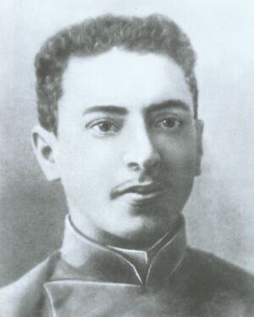
Mark Vishniak in his youth (1905).
Photo source: https://en.wikipedia.org/wiki/Mark_Vishniak
In 1905 he became a member of the Moscow Committee of the Socialist-Revolutionary Party and took an active part in the December armed uprising in Moscow.
Mark Vishniak remained a staunch anti-communist throughout his life.

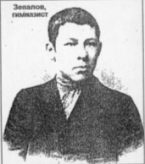
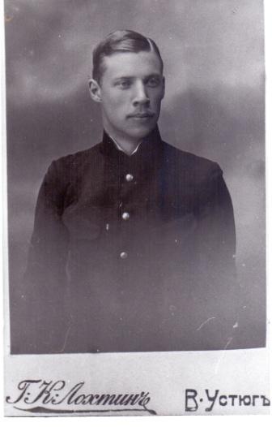

Pitirim Sorokin's friends, shot by the Chekists in Veliky Ustyug in 1918: Pyotr Zepalov and Pyotr Dvuzhilny. Photo from the collection of the Veliky Ustyug Museum-Reserve.
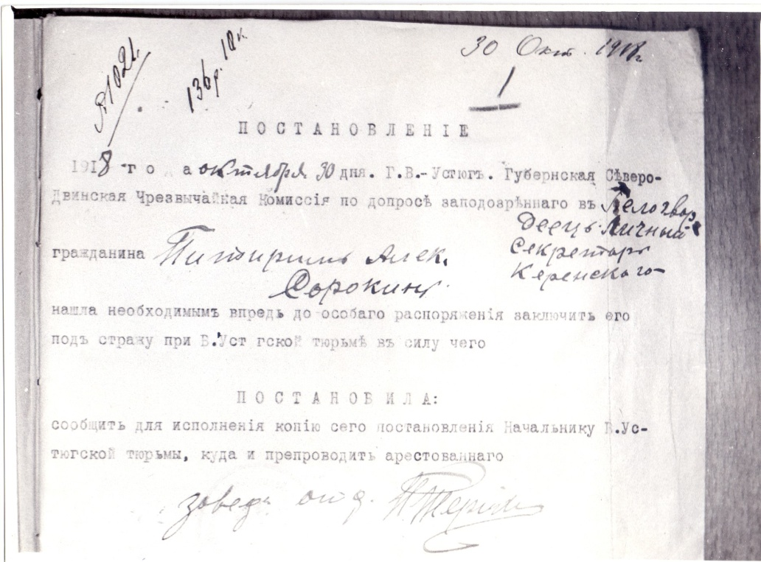
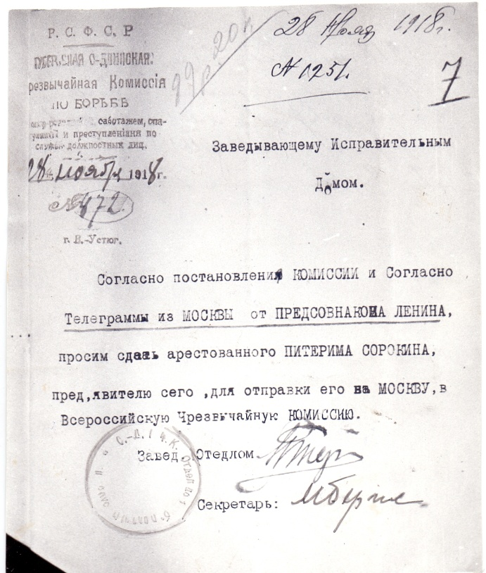

Photo from the archive of the Veliky Ustyug Museum-Reserve

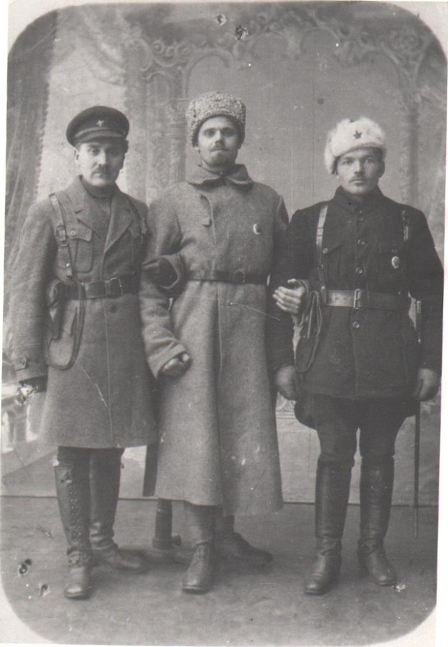

Pitirim Sorokin remembered the head of the Chekist convoy, Y. K. Peterson, who carried him from Veliky Ustyug to Moscow, for the rest of his life and mentioned his name in his American
the memoir "A Long Journey" ...
Photo from the Museum of Political History (St. Petersburg).
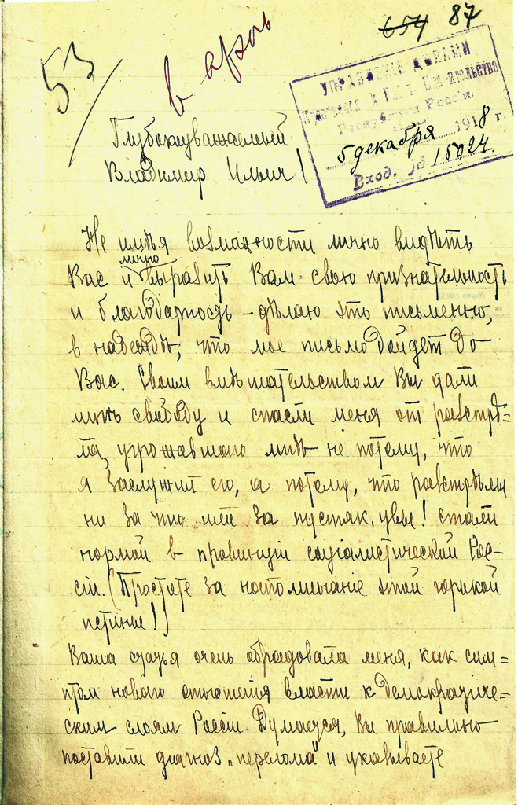

Letter from P. A. Sorokin to V.I. Lenin. December 4, 1918. Moscow.
Central Association of Flax Growers.
B. Lubyanka.
RGASPI. F. 5. Op. 1. D.
1394. pp. 87–88. Original. Autograph.
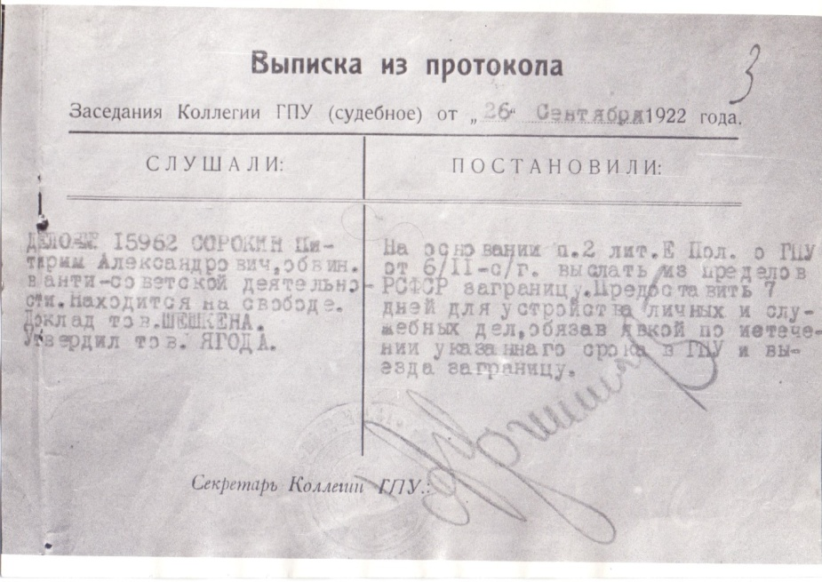
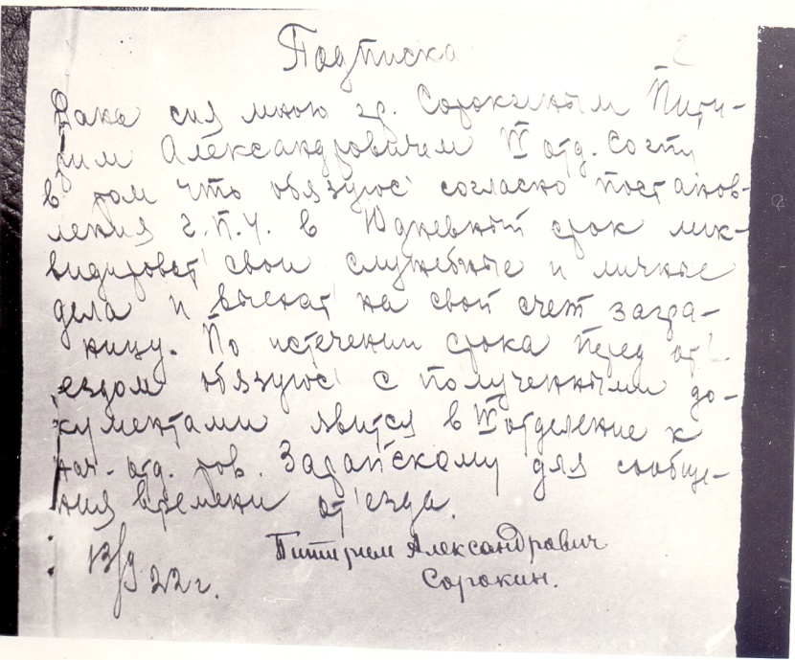

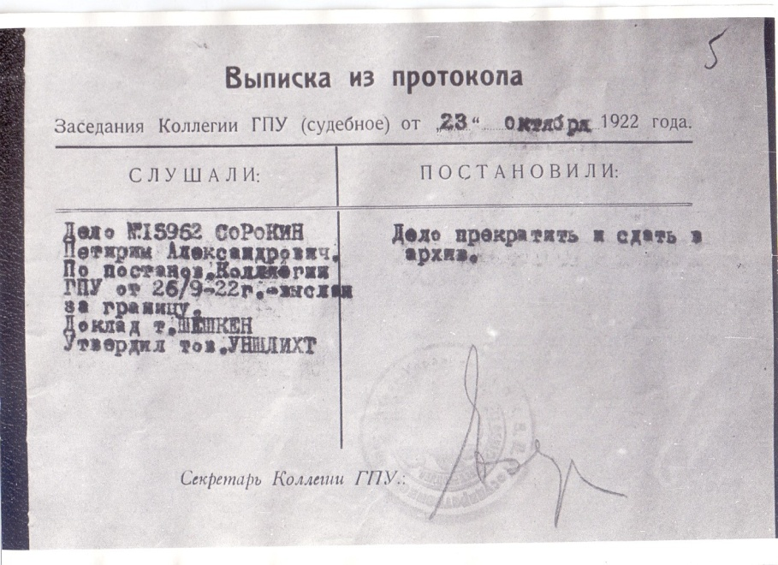
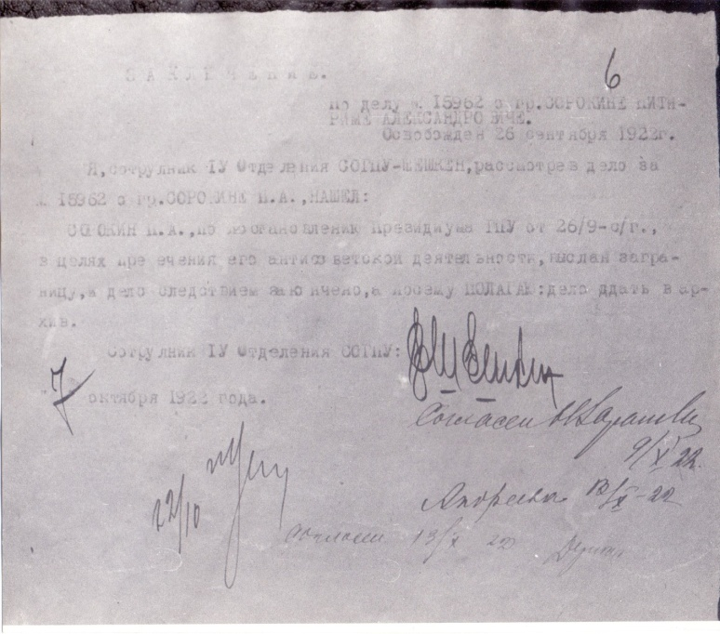

Photocopies from the Central Archive of the FSB
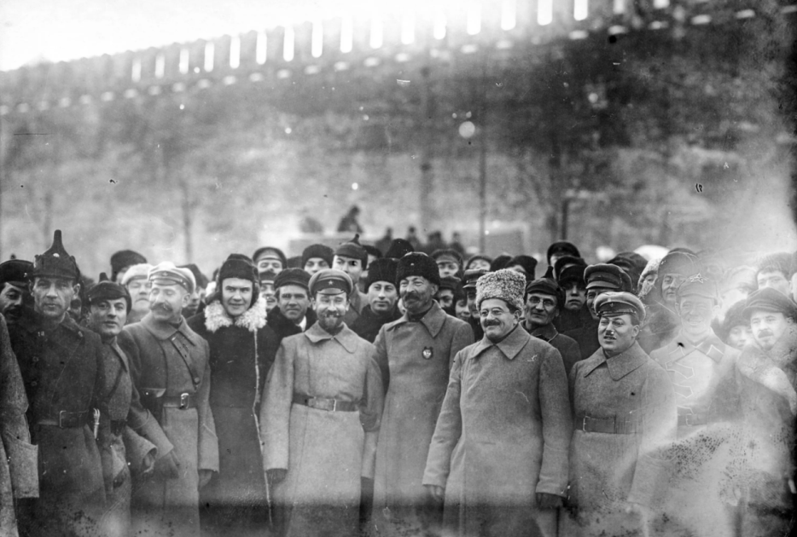

Bogdanov, Dzerzhinsky, Unshlicht. Parade of OGPU troops on Red Square.
20 December 1922

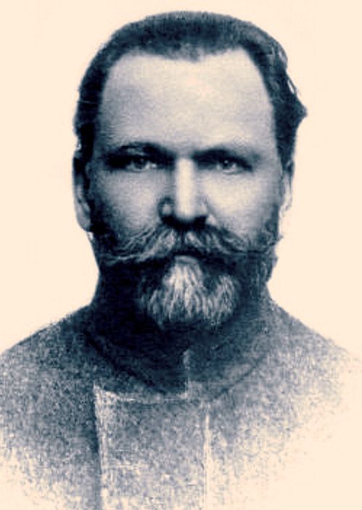
Jan Petrovich Kroders (08.07.1960, vol. Lauteres – 21.10.1938, Leningrad).
Father of Jan Kroders.

In 1907 he was sentenced to death for his revolutionary activities, which was commuted to eternal hard labor. He was liberated by the February Revolution. From 1921 he lived in Novgorod. Employee of the Provincial Commission in Novgorod. Retired in 1925, organizer of agricultural artels, etc.

He was shot at the NKVD firing range in Levashovo, near Leningrad.

Jan Kroder. Photo by https://timenote.info/en/Jan-Kroder

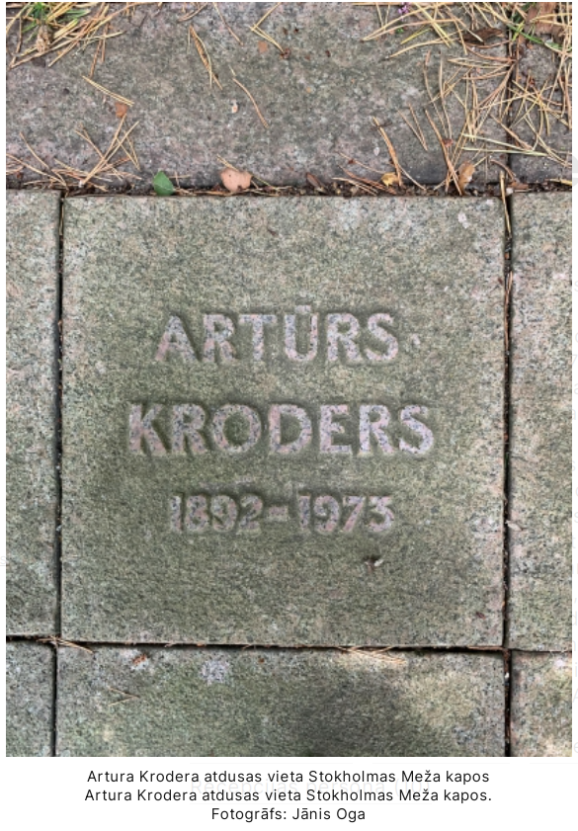
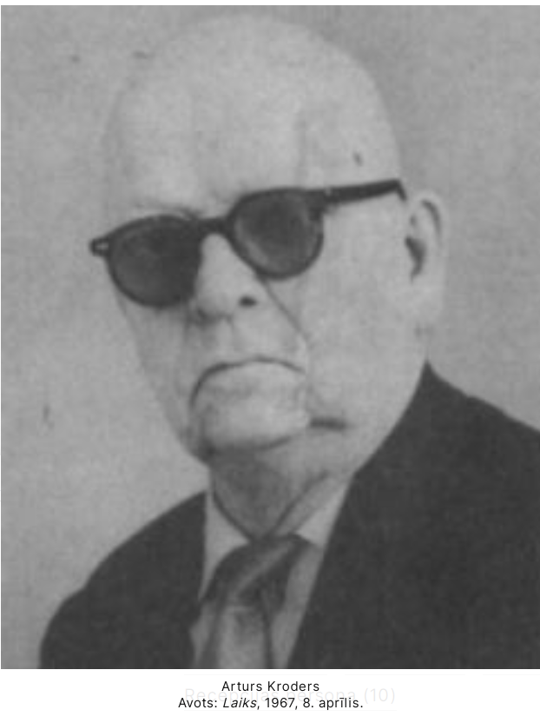
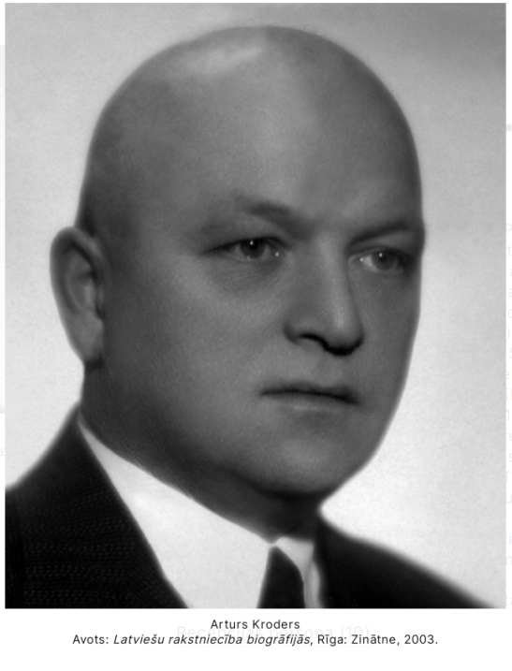

Photo source: https://www.literatura.lv/personas/arturs-kroders

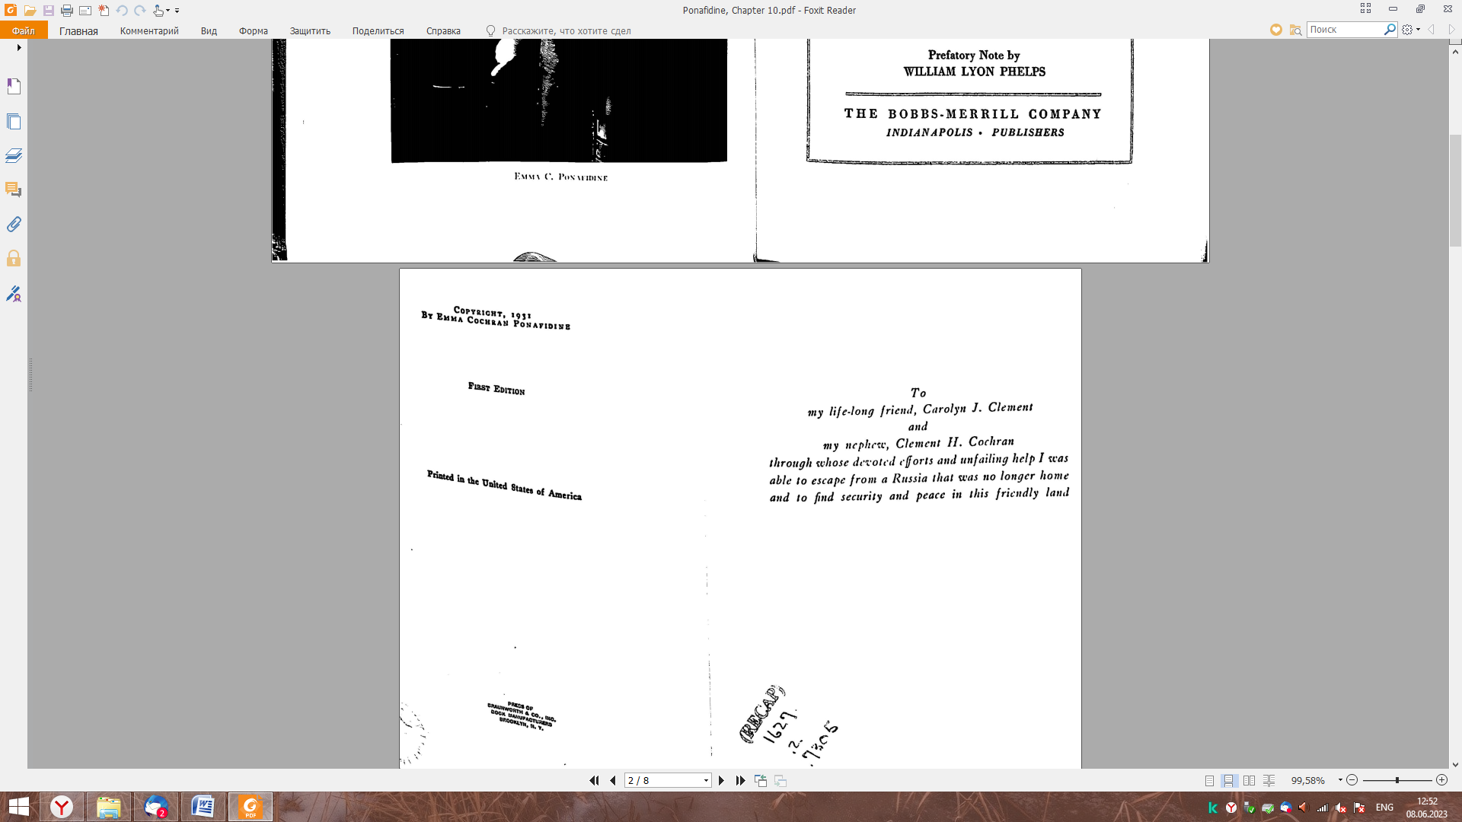
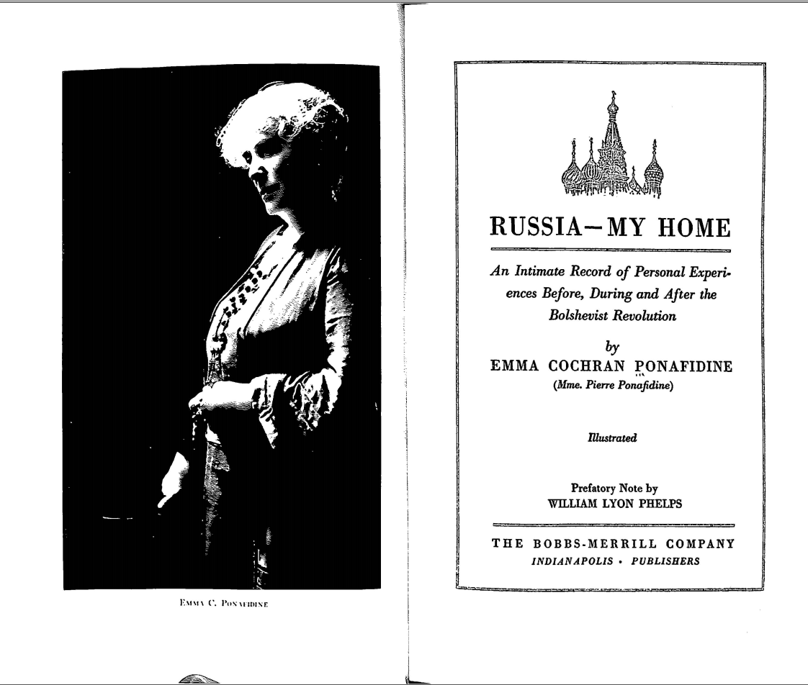

First Edition. 1931.

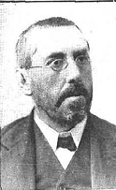
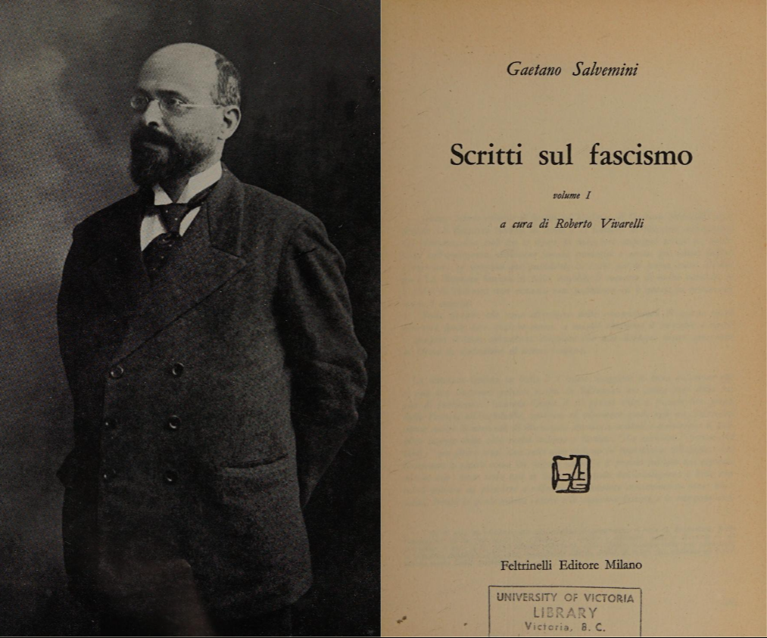

Adolfo Posada (1860-1944)

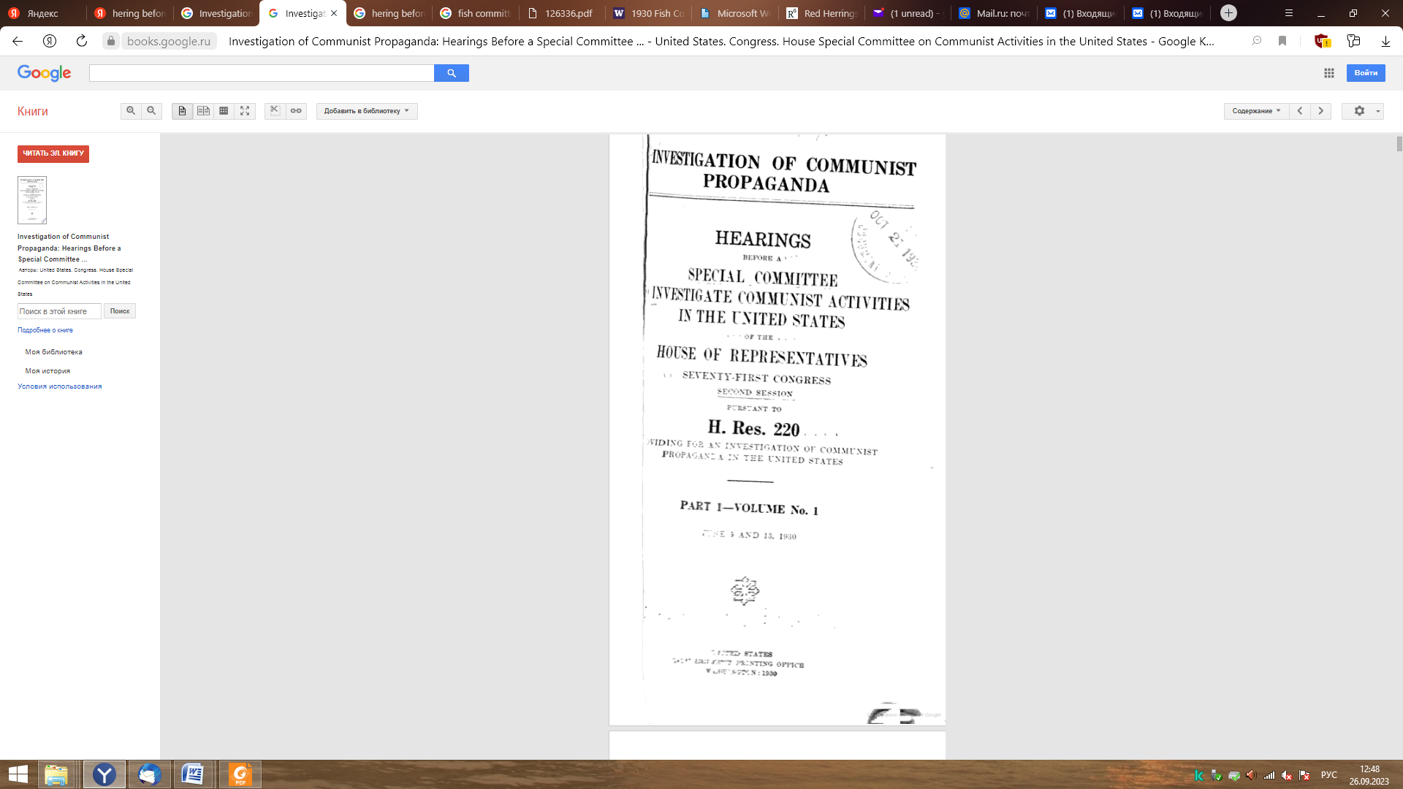
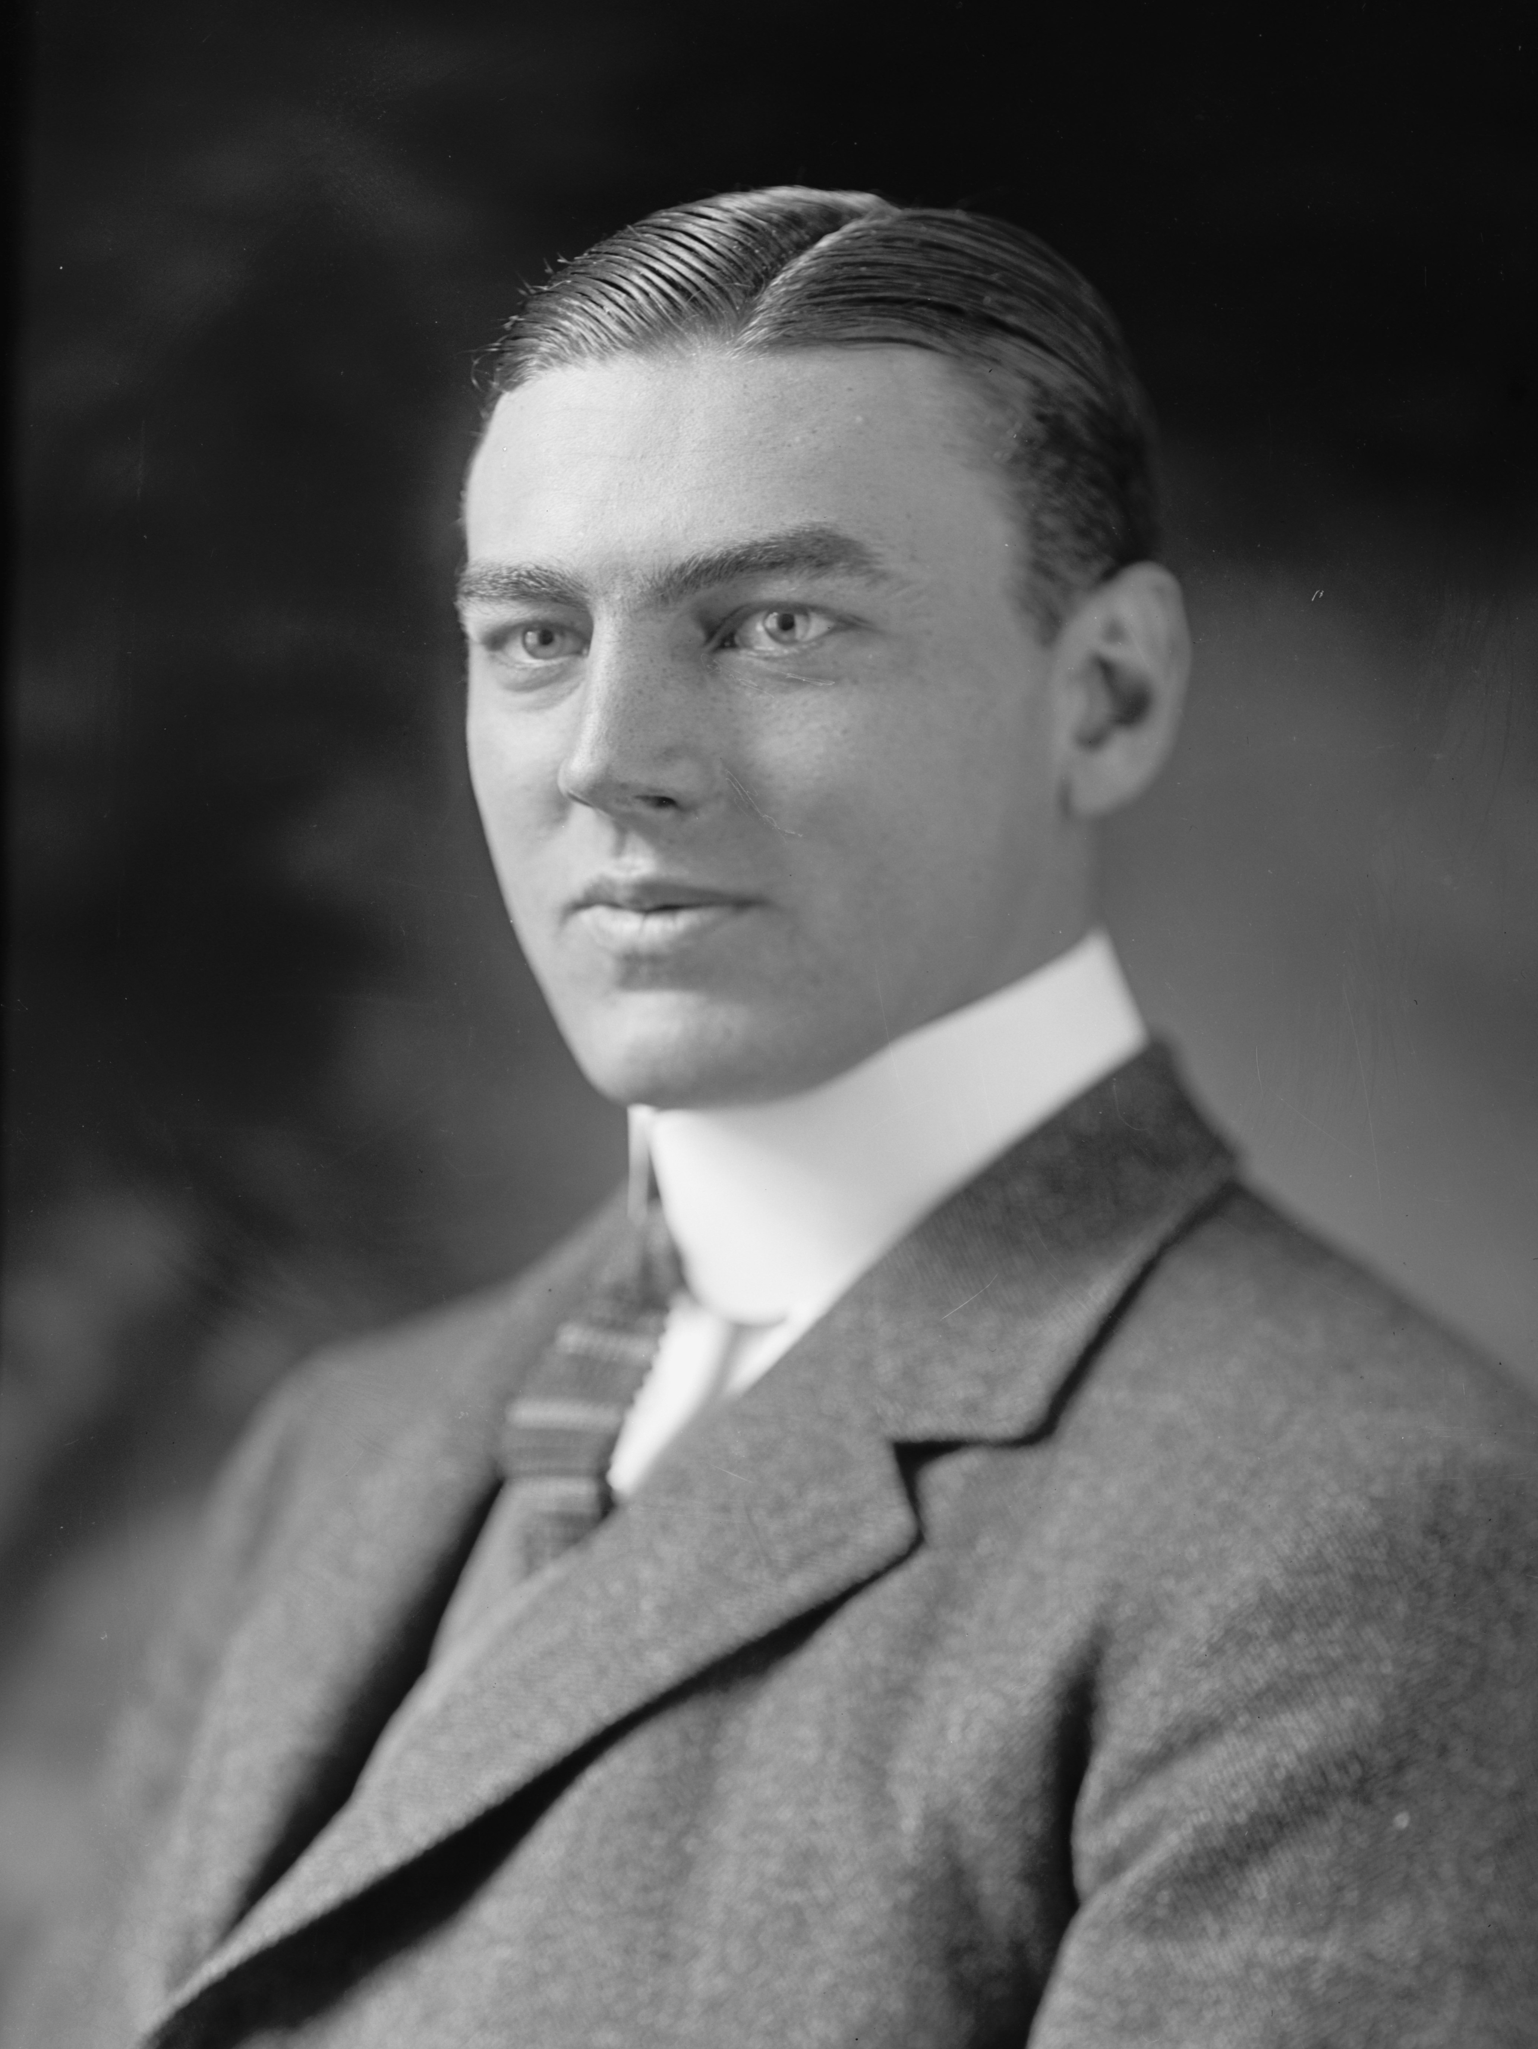

Hamilton Fish III (1888-1991)

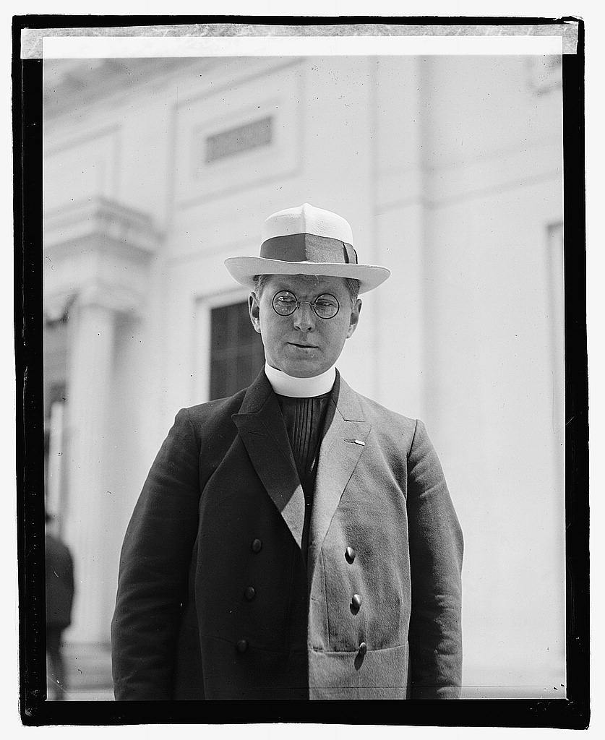
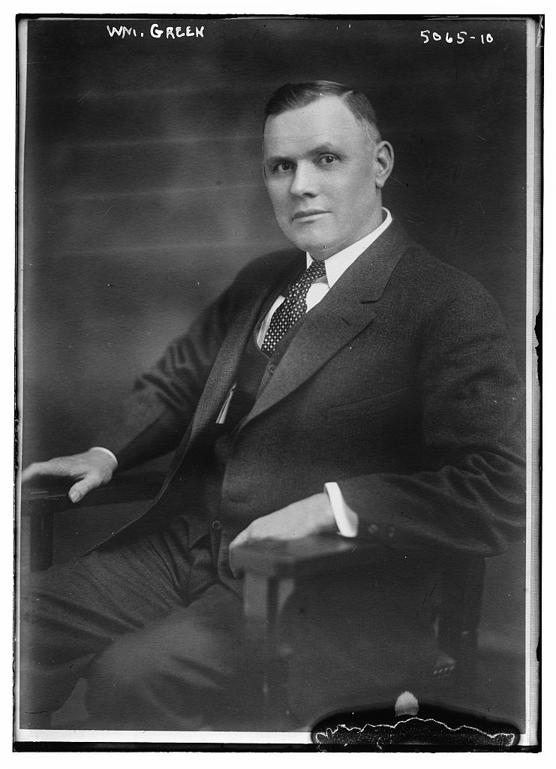

Father Edmund Walsh (1885-1956), William Green in 1919
May 31, 1922

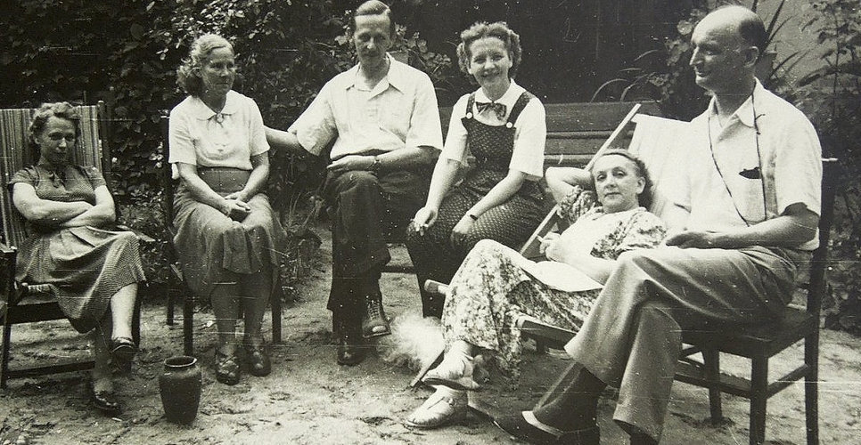
Soviet atomic spy, Colonel Rudolf Abel and his colleague Lieutenant Colonel Willy Martens with their wives. Abel's dacha (Chelyuskinsky village, Mytishchi). Summer 1955
Notes

Instead of a Preface

1. Roger Smith, New York City. Email to Yuri Doykov, Archangel, June 7. 2023.

2. Vishniak, Mark. Gody emigratsii, 1919-1969: Parizh-N'yu-York: vospominaniya (Years of Emigration, 1919-1969: Paris-New York: Memories), Stanford, California: Hoover Institution Press, 1970, pg. 151.

3. Letter from P. A. Sorokin to V .I. Lenin. Dec. 4, 1918. Moscow. Central Association of Flax Growers. B. Lubyanka. RGASPI. F. 5. Oops. 1, d. 1394. pp. 87–88. Original. Autograph. Historian. №4. April 2015. https:// historian.rf/journal/post/5854

4. Split Threatened in Ranks of Bolsheviki Over Bayonet Policy. New York Tribune. Dec. 31, 1918. pg. 3.

5. In 1918, in Veliky Ustyug, the Cheka shot tens and hundreds of people. The temple in the center of the city was turned into a prison.
They were shot right in the yard. One of those shot was Sorokin's closest friend, Pyotr Nikolayevich Zepalov. To him and to his late teachers, Maxim Kovalevsky and Eugène de Roberty, Sorokin dedicated his System of Sociology (Petrograd, 1920).
... Zepalov was born on July 20, 1892 in Veliky Ustyug. In 1910 he graduated from the eighth grade course of the Veliky Ustyug Men's Gymnasium. At the same time as Sorokin.
From 1908 he was a member of the Russian Social Democratic Party (Mensheviks).
In 1917, Zepalov published in Veliky Ustyug the monograph "An Essay on the History of Legislation on Vagrancy and Poverty in France.” In the preface to it, Professor S. V. Poznyshev wrote:
"Let's hope that this first work of the young author will be followed by his other works..."
... On October 13, 1918, in the Permogorye region, Zepalov was arrested by the Arkhangelsk Cheka. On the night of November 4, he was shot with a large group of prisoners.
In the execution order we read:
"For the article 'Stillborn Decree.'"
"For covert agitation against the Soviet regime."
"For open agitation in the press..."

§1-2

1. Henry Noble MacCracken (President, Vassar College). Russia of To-day. The Literary Review of the New York Evening Post. May 5. 1923. pg. 665.

2. Sorokin, Pitirim. Society Modified by Revolution. The Vassar Miscelany News, Jan. 16, 1924. pg. 3,

3. Sorokin, P. A., Letter to Henry Noble MacCracken. Aug. 2, 1924.

4. Professors in Hot Debate on Soviet Russia. Yale Man Nails Lies of Counter-Revolutionist. Daily Worker. Jan. 2, 1925. pg. 2.

5. Starr, Burn. Was Marx Wrong? An Answer to Sorokin... and Others. The Communist (edited by A. Bittelman). July 1, 1927. pg. 323.

6. Ibid. pg. 326.

7. Sorokin P. A. Letter to Petr B. Struve. Apr. 25, 1925. P. B. Struve Papers. Hoover Institute Archive.

8. Sorokin P. A. Letter to Petr B. Struve. Nov. 6, 1925. P. B. Struve Papers. Hoover Institute Archive.

9. Sorokin P. A. Letter to Petr B. Struve. Oct. 4, 1927. P. B. Struve Papers. Hoover Institute Archive.

10. Sorokin P. A. Letter to Petr B. Struve. June 1926. P. B. Struve Papers. Hoover Institute Archive.

11. Sorokin, Pitirim. No Reason Either To Fear Or Welcome Soviet Russia. The Atlanta Constitution. Apr. 26, 1925. pg. E6.

12. Guchkov, Alexander. Letter to Pitirim Sorokin. Apr. 4, 1924. GARF (Moscow). Fond 5868 (Guchkov). Opis 1. Delo 15. Str. 25-29 (microfilm).
Cit. by: Yuri Doykov, Pitirim Sorokin: Chelovek vne sezona; Biografiya, Tom 2 (1922–1968) (Pitirim Sorokin. A Timeless Man: A Biography, Vol. 2 (1922-1968). Archangel, 2009. Str. 78-80.

13. MacCracken, Henry Noble. Letter to Pitirim Sorokin. Dec. 2, 1925. MacCracken Papers. Vassar College Libraries. Special Collection. Poughkeepsie, New York.

14. Sorokin, Pitirim. Letter to Henry Noble MacCracken. Dec. 5, 1925. MacCracken Papers. Vassar College Libraries. Special Collection. Poughkeepsie, New York.

15. Page, Myra. In a Generous Spirit. A First Person Biography of Myra Page. Urbana. University of Illinois Press. 1996. pg. 92.

16. Ibid. (pages about P. A. Sorokin) pp. 67-68, 92-93

17. Martindale, Don. The Romance of Profession: A Case History in the Sociology of Sociology. Second Edition. New Delhi, India. 1986. pg. 62. (First Edition Published in 1976, St. Paul, Minnesota).

18. Johnston, Barry V. Pitirim A. Sorokin. An Intellectual Biography. University Press of Kansas. 1995. pg. 28.

19. Lind, Andrew W. Review of Social Mobility by Pitirim Sorokin. American Journal of Sociology. Vol. 33. No 5. March 1928. pg. 847.

20. Sorokin P. A. Letter to Ivan V. Emelianoff. Dec. 22, 1924. Ivan V. Emelianoff Papers. Museum of Russian Culture. San Francisco, California, USA. Box 4, Folder 13.

21. Sorokin P. A. Letter to Ivan V. Emelianoff. March, 20, 1927. Ivan V. Emelianoff Papers. Museum of Russian Culture. San Francisco, California, Box 4, Folder 13.

22. Wolfe, Alberte. Review of Contemporary Sociological Theories by Pitirim A. Sorokin. The American Economic Review. Vol. 18. No. 4. Dec. 1928. pp. 715-717

23. Stolting-Gernym. Julius Friedrich Lehmann. Volkischer Beobachter. Mar. 27. 1935.

24. Sorokin, P. Revolucijas Sociologija. Riga, 1929. Translated into Latvian by Arturs Kroders.

25. Kroders, Artur. Atmiņas. Kopenhagenā: Imanta, 1968. 359 pp.

26. Andersons, Edgars. Pazīstama žurnālista atminas (Memoirs of a famous journalist). Jaunā Gaita nr. 105, 1975. // https://jaunagaita.net/jg105/JG105_gramatas_Andersons.htm

27. Bleiere, Daina, Butulis, Ilgvars et al. Istoriya Latvija [History of Latvia]. XX century. Translated from Latvian. – Riga, 2005. Page. 246.

28. Novye raboty P. A. Sorokina [New works by P. A. Sorokin]. Vozrozhdeniye (Renaissance), Paris. Jan. 12, 1928. No. 954.

29. Huntington, Ellsworth. The Social Pyramid. The Saturday Review of Literature 4 (Dec. 3, 1927), pg. 370.

30. Sarkar, Benoy Kumar. The Political Philosophies Since 1905. Madras: B.G. Paul & Co. 1928. pg. XII.

31. Ibid. pg. 293.

32. Another Russian Prophet. The Indianapolis Star. Nov. 22, 1923. pg. 6.

33. Sorokin. Pitirim. Changes in Russia’s Intelligentsia: Former Idealistic Views Concerning Russian People Profoundly Modified by Revolution. (Translated, with some condensation, by David A. Modell from Dni, Russian-language daily in Berlin). New York Evening Post. Dec. 18, 1923. pg. 8.

34. See Štaif, Jiří. Jan Slavík and “Anti-guild” Discourse. Social History between Historical Thought and Historical Practice. Prague perspectives III. Jan Slavík (1885–1978): a Czech historian of revolutions. Roubal, Petr; Babka, Lukáš (eds.). Prague: The National Library of the Czech Republic, 2009. pg. 87.

35. Pitirim Sorokin. Letter to Josef A. Kral. May, 5. 1924. Josef Kral’s File. Archiv Akademie VED. Praha, CR.

36. Giddings, Franklin. Review of Social Mobility. The Saturday Review of Literature. Aug. 6. 1927. pg. 21.

37. Sorokin is Reluctant to Accept Soviet Call. Russia’s Famous Cultural And Political Leader To Remain In Poughkeepsie. “Watchful Waiting.” The Sunday Courier (Poughkeepsie, NY). Jan. 20, 1924.

38. Sees Peasant Rule Redeeming Russia. Prof. Sorokin, Exiled by Lenin? Prepares to Return to Aid Fight “for Liberty.” Expects an Easy Victory. Within Three Years a New and Rich Nation Will Have Arisen He Declares. New York Times. Jan. 27, 1924. pg. E7.

39. Overtaking the Lies (Editorial). The Decatur Herald (Decatur, Illinois). Mar. 23, 1924. pg. 6.

40. Mrs. Pitirim Sorokine on Way to This Country Now. The Decatur Herald (Decatur, Illinois). Mar., 23. 1924.

41. Pitirim Sorokin. Denies U. S. Recognition Will Bring Soviet Trade. The Washington Post. Apr. 26, 1925. pg. 3.
This article was also published under the title "No Reason Either To Fear Or Welcome Soviet Russia" in The Atlanta Constitution, Apr. 26, 1925. pg. 6.

42. Lenin V. I. Letter to L. K. Martens. October 19, 1921 Lenin, V.I. Polnoe sobranie sochinenii. Letters of June-November 1921 Moscow: Publishing House of Political Literature, 1975. Volume 53. pg. 283.

43. Sorokin, Pitirim. Fanatic and Anti-Social Extremist. Current History. March 1, 1924. Vol. 19. No. 6.
Sorokin buries Lenin. The eminent sociologist tried to bury Bolshevism as well, but, like many in his time, he indulged in wishful thinking. Novoye Vremya (Moscow). January 20, 2002. pp. 34-36.
Republished in English: Yury Doykov. Pitirim Sorokin Buried Lenin. The New Times (Moscow). Feb. 2002. pp. 58-60.

44. Sorokin, Pitirim. Lenin, the Destroyer. Forum. Vol. LXXI, No. 4. pp. 417-422.
Translated into Russian by Vadim Sapov (Moscow). Vestnik Syktyvkarskogo universiteta. Issue 1. 2017. pp. 5-9.
Pitirim Sorokin, “Was Lenin a Failure?–A Debate: I–Lenin the Destroyer,” Forum, vol. LXXI, no. 4 (April 1924). https://rogersmusingscom.files.wordpress.com/2017/09/sorokin-was-lenin-a-failure-forum-1924.pdf
45. An Open Letter to American Liberals. Daily Worker (New York). Feb. 9, 1937. pg. 2.

46. Koenen G. (b. 1946). Die großen Gesänge. Lenin, Stalin, Maotsedun. – Führerkulte und Heldenmythen des 20 (Great Songs. Lenin, Stalin, Mao Zedong. – Cults of Leaders and Myths about the Heroes of the Twentieth Century). - Jh. Frankfurt a. M., 1991. pg. 132.

47. See Soviet Russia Today. 1937. 1937. Vol. 6. No 9.
T. Dreiser. I Am Grateful to Soviet Russia.
M. Ilin. Triumph of the Intellect.
H. P. Smolka. Arctic Frontier.
B. Hopper. Seeds of Tomorrow in Taiga and Steppe.
etc., etc.

48. Page, Myra. In a Generous Spirit. A First Person Biography of Myra Page. Urbana: University of Illinois Press. 1996. pg. 124.

49. Rosberg, Gerald M. Pitirim A. Sorokin. The Harvard Crimson. Nov. 5, 1966. https://www.thecrimson.com/article/1966/11/5/pitirim-a-sorokin-ppitirim-a-sorokin/

50. Killinger, Charles L. Gaetano Salvemini: A Biography. Westport, Connecticut: Praeger, 2002. pg. 173. The quotation is from Roberto Vivarelli, Il dopoguerra in Italia e l'avvento del fascismo (1918-1922) (Naples, Italy, 1967), pg. viii.

51. Ibid. pg. 3.

52. Salvemini, Gaetano. Under the Axe of Fascism. London, Victor Gollancz LTD. 1936. pg. 3.
The preface to the book is labeled: "Cambridge, Mass. / November 30th, 1935.”

53. Kohlman, Arnosht. My ne dolzhny byli tak zhit (We weren't supposed to live like this). New York: Chalidze Publications, 1982. pp. 322-323.

54. Salvemini, Gaetano. Scritti sul fascismo. Vol. 1. A cura di Roberto Vivarelli. Milan: Feltrinelli Editore Milano, 1961.

55. Pitirim Sorokin Dead. New Russian Word (New York). Monday, Feb. 12, 1968. pg. 1.

56. Nevins, Allan, Commager, Henry Steele with Jeffrey Morris. The Pocket History of the United States. Eighth Revised Edition (First Edition, 1942). Washington Square Press. Published by Pocket Books. 1986. pg. 410.

57. Ibid.

58. Mme. Ponafidine, Widow of Czarist Diplomat, Dies at 92. Buffalo Evening News. Feb. 8. 1956.

59. Ponafidine, Emma C. "Not Soviet Russia” (letter to editor). New York Times. June 25. 1931. pg. E5.

60. Nazaroff, Alexander. Russian Life in the Twilight Days of the Romanoffs. New York Times Book Review. Dec. 27, 1931. pg. 56.

61. Sorokin, Pitirim. Sovremennoye Sostoyaniye Rossii (The Current State of Russia). Prague, 1922. pg. 104.

62. Denies Russia is Free and Tells of Escape. Mrs. George Ponafidine, Describing Soviet Rule, Says She Spent Three Years in Getting Away. New York Times. Apr. 5, 1925. pg. 19.

63. Says Russian Graft Equals That in U. S. New York Engineer Tells of Working Under Regime of Soviets. Talks at Meeting of Women’s Clubs. Baltimore Sun. Apr. 27. 1932. pg. 22.

64. Ibid.

65. Old Russia Was Gay, Anti-Red Writer Says: Mme. Ponafidine Sees Bolshevism Failure, Charges Revolt Came From Top; America Told to Be on Guard. The Washington Post. Feb. 16. 1935. pg. 19.
For Ponafidine, see:
American Woman Writes of Escaping Death in Russia. Tale of Red Terror Sent Sister Here. Sufferings of Ponafidine Family at Hands of Bolsheviki Related. Husband, Who Held Diplomatic Post, Dies as Result of Persecutions. San Francisco Chronicle. Sep, 20, 1920. pg. 13; Madame Ponafidine Tells of Soviet Russia. The Vassar Miscellany News. March, 7, 1923. pp. 2, 4.

66. Letter of diplomatic agent of the People's Commissariat for Foreign Affairs of the USSR IN THE USA B.E. Skvirsky to the People's Commissar of Foreign Affairs of the USSR M. M. Litvinov about Soviet-American relations. December 11, 1930. Soviet-American Relations. Years of non-recognition. 1927-1933. Ed. by G. N. Sevostyanov and J. S. Sevostyanov. Haelema. Moscow: International Foundation "Democracy,” 2002. 824 pp. (Russia. XX century. Documents. pg. 373)

67. Karpovich, Michael (Cambridge, Mass. Dec. 5, 1930). The Dead Hand (letter to editor). New York Times. Dec. 8, 1930. pg. 20.

68. Zimmerman, Carle. Sorokin, the World's Greatest Sociologist: His Life and Ideas on Social Time and Change. Sorokin Lectures No. 1 delivered by Carle C. Zimmerman. University of Saskatchewan Saskatoon, Saskatchewan, Canada, 1968. pg. 19.

69. AUD (archival criminal case on the charge of N.D. Kondratiev et al.). Central Archive of the FSB. Case R-33480. T. 4. Fol. 249 [manuscript].

70. Gopner. Excerpts from the transcript of the meeting of the Agitprop Department of the Executive Committee of the Comintern to discuss the course of the foreign campaign around the trial of the "Industrial Party" and the possible military threat to the USSR. January 20, 1931 Secret. Meeting of APO IKI. January 20, 1931 Protocol No. 2. The Trial of the "Industrial Party" of 1930: Preparation, Conduction, Results: in 2 books. Holes. Ed. by S.A. Krasilnikov. Moscow: Political Encyclopedia, 2017. (Kremlin Archives). Book 2. pg. 418.

71. Ibid. pg. 419.

72. Events in Russia. Caution is Urged in Dealing With Day-to Day Developments (letter to editor). The New York Times. Oct. 8. 1930. pg. 24.

73. "Summaries" of telegrams from foreign correspondents in Moscow on the trial of the "Industrial Party" for November 11-December 2, 1930. The Trial of the "Industrial Party" of 1930: Preparation, Conduction, Results: in 2 books. Holes. Ed. by S. A. Krasilnikov. Moscow: Political Encyclopedia, 2017. (Kremlin Archives). Book 2. pp. 551-596.

74. Tagore Smashes Hoover’s Propaganda Against USSR. World Prize Winner in Literature Finds Soviet Union Labor Gains Culture; Against This Capitalist Starvation System Plans War. Daily Worker. Oct., 14. 1930. pg. 2.

75. Russia Shows India the Way, Says Tagore, Noted Indian Poet. Daily Worker. Dec. 27, 1930. pg. 4.

76. Iwan I. Ostromislensky, Sergei Rachmaninov, Count Ilya L. Tolstoy (New York, Jan. 12, 1931; letter to editor). “Tagore on Russia. The “Circle of Russian Culture” Challenges Some of His Statements. New York Times. Jan. 15. 1931. pg. 22.

77. Tagore Visits Hoover Today. New York Times. Nov. 29, 1930.

78. See R. Tagore, Crisis in Civilization. Rabindranath Tagore: Selected Essays. New Delhi, India: Rupa & Co, 2004. pg. 264.

79. Parry, Albert. Americanisms Are Adopted By Russians. Words Learned from Visitors Changed To Terms Such As “Fordizatzia,” “Amerikanizatzia.” New York Times. March, 23, 1930. pg. A5.

80. On Duranty, see Taylor, S. J. Stalin's Apologist. Oxford University Press, 1990.

81. Posada, Adolfo. Sociología y Etica de la Revolución. La Nación (Madrid), Dec. 6, 1925. pg. 11.

82. In 1997, The Black Book of Communism was published in Paris under the editorship of Stéphane Courtois (a former Maoist). In the "Spanish" chapter of the book, the Red Terror is condemned only against the "Left Oppositionists"—socialists, Trotskyites, anarchists. Other "categories" of victims (Catholics, military, monarchists, "middle and upper classes") are passed over in silence. It is not surprising that the name of "one of the leading Spanish intellectuals," A. Posada, as it is said in one of the Spanish articles about him, "remains largely unknown." He is better known in Argentina and Uruguay. He is not forgotten in his homeland of Oviedo. Something similar in memory of Pitirim Sorokin, in whose honor after the fall of the USSR in Syktyvkar, the capital of the Komi Republic, the Pitirim Sorokin University was hastily organized, and the main street "Kominternovskaya" was named in honor of an outstanding countryman ...
Sorokin's correspondence with Posada, one of the most extensive and long-lasting, is kept in the Canadian archive of the Russian exile.

83. Cowl, Carl. Review of Thomas D. Campbell, Russia: Market or Menace? The Militant, vol. V, no. 24 (whole no. 120; June 1932). pg. 2.

84. Stalin I. V. Zapisa besedy s Mr. Campbell [Record of conversation with Mr. Campbell]. January 29, 1929. Stalin I. V. Compositions. Vol. 13. July 1930 - January 1934. Moscow, IPL Publ., 1951. pg. 154.
First published: Bolshevik, No. 22. Nov. 30, 1932.

85. Ibid.

86. A Big Question for Authors. What Position in War with Russia? “G.B.S’s” Short Reply. The Manchester Guardian. June 24, 1930. pg. 18.

87. Duranty, Walter. Reds Still See War Certain for Soviet. Radek Comments on Replies of World Authors to Question of Communist-Capitalist Clash. Attitude Like Kaiser’s. Moscow Journalist Puts Onus on Others in Event of Outbreak Scores Dreiser and Roland. New York Times. June 24, 1930. pg. 11.

88. Quoted from: Damerau, Reinhard. Boris Pil’njaks Geschichts- und Menschenbild: biographische und thematische Untersuchungen; Osteuropa-Studien der Hochschulen des Landes Hessen 2/11 (Boris Pilnyak's View of History and Humanity: Biographical and Case Studies; East European Studies at the Universities of Hesse 2/11); Gießen: W. Schmitz, 1976. pg. 91.

89. See: Polyakov, A.A. Pokushenie na GOERLO: Povest'-khronika [Encroachment on GOERLO: A Story-Chronicle]. Moscow, Politizdat Publ., 1983. pg. 97.

90. Fish, Hamilton Jr. The Menace of Communism. The Annals of the American Academy of Political and Social Science, vol. 156 (July 1931), pp. 54-61.

91. Churchill, Winston. Introduction. de Battaglia, Otto Forst, editor. Dictatorship on Trial: By Eminent Leaders of Modern Thought. New York: Harcourt, Brace and Company, 1931. pg. 9.

92. de Battaglia, Otto Forst, Editor’s Preface. Ibidem. pp. 11-12.

93. Sorokin, Pitirim. Review of Dictatorship on Trial: Twenty-Two Essays by Eminent Leaders of Modern Thought, edited by Otto Forst de Battaglia, translated by Huntley Paterson, introduction by Winston S. Churchill, Harcourt Brace & Co. Yale Review, 20.4 (Summer 1931), pp. 853, 854.

94. Churchill, Winston S., the RT. Hon., C.H., M.P. The World Crisis. The Aftermath. London: Thornton Butterworth Limited, 1929.

95. Sarolea, Charles. Impressions of Soviet Russia. London: Eveleigh Nash & Grayson Limited, 1924. pp. 81-82.

96. See Libbey, James K. Alexander Gumberg & Soviet-American Relations. 1917-1933. University Press of Kentucky, 1977..
Gumberg's biography was written during the so-called "détente" period of the 1970s and explores the fate of this forgotten character, John Reed's rival. Reed is buried near the Kremlin wall and entered the world communist pantheon, while Gumberg, after Stalin's purges, in which many of his Soviet friends disappeared: Krestinsky, Pyatakov, Skvirsky, his two brothers, the same Boris Pilnyak, realized that he was serving the wrong cause and died in 1939 at the age of 52.

97. Preface. Ehrt, Adolf. Communism in Germany. The Truth About the Communist Conspiracy on the Eve of the National Revolution (Berlin: Eckart-Verlag, 1933), pg. 7.
Original German edition: Totale Krise - Totale Revolution? Die "Schwarze Front" des völkischen Nationalismus, in: Die Notreihe, Heft 11, Berlin, 1933.

98. Nadezhda Ulanovskaya and Maya Ulanovskaya. The Family Story. Translated by Stefani Hoffman. Seven Arts, Hannover, 2016. pp. 95-96.

99. Ibid. pg. 94.

100. Dreiser, Theodore. Amerikas angst von den Kommunisten. Der Querschnitt XII (Berlin). August 1932: 549-550.

101. Tatcher Feinstein, J. M. Fifty Years of U.S.-Soviet Trade. New York: Symposium Press, 1974. pg. 66, etc.
The author of the book, an employee of Amtorg for 45 years, prepared it for the fiftieth anniversary of his organization. Amtorg finally ceased its activities only with the collapse of the USSR.

102. Quoted in Carynnyk, Marco, The Famine the “Times” Couldn’t Find. Commentary. Nov. 1, 1983 76.5. pg. 38.

103. See. Investigation of Communist Propaganda: Hearings Before a Special Committee to Investigate Communist Activities in the United States of the House of Representatives, Seventy-first Congress, Second Session, Pursuant to H. Res. 220, Providing for an Investigation of Communist Propaganda in the United States. – United States. Congress. House Special Committee on Communist Activities in the United States. U.S. Government Printing Office, 1930. Part 1. Vol. 1 and other volumes.
Some Names

Battaglia, Otto
Bogdanov (Amtorg)
Campbell, Thomas D. American farmer
Churchill
Dreiser, Theodore
Duranty, Walter
Dvuzhilny, Pyotr
Einstein

Emelyanov, I. V.
Fish, Hamilton III
Guchkov
Izvolskaya, Elena
Karpovich, Mikhail
Kroders
Lenin
Martens, Ludwig
Martens, Willie
Pilnyak, Boris
Ponafidine
Posada, Adolfo
Rachmaninoff, Sergei
Salvemini
Sarkar
Skvirskiy (Amtorg)
Sorokin
Struve P. B.
Tagore, Rabindranath
Tolstoy, Ilya Lvovich
Vishniak, Mark
Walsh, Edmund
Zepalov, Pyotr
Zyakin, Chekist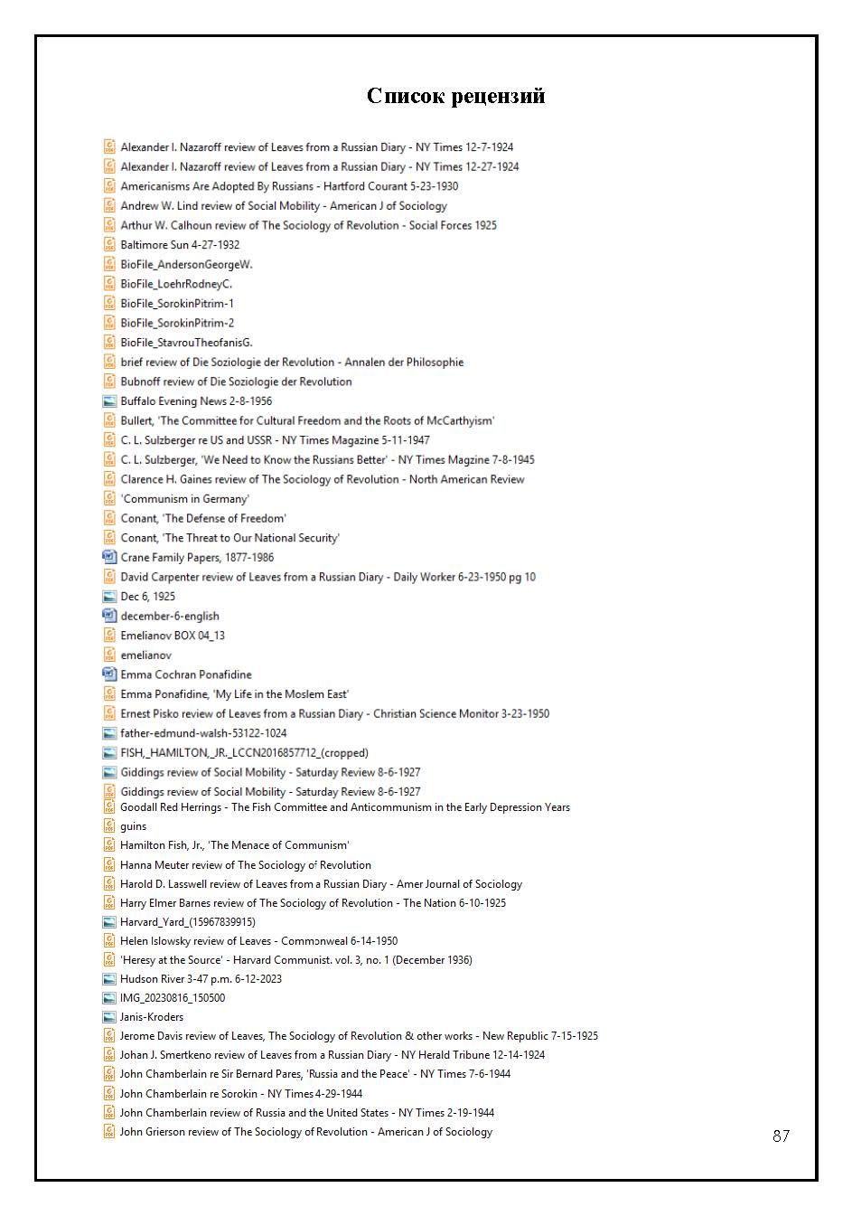
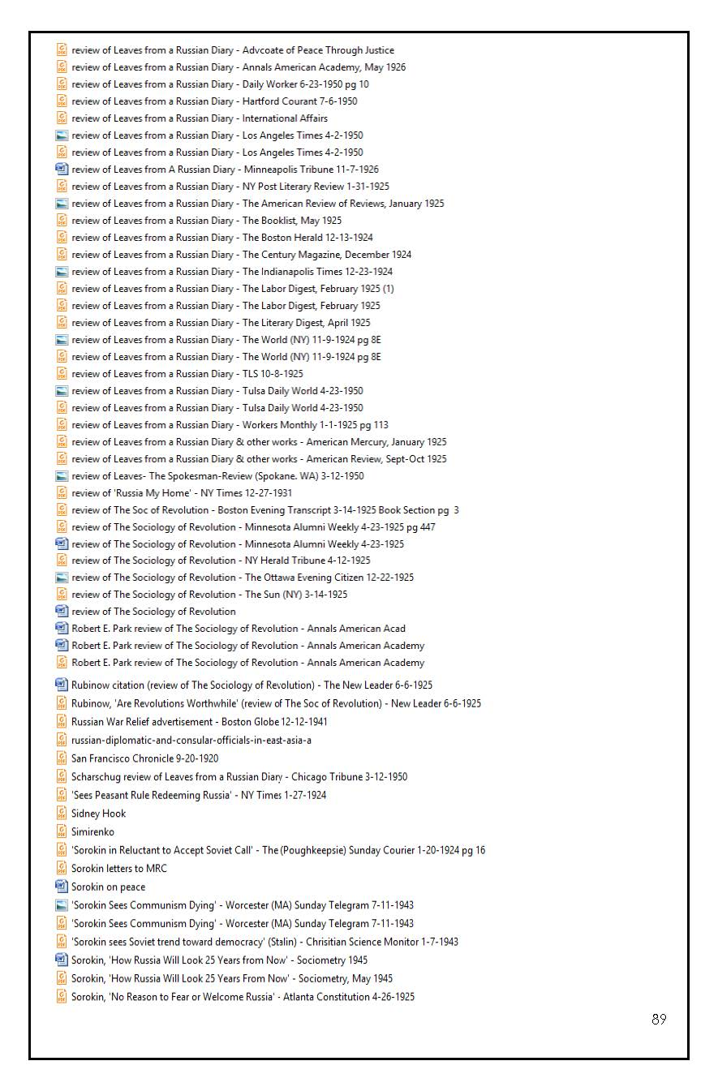
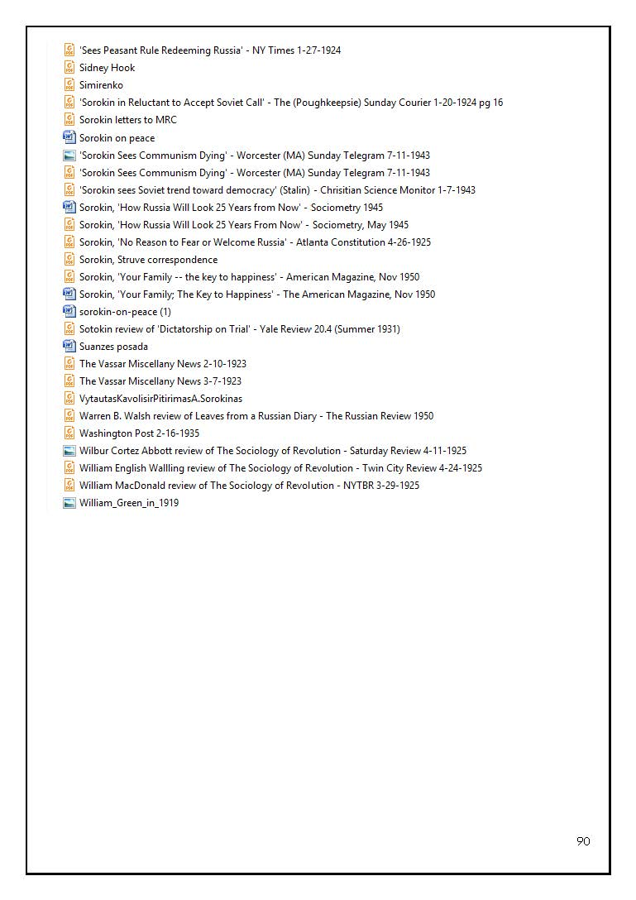
CONTENTS

Instead of a preface.............................................................................................3

§ 1..............................................................................................................7

§ 2.............................................................................................................59

Photographs................................................................................................70
Notes................................................................................................77
Some names..........................................................................................86
List of reviews.........................................................................................87
Translation by Roger W. Smith

Roger W. Smith, American writer and independent scholar. Host/editor of website dedicated to Sorokin: https://pitirimsorokin.com/
Vishniak, Mark (1883, Moscow – 1976, New York). Anti-communist journalist. He worked for twenty-three years on the editorial board of Time magazine and as its specialist on Soviet affairs.
Pyatakov, Yuri Leonidovich (1890-1937). A student friend of Sorokin. In 1923 he was Dzerzhinsky's first deputy in the Supreme Council of National Economy. He was shot in the same way as Eliava during the Great Terror.
Interestingly, the protocols of interrogations of the passengers of the notorious "Philosophy Steamer"—Berdyaev, Frank, Zworykin—were published by the Chekists-archivists ...
Drankovskiy, Mikhail (? – ?). Uncle of P. A. Sorokin. In 1909, in his house, Sorokin was preparing for the matriculation exams at the Veliky Ustyug gymnasium.
Shumilov, Ivan Mikhailovich (1895, Veliky Ustyug – 1938, Moscow). Chairman of the Severo-Dvinsk Provincial Executive Committee, member of the Provincial Committee of the Russian Communist Party (Bolsheviks). In 1918, he played one of the main roles in saving Sorokin from execution in Veliky Ustyug. For a bribe (as Lenin wrote to his deputy Tsuryupa," ... we have bribes at every turn") or at the request of Katya's wife – these are details. He was arrested in 1938 and served as head of the railway sector in the People's Commissariat for Water Resources. He lived in the "Government House" (Serafimovich, 2, apt. 358). He was shot at the NKVD training ground "Kommunarka" near Moscow.
Shumilova (née Pokrovskaya), Ekaterina Ivanovna (? – after 1963). Daughter of a priest. "First Love" of P. A. Sorokin. Wife of M. I. Shumilov. A Bolshevik since 1919, her two brothers (Sorokin's childhood friends) died in the Civil War. In honor of Pavel, who died near Bobruisk, on the "Polish front," a street in Veliky Ustyug is named.
Klaas, Genrikh Karlovich (1878, Pernov – 1938, Krasnoyarsk Territory). Chekist in Veliky Ustyug. In the 1920s, he directed writers in Leningrad. He died in a camp.
MacCracken, Henry Noble (1880-1970).
Borah, William (1865-1940). Senator. A leading proponent of the recognition of Soviet Russia. On January 7, 1924, The New York Times published a letter to the editor" from Sorokin entitled "Borah’s Injury to Russia: Identifying the People With Soviet Government Makes Matters Worse."
Radziwill, Catherine (1858, St. Petersburg – May 12, 1941, New York). After the collapse of tsarism, she came to New York through Sweden, where she lived until her death. She was the author of a dozen books on Russia and other topics.
Smertenko, Jonas J. ( ). Reviewer for The New York Times. Professor of journalism. Teacher of English literature and contemporary drama.
Mavrogordato E.E. TLS book reviewer.
A note from the editor to this review states that Sorokin will be coming to Vanderbilt [university] in April to read the Cole Lectures and to take part in the company of Reinhold Neiburh, Dr. George A. Buttrick and Dr. Nels Ferre in a symposium to be held on April 16, 17, 18.
Next to Alice Davis's review is Gerald Tetley's review of the book The Police State by American journalist Craig Thompson. The author was an American journalist who worked for two years in the mid-1940s in Moscow. Tetley concludes that this informative tome will make Americans glad they don't live in Russia.
In 1967, on the occasion of the 50th anniversary of the October Revolution in Russia, the book was republished for a second time. Pitirim Sorokin wrote a preface to this edition. In February 1968, Sorokin died. In 2000, The Sociology of Revolution was published in English for a third time.
Walling, William English (1877, USA – 12/09/1936, Amsterdam). From a wealthy family. He was a member of the Socialist Party of the USA (1910-1917). An AFL employee. He lived in tsarist and Soviet Russia. He was the author of Russia's Message: The People Against the Czar (1917); Sovietism. The ABC of Russian Bolshevism (New York, 1920). An AFL employee. Wife: Anna Strunsky (1877, Babinots, Belarus – 1964, New York).
Jenny Ernst (1872-1939). He was the son of the Swiss consul in Odessa. As a result of the Russian Revolution, he lost real estate, agricultural land, etc. Professor at the University of Hohenheim. He was the author of the following books: Achievements of the Russian Revolution (Berlin, 1920), How Russia Became Bolshevik. Essay on the Russian Revolution (Berlin, 1921).
Pitirim Sorokin. Die Soziologie der Rewolution. J. F. Lehmanns Verlag. Munchen. 1928.
Stepun was an old acquaintance of Sorokin's. In 1917 he published his articles in The Will of the People, and in 1918 in the Socialist-Revolutionary Moscow newspaper Vozrozhdenie. These newspapers were edited by Sorokin, Vishniak, and others. From the end of the 1920s, Stepun was a professor of sociology at the University of Dresden and was engaged in the "historiosophy of the Russian Revolution."
Martens, Ludwig Karlovich (1874, Bakhmut, Ukraine – 1948, Moscow). Unrecognized "plenipotentiary" of Lenin in the United States. 1896-1899 – Tsar's prison. Deported to Germany, lived in England (1906-1916). USA (1916-1921). In January 1921, together with his entire mission (46 people), he was deported to Soviet Russia. In 1930 he appeared in Moscow as an "expert" at a show trial of British spies. The Metro-Vickers case. He was buried at the Novodevichy Cemetery. L. Martens' son, Wilhelm "Willy" Martens (1910, London-1960s?) – OGPU/KGB officer since 1927, Lieutenant Colonel. Journalist.
Khurgin, Isai Yakovlevich (1887, Pryluki, Poltava province – 1925, Long Lake, USA). He died by drowning on August 27, 1925, while boating in a lake together with Trotsky's former deputy Sklyansky.
Charles Recht (1887-1965).
The Nation magazine has always adhered to and still adheres to the pro-Moscow line. In addition to Recht, the issue criticizing Sorokin included Louis Fischer (correspondent in Moscow), Leon Talmi (TASS correspondent in New York), Max Eastman (left wing journalist), Jessica Smith, Abraham Yarmolinsky, etc.
Dr. Aristine Pixley (Munn) Recht (1887-1952). After Recht's death, she described herself as "the widow of the first Soviet ambassador to the United States."
Davis, Jerome (1891-1979). Representative of Y.M.C.A. in Russia in 1917-21. He visited the Soviet Union many times and met with Stalin (1927), Khrushchev (1957), and Kosygin (1970).
Bittelman, Alexander (1890, Berdichev, Kiev province - 1982).
Bittelman's unpublished memoir "Things I Have Learned" is dated 1963 (as are Sorokin's published memoirs). Bittelman wrote one of the first reviews of Leaves from a Russian Diary (Workers Monthly, Jan. 1, 1925, pg. 113). Over the years, the former opponents have "converged" in terms of life and ideology and politics. Both became "disillusioned petty-bourgeois intellectuals."
Rubinow, Isaak Max (1875, Grodno – 1936, Bronx, NY). Reviewer for The New York Times. Public figure. Social insurance expert.
After the RZS {Rossiyskiy Zernovoy Soyuz; Russian Grain Union], Struve lost the post of editor-in-chief of Vozrozhdenie [Revival (Renaissance)] and in 1927 began to publish the weekly newspaper Rossiya under the banner Organ of the National and Liberation Struggle. The newspaper existed until May 1928, when in the same year Struve renounced overt political activity and moved to provincial Belgrade, where he became a professor at the local university.
Ponafidina, Emma Cochran (1863, Orumiyeh (Urmia), Iran, West Azerbaijan – 1958). Wife of P. E. Ponafidin, author of the following books: 1. Russia - My Home; An Intimate Record of Personal Experiences Before, During And After The Bolshevist Revolution. (prefatory note by William Lyon Phelps). Indianapolis, The Bobbs-Merrill Company, 1931. 2. My life in the Moslem East. Indianapolis: Bobbs-Merrill Co., 1932. Her anti-Bolshevik articles appeared in The Atlantic Monthly, Harper’s Magazine, Yale Review, etc. In the preface to one of her books, it is written: "Happily married to a Russian gentleman." She translated her husband's book Life in the Moslem East (New York, 1911) from Russian into English.
Ponafidin, Pyotr Egorovich (1848-1919). State Councillor. Secretary of the Embassy in Tehran, Consul General in Tabriz, Consul in Baghdad for five years, Consul General in Mashhad (5 years). Two years with a special mission in Tashkent and the Pamirs, Consul General of Russia in Constantinople (1903-1910). After his retirement, he lived with his wife and children on his estate... Son: Joseph Peter (1898, Meshed, Persia – 1971, Missouri). She arrived at the port of New York on January 31, 1922 on the ship "Hellig Olaf" from Petrograd via Christiania. His declaration states that he is a bank clerk, unmarried, and resides at 105 Knox Road, East Aurora, New York. // Joseph Peter Ponafidine. Declaration of Intention United States of America. Scan in the archive of Yuri Doykov. Thanks to Roger W. Smith, New York, NY.
Francis Stuart Chapin (1884-1974).
Dorothy Page Gary-Markey (1897-1993). She went down in U.S. history under her literary pseudonym Myra Page. A member of the Communist Party of the USA since 1928, she was a publicist, writer, and trade union activist. Together with her husband, she was a supporter of Foster. She traveled to the Soviet Union (1928, 1931-32). She wrote apologetics: Soviet Main Street (1933), Moscow Yankee (1935). Took no notice of Stalin's famine. Together with her husband, she was an agent of the OGPU. She carried out special assignments in Europe and China. After Stalin's death, she left the Communist Party.
John F. Markey (1898-1991). According to some sources, he was a member of one of the Soviet intelligence networks created in US government agencies. Possibly the Ware Group.
Lind, Andrew W. (1901-1988). Throughout his academic career, he was engaged in the study of Japanese-American relations.
Heberle, Rudolf (1896, Lübeck – 1991, Louisiana). German-American sociologist. Son-in-law of Ferdinand Tennis. After Hitler came to power, he emigrated to the United States.
Emelianoff, I. V. (1880, Tobolsk – 1945, Washington). Cooperator. Agronomist. Kharkov Professor (1916-1920). Under Denikin, he was chairman of the Kharkov Zemstvo Council. He left Soviet Russia in 1921 and became a professor in Prague. He also headed the Union of Labor Intelligentsia, was the rector of the journal Khozyain (Master), in which Sorokin was published. Professor at Rutgers University (1927-1933). Then became an economist in the civil service.
Vinnichuk, Alexei Grigorievich (1887-1982, Prague). Lawyer. Publisher of the magazine Khutor, in which Sorokin was published.
Dolgopyatov, Grigory Ivanovich (1895, Don region – 1948 (according to other sources, 1966), Prague). Engineer, journalist, writer. He was a Russian émigré in Prague. In 1945 he was arrested by SMERSH. Term – 10 years. He returned to Prague in 1948.
Emelyanova, Nadezhda Vasilyevna (née Osvyatinskaya) (1890-1960, Washington). Graduated from Kharkov University in 1919. In exile since 1922. Doctor of Biology from Charles University in Prague (1925). Employee at Cornell University, Ithaca, NY.
She took on a life of her own. In 1930 it was translated into Japanese; into German (1931); Serbo-Croatian and Turkish (1932); Chinese (1932); Czech (1936); Spanish (1944); Italian (1954); Polish (1957); Ukrainian (1957); Hindi (1961)... At the beginning of the XXI century, its fragments appeared in the Russian language ...
Wolfe, Alberte B. (1876, Illinois – 1967, Ohio).
Girsa, Václav (1875, Shepetovka, Volhynia Governorate – 1954, Prague). Deputy. Minister of Foreign Affairs of Czechoslovakia (1921-27).
Lyatskoy, Evgeny Aleksandrovich (1868, Minsk - 1942, Prague). He fled Russia in 1917 and became the head of the Plamya publishing house in Prague (1923-26).
Kasspohl, Hans (? - ?).
Lehmann, Julius Friedrich (1864, Zurich – 1935, Munich).
von Wiese, Leopold (1876, Glatz – 1969, Cologne). Sorokin established personal contact with him in 1922-23.
It is impossible to vouch for the fact that there were no reviews of Sorokin's Sociology of the Revolution in the German mass media during the Nazi era.
Turnwald, Richard (1869, Berlin – 1954, Berlin, GDR). Ethnologist, sociologist. He became a professor at the University of Berlin from 1924 and lived in the United States from 1932 to 1946. He returned to Berlin and worked at the Free University. In the pre-Hitler era, he was associated with the Nazis (one of the founders of the German Society for Racial Hygiene, etc.). Probably for this reason, the list of famous professors of the Free University does not include him... Thurnwald also introduced Sorokin to the German public by reviewing Social Mobility in 1927.
In the interwar period, there were a huge number of Russian professors in Riga. The friend of Sorokin Max Laserson was even a deputy of the Latvian Seimas... But the honor of publishing the book went to the Latvian...
Kroders, Arturs (1892, Livonia Governorate, Russian Empire – 1973, Stockholm).
Ulmanis, Kārlis (1877, Courland – 1942, Krasnovodsk, Turkmenistan). President of Latvia (1934-1940). He was arrested in 1941 and sent to the Gulag, where he died.
On the night of June 14-15, 1941, the NKGB of the USSR deported 15,424 people from Latvia to Soviet Siberia.
Plensners, Aleksandrs (1892, Livonian Governorate – 1984, Stockholm). Writer, publicist, colonel, military attaché of the Latvian Embassy in Germany (1937-1940). In July 1941 he became the head of the Latvian Self-Defense Forces. Germany (1944-1950), Sweden (1950-1984). A national hero of modern Latvia.
Anderson, Ergars (1920, Tukums, Latvia – San Jose, California). Latvian-American historian.
Brezgin, Alexander Ivanovich (1910, Solikamsk district, Perm province – after 1947). Colonel. He was an employee of the NKVD since 1935, and in 1941 he was deputy People's Commissar of State Security of the Latvian SSR. Then he was a special agent and SMERSHevets (1941-1946). Head of the Department of the Ministry of State Security in the Arkhangelsk Region (1946-1947). He was awarded the Order of Lenin, the Order of the Patriotic War of the First Class, etc. He was expelled from the ranks of the All-Union Communist Party (Bolsheviks) and dismissed from the "organs" in May 1947 for criminal offenses. Perhaps put on trial...
Posada, Adolfo Gonzales (1860, Oviedo – 1944, Madrid). Sociologist, lawyer, philosopher, writer. The "Lester Ward" of Spanish sociology. He was a senator from Oviedo (1921-22). One of the leading Spanish intellectuals. Professor at the Universities of Oviedo and Madrid. See about him: Suanzes-Carpegna, Joaquín. (2010) La trayectoria intelectual y política de Adolfo Posada. Teoría y Realidad Constitucional (an open access journal). La trayectoria intelectual y política de Adolfo Posada / Joaquín Varela Suanzes-Carpegna Biblioteca Virtual Miguel de Cervantes. https://www.cervantesvirtual.com/obra/la-trayectoria-intelectual-y-politica-de-ado
Veber, France (1890, Gornja Radgona, now Slovenia – 1975, Ljubljana). Philosopher, philologist.
Huntington, Ellsworth (1876-1947). Professor of Geography at Yale University.
Sarkar, Benoy Kumar (1887, Malda, West Bengal – 1949, Washington, DC). From 1925 he was a lecturer at the University of Calcutta. He praised Nazism. He was an advocate for the fascist dictatorship in India. He wrote his books in five languages. I wrote 53 in English alone. He died at the age of 61 during a lecture tour of the United States.
By the time of Sorokin's death in February 1968, more than 50 translations of his books had been made into all the major languages of the world.
Slavic, Jan (1885-1978). Historian, publicist. For many years he was the director of the Russian Archives Abroad in Prague. After the coup of 1948, he lived in "internal emigration.” In 1948, Slavik's archive was confiscated by the Czechoslovak state security, but he continued to work until his death. Slavik saw the Russian Revolution not as a coup d'état in October 1917, but as a process of the long communist era. He was both a Sovietophile and a Sovietophobe.
The same one that I found in the Kiev archive in the mid-1990s. For 80 years it lay first in Prague in the archive of Shapoval, then in Moscow and Kiev in the prisons of special storage.
Kral, Josef (1882, Perimove - 1978, Prague). Czech philosopher and sociologist. Professor of Sociology at the Faculty of Philosophy of Charles University (1934-1950).
Skvirsky, Boris Evseevich (1887, Odessa -1941, Moscow). Unofficial plenipotentiary of the USSR in the USA (1923-1933). Arrested. Shot.
The Belgenland from Cherbourg, France; arriving in New York City on March 28, 1924.
Hammer, Armand (1898, New York-1990, Los Angeles). American businessman. He wss the son of a native of Odessa. Like Sorokin, he went "from Ilyich to Ilyich.” In 1921, the first American businessman signed a concession agreement with Soviet Russia. Martens' agent, Comintern courier, Brezhnev's friend, etc.
After Stalin's death, his heirs began to talk about the "peaceful coexistence of the two systems" (something like the "convergence theory" put forward by Sorokin in 1943-44). It was clear from the very beginning to knowledgeable people like the Harvard historian M. Karpovich that this theory was built on sand and was grist for the Soviet mill.
Berstein, Herman (1876, Władysławów, Suwałki – 1935, Sheffield, Massachusetts). He emigrated to the United States in 1893 as a journalist. Diplomat. Ambassador to Albania under Roosevelt. He is the author of books on Russian literature and politics. Editor of The Jewish Tribune.
Hibben, Paxton (1880-1928). Pro-Soviet journalist. Had been to Russia many times. He died in New York City. His ashes were buried at the Novodevichy Cemetery in Moscow.
Strong, Anna Louise (1885-1970). Initially an admirer of Trotsky, then of Stalin. As early as 1925, Strong wrote that Stalin was the absolute boss of today's Russia, its undisputed master, " ... although only two or three years ago Trotsky's authority was greater than that of the entire Politburo and the Central Committee combined." In 1940, Strong was already having breakfast with President Roosevelt and advising him on Soviet affairs.
By the way, Savinkov's authority in the Russian revolutionary movement before the revolution was much higher than that of Lenin and the Bolsheviks, not to mention, of course, Pitirim Sorokin.
Lamont, Corliss (1905-1995). A pro-Soviet American millionaire. He wss the author of many books about the USSR. He headed the Independent Committee for the Recognition of the Soviet Union, the National Council of American-Soviet Friendship, etc. Many of the signatories, as it also turned out from the KGB archives, were Soviet agents ... His connections with the GPU were pointed out as early as 1937 by Sidney Hook (“Corliss Lamont: Friend of the G.P.U.," Modern Monthly [March 10, 1937], 5-8); after the opening of the KGB archives under Yeltsin, this information was confirmed (John Earl Haynes, Harvey Klehr, and Alexander Vassiliev, Spies (New Haven: Yale University Press, 2009), pg. 472.
Scariatina, Irina Vladimir (1888, St. Petersburg – 1962, Washington). A former Russian aristocrat. In exile in the United States since 1922, a citizen of the United States since 1930, author of pro-Soviet books about her trips to the USSR.
The "American Liberals" were the "American Defense Committee for Leon Trotsky" led by John Dewey. One of the members of the committee was Professor of Sociology E. Ross, who sponsored Pitirim Sorokin upon his arrival in the United States.
Hammett, Dashiell (1894-1961). Writer of detective novels. "He believed in the teachings of Karl Marx,” longtime faithful friend and companion Lillian Hellman.
Salvemini, Gaetano (1873-1957, Sorrento, Campania). Italian historian, publicist, professor at the University of Florence. Anti-fascist. He was a member of the Italian Socialist Party (1893-1911). He was an independent member of Parliament (1919-21). Mussolini's opponent. In 1925 he was arrested and tried. Like Sorokin, he was allowed to leave the country. In 1929, he headed the liberal-socialist movement "Justice and Freedom" in France. Professor at Harvard University (1934-48). In Europe and in the United States, he did a great deal of anti-fascist work (against Mussolini and Hitler). His colleague Carlo Rosselli (1899-1937, France), together with his brother Nello Rosselli, was murdered by agents of the Italian secret service. In the U.S., Salvemini had great authority in the circles of the State Department and the FBI as one of the first and most effective opponents of fascism. In 1944 he returned to Italy and held the chair of history at the University of Florence until his death. He was a proponent of a "Third Way" between communism and Christian democracy. He was the author of The Fascist Dictatorship in Italy (1928), Under the Axe of Fascism (1936), and Prelude to the Second World War (1953). Victor Serge and Oriana Fallaci wrote about G. Salvemini with respect in their memoirs.
Alexander Solzhenitsyn, who replaced Pitirim Sorokin as prophet, repeated the trajectory of his flight in his own way... From an anti-communist he turned into an admirer of the Russian tsars and a confidant of the new bosses of Russia ...
With the almost universal silence in the United States about the Holodomor and the Gulag, Sorokin, with his knowledge and connections in the American media, could well have whispered at least a few words...
He was believed to have saved Italy from Bolshevism.
Konstantinov, Fyodor Vasilyevich (1901-1991). Sorokin, of course, knew that his counterpart was the author of pogrom articles of the 1930s in the journal Under the Banner of Marxism, after the publication of which dozens of his colleagues were arrested.
Arendt, Hanna (1906, Germany – 1975, USA). A fugitive from Nazism. She arrived in the United States from Europe in 1941 and published her magnus opus, The Origins of Totalitarianism, in 1951.
Calder, Walton, author of the book Spies (2023), calculated: " There were more graduates of British universities in Soviet intelligence than in the UK's own secret services, MI5, MI6."
Barry V. Johnston, author of an intellectual biography of Sorokin, only slightly "lifts the veil" over the departmental intrigues of Harvard, about which Sorokin himself was silent in his "autobiographies."
Emma Ponafidine lived: Persia and Turkey (1863-1880), Turkey, Persia, Russia (1885-1907), Turkey, Russia (1907-1921).
Emma (Cochran) Ponafidine was born July, 12, 1863 and died February, 7, 1956. She is buried in Maplewood Cemetery, Springville, Erie County, NY. She had two children: Joseph Peter and Alexander Peter (email from Roger W. Smith dated May 28, 2023).
One of the crimes of the "Red" Russians in the Crimea was the shooting of 5,000 captured "Makhnovists" (Ukrainian peasants) who fought against both the "Red" and the "White" Russians.
The long-term result of the Russian October Revolution has left its mark on the twentieth and twenty[-first centuries. In today's "post-Soviet" Russia, yesterday's "atheists" have changed into "Orthodox" in a minute...
Campbell, Thomas Donald (1881-1966). This "peasant capitalist," a farmer from Hardin, Montana, who had 95,000 acres of land, was an expert and adviser to the Soviet government.
Boris Skvirsky (1877, Odessa – 1941, Moscow). Stalin's unofficial ambassador to the United States. After the arrival in 1933 of the official plenipotentiary Alexander Troyanovsky, he was his adviser (1933-36). Plenipotentiary in Afghanistan (1937-38). He was arrested on July 18, 1938. He was shot on July 30, 1941.
Leonid Konstantinovich Ramzin (1887, Sosnovka, Tambov Governorate – 1948, Moscow). Director of the Thermal Engineering Institute. In the summer of 1928 he visited the United States at the invitation of electric corporations and other institutions. Agent-provocateur of the GPU (Victor Serge and other sources). The case of Professor Ramzin and other professors occupied the pages of the American press throughout October-December 1930 and caused great damage to the prestige of the USSR.
Gopner, Serafima (1880, Kherson – 1966, Moscow). Member of the RSDLP since 1903, in emigration (1910-1916). Chief of the Agitprop Department of the Comintern (1931-33). Candidate member of the ECCI (1928-1943).
In Minneapolis, Sorokin was also visited by other visitors from the USSR. Of course, he did not mention these visits in his "fictionalized" memoirs in the style of André Maurois.
Koefoed, Andreas (1885-1948, Copenhagen). Danish agronomist, participant of the Stolypin reform. Attaché of the Danish Embassy in Moscow. About forty of his Russian agronomist colleagues were arrested in 1930. In 1931 he left the Soviet Union. His name was mentioned by Chayanov during one of the interrogations.
Einstein, Albert (1879, Ulm - 1955, Princeton). Like Sorokin, he was initially a critic of Lenin's dictatorship, the Gulag, but eventually became an apologist for the Stalinist regime. In the 1920s, he was one of the founders of the German Association of Friends of New Russia, etc., etc.
Brutskus, Ber (Boris) Davidovich (1874, Polangen, Courland – 1938, Jerusalem). Economist. In the summer of 1918, together with his family, he hid in Ust-Sysolsk, settling there with the help of Sorokin. Kerensky's wife and children were also hiding there.
Before being sent to the Suzdal political isolator, Kondratiev spent two years in the cells of Lubyanka and Butyrka. One of his cellmates at one time was a friend of Pitirim Sorokin from the pre-Soviet era, S.M. Lunin (1883-1971), an ethnographer and writer. In the early 1920s, he headed the branch of the State Publishing House in Vologda.
The All-Union Society for Cultural Relations with Foreign Countries (VOKS) was established in 1925 as a branch of the OGPU and the Red Army intelligence service as one of the channels for disinformation in the West.
Petrov, Fyodor Nikolaevich (1876-1973, Moscow). He headed the VOKS in 1929-33, and during the Civil War he was deputy chairman of the Council of Ministers of the Far Eastern Republic. An old acquaintance of B. Skvirsky.
Fish, Hamilton III (1888-1991). He was a member of the U.S. House of Representatives from New York (1919-41). He was chairman of the Committee for the Investigation of Communist Propaganda and Subversive Activities in the USA, established on May 22, 1930.
Wilbur, Ray Lyman Wilbur (1875-1949, Stanford). Minister of the Interior in the government of H. Hoover (1929-1933). President of Stanford University (1916-1943).
During Amtorg and in Skvirsky's residency, the New York Times, unlike the "frenzied" Washington Post, was considered a Democratic newspaper.
Pilnyak (Vogau), Boris (1894-1938, Moscow). From the Russian Volga Germans. In Soviet Russia, he made a great career as a "writer in uniform.” "Trotskyist-Zinovievite,” then Stalinist. The second most popular Soviet writer after Gorky. From 1922 he traveled freely in Europe and Asia. In 1931, on Stalin's personal order, he was sent to the United States for six months.
If one examines the archives of A. K. Voronsky and Krasnoy novi in the Moscow Russian State Archive of Literature and Literature, one may well find manuscripts by Sorokin himself ...
Álvarez González-Posada, Melquíades Álvarez González-Posada (1864, Gijón, Ovieda – August 1936, Madrid). Lawyer, politician.
Martínez de Velasco, José (1876 – 22 August 1936, Madrid). Liberal politician. Founder of the Agrarian Party. Deputy, Minister.
Cowl, Carl (1900, Minnesota -1997). He was born into a family of Jewish immigrants from Lithuania. A member of the Communist Party of the USA since 1919. Organizer of strikes. Therapist, etc. He died a Marxist.
Bogdanov, Pyotr Alekssevich (1882, Moscow – 1938, Moscow). An old communist. Chairman of the Supreme Council of National Economy of the RSFSR (1921-22). He didn't know English. Chairman of Amtorg (1930-34). He appointed his younger half-brother Alexei (a Chekist since 1919) as a representative of Amtorg in Seattle. Pyotr was shot. Alexei committed suicide in a camp by cutting his wrists.
Bron, Saul Grigorievich (Shoyl Gershkovich) (1887, Odessa - 1938, Moscow, "Kommunarka"). Chairman of Amtorg (1927-1930).
Long, William Ray (1878-1935). Hearst journalist. Cosmopolitan eventually failed. Long retired to Hollywood and committed suicide there.
Thompson, Dorothy (1893, New York - 1961, Lisbon). Journalist. Anti-fascist. Anti-Communist. European correspondent for American newspapers. Wife of Sinclair Lewis (1927-1942). Her book The New Russia (1928). In the late 1920s, she was a member of the Willi Münzenberg Circle. During World War II, she worked for the British SOE (Special Operations Executive). See her biography: Kurth, Peter. American Cassandra: The Life of Dorothy Thompson (Boston: Little, Brown, 1990).
Green, William (1873, Coshocton, Ohio - 1952). Chairman of the American Federation of Labor (1924-1952). All his life he was a staunch anti-communist. Skvirsky considered him "our main enemy in the United States."
Bessedovsky, Grigory (1896, Poltava - 1963, Paris). In 1926 he was appointed by Stalin as chairman of Amtorg, but did not receive an American visa. In 1929, from the post of Acting Plenipotentiary of the USSR in France, he went over to the side of the West. In addition to his numerous interviews with the world press, he testified before the Fish Commission, wrote the book Revelations of a Soviet Diplomat (London, 1931), and so on.
Fish, Hamilton (1888, New York – 19.01.1991, New York). He graduated from Harvard in 1910 and was a member of the U.S. Congress from New York (1920-1945).
Fyodor Mikhailovich Zyavkin (1894, Rostov-on-Don – 1946, Moscow). Chairman of the Don Cheka (1920), head of the Tver Provincial Department of the GPU (1922). Employee of the Foreign Department of the OGPU. China (1923). A resident in the United States "under the roof" of an Amtorg employee. From 1934 he worked in the apparatus of the Central Committee of the All-Union Communist Party of Belarus. Honorary Chekist. He was arrested in 1937 for a term of five years. He was released in 1941
Haskell, William N. (1878, Albany, New York –1952, Greenwich, Connecticut). The director of the ARA in Russia, whose part in saving the Russian people from starvation Sorokin, in his book "Hunger as a Factor," expressed gratitude for. Major General (1926). Chief of the New York National Guard (1926-1940).
de Battaglia, Otto Forst (1889, Vienna – 1965, Vienna). Austro-Polish specialist in Polish history and French literature. Catholic.
Aleksandar I Karađorđević (1888, Cetinje, Montenegro – 1934, Marseille). King of Yugoslavia (1921-1934). One of the most uncompromising enemies of Soviet Russia.
Ossendowski, Ferdynand Antony (1878, Łódź – 1945). In 1918 he gave Edgar Sisson documents on the financing of Germany's visit to Russia in 1917. Advisor to the Polish government, expert Sovietologist, author of more than 70 books translated into 20 foreign languages. He is the second most popular Polish author outside Poland after Sienkiewicz. He died under strange circumstances. Perhaps he was "liquidated" by the Soviet special services.
Löbe, Paul Gustav Emil Löbe (1875-1967). Chairman of the German Reichstag (1925-1932). Under Hitler, in a concentration camp. After World War II, he was a member of the Bundestag. He helped Germans who were expelled from the territories ceded to Poland and the USSR at the end of World War II. There were about 13 million of them.
Hearnshaw, Fossey John (1869, Birmingham – 1946). Professor of Medieval History at King's College (London) from 1912 to 1934.
Norris, George William (1861-1944). Senator from Nebraska (1913-1943).
Gumberg, Alexander (1887, Elizavetgrad – 1939, USA). Socialist. In 1903 he emigrated to the United States. In 1917 he was an adviser to Colonel R. Robins.
Zorin (Gumberg), Sergei (1890, Elizavetgrad – 1937, Suzdal). In 1911-1917 he emigrated to the United States. He was shot during the Great Terror.
Woolcott, Alexander (1887-1943, New York). Pro-Soviet columnist for The New Yorker magazine. A friend of Duranty and Max Litvinov. He advocated the normalization of U.S.-Soviet relations.
Dellgass, Basil B. (1892, Moscow – 1947). Dzerzhinsky's comrade-in-arms. Vice-president of Amtorg (1926 – summer 1930). He broke with the USSR and spoke before the Fish Commission. In particular, he said that Amtorg is engaged not only in communist propaganda, but also in military espionage.
Djamgarov, George Ivanovich (1897-1951). Journalist for ABS News Service. Witness before the Fish Commission.
Walsh, Edmund A. (1885, Boston, Mass. - 1956, Washington D.C.). Vice President of Georgetown University from 1924, in 1922 he headed the Pontifical Mission for the Relief of Starving Russia and at the same time the Vatican's representative for the study of the persecution of Catholics. Witness to the Fish Commission (1930). He is the author of books on communism and Nazism.
Pitirim Sorokin. Contemporary Intelligentsia. Dni. No, 20 (Nov. 21, 1922).
International Foundation "Democracy" (Chairman A. N. Yakovlev). It has been operating in the Russian Federation since 1993 and was liquidated in 2018 "due to lack of funding." A. N. Yakovlev (born 1923) is the "architect" of M. Gorbachev's perestroika. He died in 2005 and was buried at the Troyekurovskoye Cemetery in Moscow.
Polyakov, Alexander Antonovich (1904-?). In the 1930s, he was a senior lieutenant of the NKVD in Bashkiria. He was arrested in 1939. In 1941 he was sentenced to five years in a labor camp. In the 1970s and 80s, he published three books about the exploits of his colleague in the Kuban in the 1920s, the Chekist F. M. Zyavkin. He kept silent about his work with Zyavkin through Amtorg. Of course, Zyavkin was not threatened with any electric chair, or arrest. He left the U.S. because his U.S. visa was not renewed.
Adolf Ehrt (1902, Saratov-1975, Munich). A Russian "Volga German." From 1915 he lived in Germany.

