The Soul of Professor Pitirim Sorokin

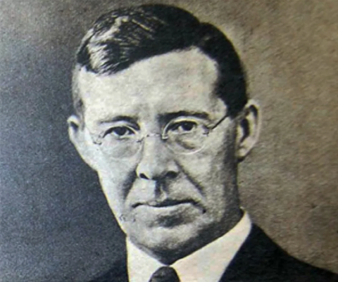
"Mysterious Half-Russian Soul" (Russian father, Zyryan mother) of Pitirim Sorokin. In 1942, Sorokin argued that Russian military successes in stopping the German invasion were due to the Soviet people, not the Communist Party...

"Since the middle ‘30s the Russian revolution’s destructive phase was over, and Stalin and the so-called Communist Party have become nothing but the agencies of resumption and continuation of the living national culture of Russia and the living trends of Russian history." -- Pitirim A. Soorkin, lecture at Boston University, October 22, 1942

Professor Sorokin did not know the Russian word "Gulag", because in 1922, fortunately, thanks to Lenin and Trotsky, he managed to leave Russia with his wife, temporarily settle in Europe, and a year later begin a career in American universities.

Boris Pasternak, the author of the novel Doctor Zhivago, was called by Sorokin in 1960, in a lecture at the San Fernando Valley State Colllege in California, only "a third class writer and poet," a “fellow traveler” of the Soviet regime; and this, Sorokin claimed, explains the fact that Pasternak was never arrested.

Yuri Doykov
October 16 2024

Quoted in “Russia and U. S. Always Friendly, Says Lecturer,” The Boston Globe, October 23, 1942.
Valley State Sundial (San Fernando Valley State College), March 17, 1960.

