https://www.svoboda.org/a/ekspeditsiya-v-tyurjmu-za-chto-filosof-nikolay-zyuzev-poluchil-semj-let/33865722.html

Expedition to prison: why philosopher Nikolai Zyuzev received seven years

04 October 2026

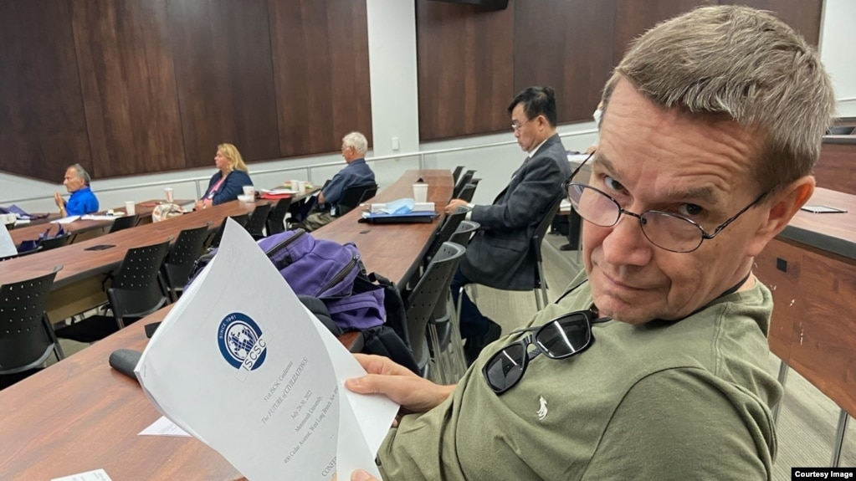
Nikolay Zyuzev

The Supreme Court of Komi sentenced philosopher Nikolai Zyuzev to seven years in a maximum security colony in a case of high treason. Zyuzev is a citizen of Russia and Canada, one of the well-known researchers of the legacy of the Russian-American sociologist Pitirim Sorokin. After the start of the war, he left Russia, but in the summer of 2025 he returned to his native village in Komi, where he was detained. According to the FSB, the scientist trained leaders of the national liberation movements of the indigenous peoples of Russia and received funding for his project from foreign organizations. T-invariant tells what Nikolai Zyuzev did, why he continued to return to Russia, and what his friends and colleagues think about the charge of treason.
Text: T-Invariant, Y.Paramonova

Classical liberal
In the summer of 2025, Professor of Philosophy Nikolai Zyuzev came from Europe to his native village of Podelsk in Komi to visit relatives. And disappeared.
"After the start of the war, he left Russia, like me. The next time I was waiting for him was in the fall of 2025. But back in the summer, he went to Russia, although we begged him not to do this. But he could not help but go - his relatives were waiting for him. Apparently, he thought that he would carry it, that they would not touch him. He left. And one day he just stopped getting in touch," says Zyuzev's friend and former student Alexander (name changed at his request).
For about a month, there was no news about the teacher. Relatives refused to communicate, and acquaintances did not know anything about his fate.
"I began to sound the alarm. Mutual acquaintances said that he was probably fishing in his village again. And one night I freaked out, armed myself with a laptop and conducted a small investigation. And I found information on the website of the Komi court about the extension of his detention in the pre-trial detention center. That is, it turns out that they took him even earlier, somewhere in the middle of summer," says Alexander.
In September 2025, information appeared on the website of the Supreme Court of Komi about the initiation of a criminal case against the scientist under Article 275.1 of the Criminal Code of the Russian Federation - "Cooperation on a confidential basis with a foreign state, international or foreign organization." As reported by Komi Daily, in the summer of 2025, investigators searched Zyuzev's house in the village of Podelsk, Kortkeros district.
Zyuzev spent more than a year in the pre-trial detention center. According to Alexander, there was a refrigerator in the cell, every day Zyuzev was taken out for an hour-long walk. In his free time, he read books from the library, solved chess problems. At the same time, as Alexander says, at times the scientist had depressive states - due to loneliness and uncertainty. On June 10, 2026, Zyuzev celebrated his 70th birthday in the pre-trial detention center.
"We correspond with him, I have already received five letters. He is in a fighting mood, although one letter was quite sad. In general, he jokingly calls his imprisonment a cultural expedition to the pre-trial detention center," says Alexander.
Why the scientist decided to return to Russia, his friends still do not understand. A former colleague of the scientist, journalist Nikolai Vokuev, suggests: "I suspect that he thought that no one was particularly interested in his person and he could spend the summer in his village. In addition, other countries began to frankly bother him. He complained that he did not like the climate in Canada and, in principle, somehow did not like everything very much. So he went fishing, to spend the summer in his village. At the same time, back in 2020, he himself strongly recommended that I leave Russia: they say, I can't stay here. And he returned. I don't understand his act. How did he, after all his English-language publications, where he directly condemned the war and the policy of the regime in general, dare to take such a risk? And whether he was aware of this risk, I cannot say."
Nikolay Zyuzev is a Doctor of Philosophy. Before Russia's full-scale invasion of Ukraine, he taught at the Komi State Pedagogical Institute, Syktyvkar State University and Ukhta State Technical University, where he headed the Department of Philosophy. A significant part of Zyuzev's scientific work is devoted to the legacy of the Russian-American sociologist Pitirim Sorokin. Sorokin was a representative of the Komi people, like Zyuzev. After the 1917 revolution, he opposed Bolshevik policies and was expelled from the country in 1922. Subsequently, Sorokin moved to the United States and became the founder of the Department of Sociology at Harvard University. Zyuzev wrote candidate and doctoral dissertations about the legacy of Pitirim Sorokin and published several books. Two of them, "Pitirim Alexandrovich Sorokin" and "Pitirim Sorokin: Doctrine and Life", were published in Syktyvkar in 2019.
In 2005-2006, Zyuzev trained as a professor at Harvard University, where he collected materials for the book "Pitirim Sorokin's Roller Coaster". "In America, he starts almost from scratch and soon finds himself at Harvard - and so Nikolai Zyuzev was engaged in his "roller coaster," says Alexei T-invariant, a historian and specialist in the history of Russian scientific emigration (the last name is not given at the request of the interlocutor).
In 2008, Zyuzev moved to Canada, where he taught at a college at the University of Toronto, and in 2015 he received Canadian citizenship. A few years later, he returned to Komi and again began teaching at Syktyvkar University.
"Nikolay was my professor when I was a master's student at Syktyvkar State University. An amazing teacher, one of those who inspired me to study, immediately interested me in the humanities. A person of liberal views close to me, a classic liberal," Alexander recalls.

FSB report video
After Russia's full-scale invasion of Ukraine in 2022, Zyuzev left Russia. At the same time, he continued to periodically come to his native village of Podelsk. According to his acquaintances, Zyuzev missed home and the opportunity to teach in his native language.
"Nikolai speaks, teaches and writes perfectly in English, he has no problems with this. But I know very well, having lived in Germany for more than 30 years: you can feel like a fish in water in a foreign language. And yet, this sheltering feeling that a person experiences when communicating in his native language may not exist in another language, – says Hasan Huseynov, Professor of the Free University, Doctor of Philology. – Pitirim Sorokin reflected on his emigration, wrote a lot about it and was a bilingual Komi-Russian person. And, despite the fact that he was absolutely integrated in the United States, he still did not become a trilingual person, despite the fact that he wrote in English. And Nikolai felt it. On the one hand, this is a very personal topic, and on the other hand, it is politically loaded for modern times."
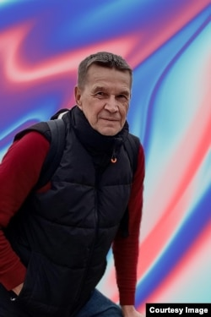
Philosopher Nikolai Zyuzev
On September 16, 2026, it became known that the Supreme Court of Komi sentenced Zyuzev to seven years in a maximum security colony. By this time, the charge had been reclassified as treason. The media referred to the FSB Public Relations Center, which reported that the scientist "trained leaders of movements for the liberation of small peoples of the Russian Federation and developed a project directed against the sovereignty of Russia," receiving funding from foreign funds and organizations recognized as undesirable in Russia. In the video published by the FSB, Zyuzev says that he originally planned to create an educational website for teaching the humanities, but European sponsors were not interested in this project. Much more, Zyuzev said in the FSB video, they were interested in "spreading false information about what is happening in Russia, inciting ethnic hatred, criticizing the policy of the Russian authorities and destabilizing Russia as a whole through the development of national movements."
"He recalls in this video that he wanted to engage in an educational project, and we also corresponded with him about this, but it didn't work out. What he says next is, of course, a text written by Comrade Major. These are not his words, it is felt - about the fact that he allegedly wanted to destabilize the situation in the country and so on. These are absolutely not his formulations," Vokuev believes.
According to the FSB, Zyuzev received a total of 2 million euros from 12 foreign organizations. Among the organizations were German, Czech, Swedish, French and British foundations recognized as undesirable in Russia.
"People who know the realities of our brother's life now abroad understand that the amounts of grants attributed to him in the indictment are absolutely astronomical - with six zeros, literally the budget of an entire scientific center. This is something like the confessions of the 1930s about the tunnel that people from Central Asia had to dig to India or Japan to transmit secret data on the defense of the Soviet state. Absolutely incredible nonsense. And there were some lawyers and even lawyers who glued all this to the case, listened to it, did not object," Oleksiy notes.
"This is a kind of report video about what eagles we are, how good we are. Here is such a terrible professor, a Canadian citizen: look, he has a euro, he has a Canadian passport, you live here in poverty, and they are trying to destroy our great Russia in their Canada. Someone will get an asterisk for this," says Alexander. "It is reported that he received two million euros. This is ridiculous. I would not call him a poor man, but his financial capabilities are clearly not the same as those of a person who received grants for two million euros. I don't believe in it."

The collapse of Russia by small nations
According to Zyuzev's colleagues, the preservation of indigenous languages and culture has always been an important topic for him.
"His project could be aimed, figuratively speaking, at the development of regional self-awareness, the maintenance of the Komi language, the support of small peoples. But for the FSB, it does not sound so pretty. But to train separatist detachments... Sorry, it sounds like they caught a foreign superspy who was engaged in subversive activities. I think that even if the project was aimed at developing national identity, preserving the languages and culture of peoples, the FSB simply reshaped it for its propaganda material," Alexander believes.
According to Nikolai Vokuev, after the start of a full-scale war in Ukraine, there was noticeably more attention to the situation of indigenous peoples in Komi.
"When the war began, it became commonplace. There was a kind of wave, there was an understanding that this war was also against the indigenous peoples who live in Russia. In this context, there was a lot of talk about the Buryats, who were sent to war en masse. I work for Komi Daily. Once, on the anniversary of the start of the war, we made an article where we tried to understand how many people died from different municipalities of Komi. And we came to the conclusion that in percentage terms, more people were sent from villages and villages where the Komi language is predominantly spoken. That is, the war hits the Komi speakers very disproportionately," Vokuev notes.
Vokuev suggests that Zyuzev's interest in the situation of indigenous peoples could be one of the reasons for the attention to him from the FSB:
Total Russification in Komi
"There is such a thing here - separatism. This is what the FSB people love. Something that allows them to make good careers, to show how hard they try. They did not want to miss such a chance. There is no need to invent anything here. Here is the case for you - attempts to destroy the country. And, probably, they are not worried out of thin air. Back in 2020, a reassessment of relations with Moscow began. This was strongly influenced by the story with Shies (mass protests against the construction of a landfill at the Shies station in the Arkhangelsk region, which began in 2018 - T-invariant). And it was quite possible to hear reasoning that Moscow's policy is a colonial policy. If in the tenth years it was an extremely marginal phenomenon, then after Shies, this is how people began to perceive relations with Moscow. Therefore, I think the FSB put its tentacles into this case for a reason."
"In Komi, of course, there is total Russification. According to the Constitution, we have two state languages in the republic - Russian and Komi. But there was a story when a guy was detained at a rally in support of Navalny, back in those conditionally non-cannibalistic times. And he tried to speak Komi in court. To which he received a rather boorish answer from the judge, they say, you graduated from a Russian school, what kind of circus is this. But where else can I speak Komi, if not in Komi?" recalls Alexander.
Huseynov believes that the Zyuzev case poses a threat to all scientists who study the languages of small peoples.
"When the Soviet Union was being built, the Bolsheviks destroyed the independence of small countries - from Georgia to Tuva. But at that time, the official ideology was the ideology of national-Russian bilingualism. Russian scientists were engaged in the so-called young-written languages. That is, languages were given a written language, then their own writers appeared, some publishing houses appeared, films were made. These languages were raised and even reanimated. And in nine cases out of ten, this was done artificially - in the sense that the language itself would not have survived, help and education were needed. And then the collapse of the Soviet Union came, and this official doctrine also burst. And suddenly, overnight, in 2018, people are told that no one needs small languages. And when a person like Nikolai Zyuzev goes against the tide, returns to his place to engage in educational activities, to study his language, he is imprisoned here for God knows what," Huseynov notes.

What could be of interest to the FSB
According to Oleksiy, the interest of regional state security agencies in humanities scientists became noticeable long before the full-scale war in Ukraine: "I remember the first conversation about the fact that in the regions the local state security is beginning to actively call humanities scientists for conversations, slyly squinting when it comes to scientific cooperation, from about 2007-2008. It would seem that some distant clouds are on the horizon, but even then it began: who do you guys work for, with whose money do you prepare publications - let's just talk. This has been rolling through the regions for a long time and clearly began earlier than in Moscow and St. Petersburg. And it concerned the humanities - historians, ethnologists and sociologists."
Zyuzev expressed his views on the situation of the Komi people and the relations of Russian regions with the federal center publicly. In January 2023, the Canadian socio-political magazine Maclean's published his article "I fled from Putin's Russia to Canada. It opened my eyes." This material also appears in the FSB video about the Zyuzev case. In this article, the scientist explained the reasons for his departure from Russia, criticized the policy of Vladimir Putin, wrote about the war in Chechnya and the murder of journalist Anna Politkovskaya.
"The murder of Politkovskaya was a warning to dissidents, and the suppression of the Chechen uprising was a warning to representatives of the indigenous peoples and ethnic minorities of Russia. I was one of both. I come from the Komi people, a Finno-Ugric people whose republic of almost a million people is located a thousand kilometers northeast of Moscow. The Komi people have their own distinctive language and culture, the history of which dates back at least two thousand years. However, under Putin, we face the threat of the disappearance of our culture and language. Like almost two dozen republics and four autonomous districts of Russia, the Komi Republic should formally have a certain degree of autonomy. In practice, it has no autonomy," Zyuzev wrote.
In the same article, Zyuzev said that in 2015 he was offered to head a new research center at Syktyvkar State University. By that time, his daughter had grown up, the marriage had broken up, and there were problems with work in Canada - and the scientist decided to return to Russia. According to him, the task of the center was to establish ties with scientists from Europe, North America and other regions. "Therefore, in the fall of 2021, I turned to two friends - a sociologist and a linguist studying the Komi language - and offered them a radical new idea: to create an online university of Finno-Ugric culture. It would offer high-quality education in the social sciences to Komi youth, help them think more critically and, importantly, raise awareness of the injustices suffered by the Komi people," Zyuzev wrote.
According to Zyuzev, businessman Leonid Zilberg invited him to cooperate with the 7×7 publication. After the outbreak of the war, the project team left Russia and moved to Lithuania. In May 2022, Zyuzev also moved to Vilnius and began looking for funding for the Information and Education Center of Indigenous Peoples of Russia.
Indigenous peoples have been disproportionately affected by the war
"We see the opportunity opened up by Putin's disastrous invasion of Ukraine: indigenous peoples have suffered disproportionately from the war – both on the battlefield and as conscripts into the Russian army. Minorities in the republics are once again aware of the threat posed by the Kremlin. We hope that demands for decolonization will intensify and the Kremlin will lose its power over the republics. Now there may be a rare opportunity to change the situation in Russia – an opportunity that should not be missed. The only way to remedy the situation now is to abandon Putin's vision and embrace the diversity and vitality of its many peoples," Zyuzev wrote.
"And the big trouble is that he, being in the grip of a deep feeling of love for his homeland, came to his land for enlightenment, educational purposes. And now these brutes attribute to him the devil knows what. After all: we have our own life here, everything is captured, we don't need this Komi language. And you are mad with fat. You went to the West, grabbed enough there, came and begin to teach us - and we will show you your place, filthy intellectual. Such revenge for your own indifference, for misery. Nikolai returned to a completely fascized country, where it was clear that they would do something to him, some kind of meanness towards him. He was ruined by life in a state governed by the rule of law. He could not imagine that such a thing could be done to him. Such naivety," Huseynov emphasizes.
Zyuzev's detention took place shortly before the searches in the Syktyvkar Revolt Center, an independent cultural space co-founded by Leonid Zilberg. In the summer of 2025, the center was recognized as a foreign agent and closed, and one of its founders, Pavel Andreev, was subsequently accused of treason.
Currently, Zyuzev's friends are trying to attract the attention of the international academic community to his case. "Now we are looking for eminent Canadian sociologists and philosophers who could convey information about the Zyuzev case to politicians. Perhaps, against the backdrop of Canada's rapprochement with Europe, it will be interesting for them," says Alexander.
Zyuzev is not the only Russian scholar in the humanities who has received a long sentence in a criminal case in recent years. In the colony is, in particular, sociologist and politician Boris Kagarlitsky, convicted under the article on the justification of terrorism.
"I have a lot of acquaintances who are now in prison. Boris Kagarlitsky, whom I have known since childhood - we were neighbors at the entrance. This is some kind of absurdity. These are people who are imprisoned for being smart. This is the drama. This is the specifics of persecution, which was in the 30s, and in the 40s, and in the 50s: oh, you are too smart - and you will be like this. Sociology is a science that allows you to improve society. Or allows you to destroy it if it is extinguished. And we are witnessing the second process. These idiots do not even understand what the meaning of Nikolai Zyuzev's activities is. They simply do not understand what the meaning of intellectual activity is. Because their brains simply do not work. The jaws that chew people are working. And with Nikolai, it is especially disappointing that no voice that comes or could come from the West, from Canada, for example, will reach the ears of his jailers. Maybe there will be some exchanges. There are no other options for him to be released," Huseynov says.
Alexei also sees the Zyuzev case as a warning to other academics working on politically sensitive topics:
"Now anyone, for example, a Tatar, Karelian or Bashkir historian or ethnologist, who back in the 2010s freely traveled to Turkey or Finland, dealt with figures during the Civil War and emigration, and, God forbid, collaborated with some Germans, touching on sensitive topics like collaboration, I think, feels in the crosshairs. And the Zyuzev case for him is an absolutely clear signal that now and in the future everyone can remember. It seems to me that now the task is clearly to intimidate scientists. I hope that in the Zyuzev case there were no informers. But in other areas, unfortunately, they can be found - guardians and pseudo-patriots from their own midst."
"The only thing you can count on is that scientists who have a sense of self-preservation, and people who would like their children to be scientists, will simply leave. Now mobility is completely different, not the same as in the 20th century. People are very mobile and can cross the border relatively easily. And if you prepare for such a movement, then young people, in any case, can and should be taken out of the Russian Federation - to receive a normal education, to integrate into a more or less human society," Huseynov sums up.

